

Prepared by:

**Gerber Technology**

**YuniquePLM**

**Style Folder**

One of the primary functions of YuniquePLM™ is to create organized folders for new product data, otherwise known as a Style Folder. Styles could be any product category that is planned and developed for either a retail or wholesale chain. A Style Folder contains all of the detail information related to the product being developed. For example all information related to constructing the product, measuring the product, and even packaging the product for shipping could be contained within the Style Folder.

To create a new Style Folder, click on the **New Style** header found in the center of the Desktop screen.

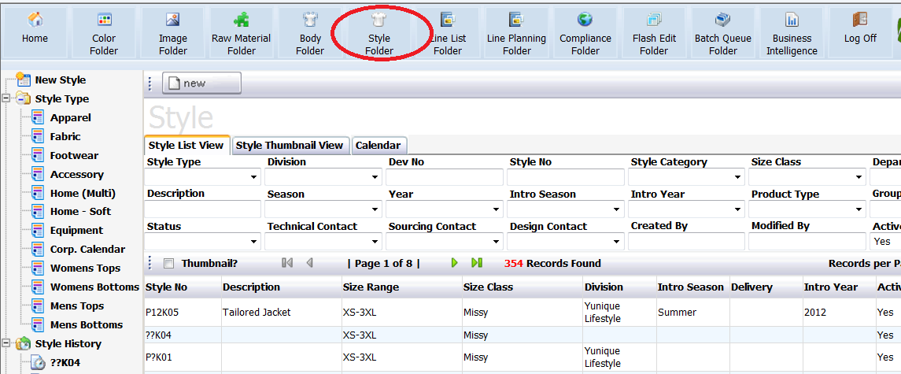

Next, click on the **New Style** node located on the left side of the window or click on the **New** button located across the top of the Style Folder window.

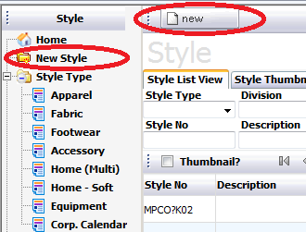

The data information completed in the next step will establish what header fields and workflow pages that will be available in the new style folder being generated.

Active is a Yes/No field indicating that the style folder being developed will immediately be active and available to all appropriate parties for contributing and/or reviewing the data.

The Style Type field relates specifically to the type of product for which the style folder is being prepared. Depending on what is selected in this field, different header information will be presented for data population. For example a style type of apparel might have a different header page than a style type of footwear or home goods. User permissions are also associated with each style type as well. These permissions allow for more convenience and protection while working in the YuniquePLM™ application. Users would only have access to data that would make sense for business practices within a specific company, department, division, etc

The Workflow Type field relates specifically to the template of preselected pages for the style folder being prepared. For example a workflow type for apparel would likely include pages related to body measurements and fit, but a workflow type for home goods would not contain such pages.

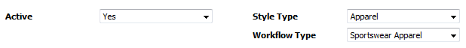

Once the data fields have been populated, click on the **Next** button across the top of the window.



The Style Folder header page will be presented with data entry fields related to the Style Type that was selected. The header data fields can be drop down or free type.

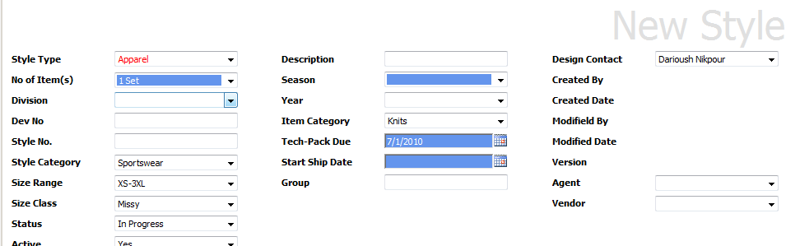

Some fields may be required, and if they are left blank will prevent the new style folder from being saved. If a required field is not completed an exclamation mark will be presented next to the field.

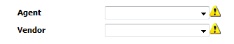

Once all of the header fields have been completed, click on the **Save** button across the top of the window.



When the new style folder record has been entered in the database, the workflow will be visible on the left side of the screen and a place holder with a question mark icon for the representative image will be visible on the right.

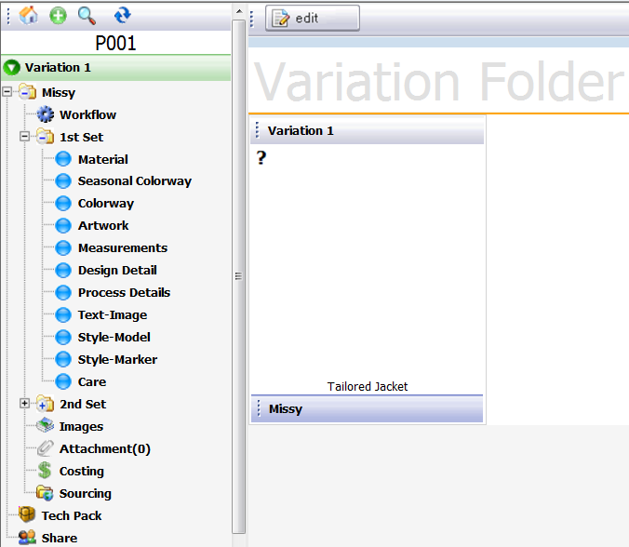

**Size Class**

Once a style folder has been created, a Size Class node will be present on the left side of the window. Clicking on this node will allow header fields to be edited. There will also be some additional tabs available behind the Style Header tab where specific comments can be entered.

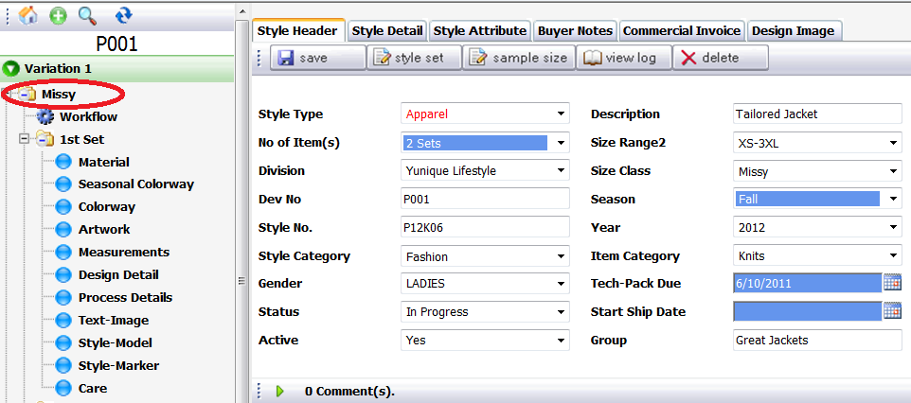

The Design Image tab is where an image can be added as the main representative image for the entire style. Images can be retrieved from the Image Folder, Uploaded from a network location, or created using a proprietary CAD software application that has been made accessible for use from within the YuniquePLM™ application. The image that is populated on this tab will be used as the main reference image for the style folder. To associate a specific image with the style folder, click on the Design Image tab.

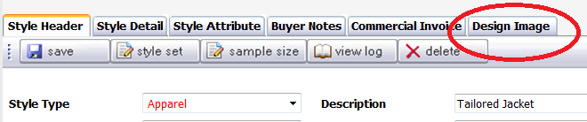

Next populate the File Type field with the appropriate information related to the image that will be used. Fill in any additional data information to be associated with the image.

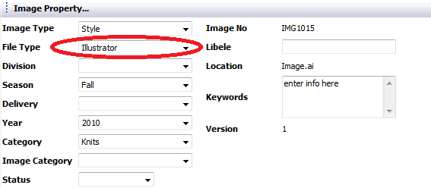

If the image file being used is already in the Image Folder, click on the **Select Image** button across the top of the screen.



Once the Image Folder is open, click on the chain **link icon** to link the existing image to the style folder.

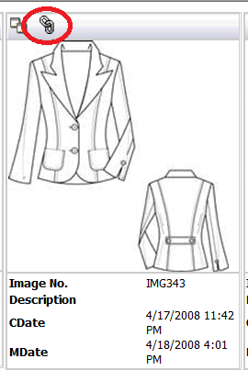

Once the representative image has populated the Design Image tab, click on the **Save** button across the top.

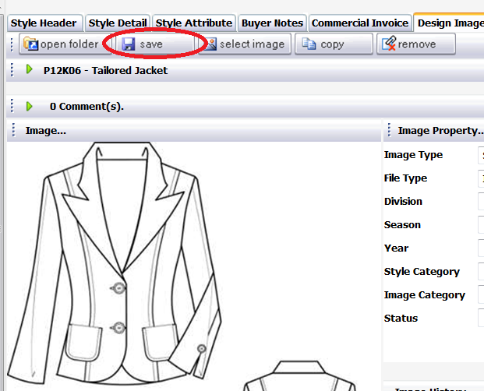

Style Set

Very often a Style Folder will be prepared for a product that contains multiple components, such as a jacket and pant sold as a suit. The YuniquePLM™ system refers to each component as a “set”. When a new style folder is developed the number of components that will ultimately complete the style can be selected from a drop down menu labeled No. of Item(s).

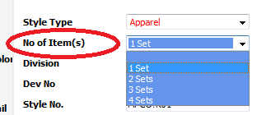

Each item within a style set will have a set of pages listed on the left side of the style folder. This allows for parallel development to occur, since each individual component will need to go through all necessary workflow milestones.

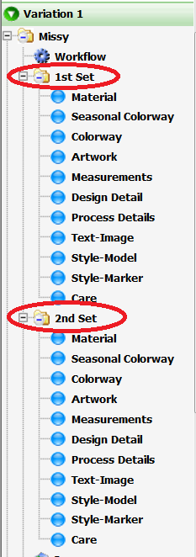

The headers of each component will be named 1st set, 2nd set, and so on up to the maximum number of items within a style. These headers can be renamed to reflect the actual item being developed. To do this, click on the **Style Set** button across the top of the window.

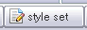

Enter the name of the item in the appropriate data field to replace the default title and click on the Save button across the top of the window. Then click on the **Close** button to return to the style folder.

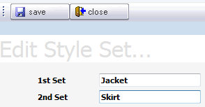

The header at the top of each of the style set pages will reflect the name change. The plus/minus icon to the left of the title will expand or collapse the list of pages beneath each item.

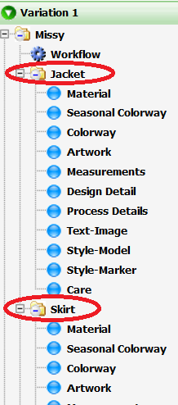

**Workflow**

The workflow node is where specific individuals can be assigned the responsibility of approving each of the style folder pages within a specified time frame. It is also the place where the workflow template is changed should that be necessary. To assign workflow responsibilities or change the workflow being used click on the workflow node on the left side of the style folder window.

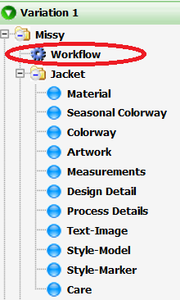

To change the Workflow being used, select from the drop down list provided in the StyleWorkflowID field. To establish a final completion date for all tasks associated with the workflow of the new style folder, enter a date in the Tech-Pack Due field by clicking on the calendar icon. The Status of the entire style folder can be changed by selecting the appropriate label from the drop down list in the Status field.

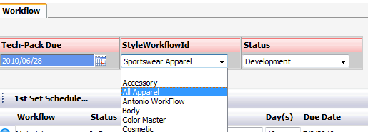

Once the selected workflow template is presented, select a user name from the drop down list provided to the right of each of the pages listed. This will assign a specific user to be responsible for final approvals of each of the pages of the selected workflow.

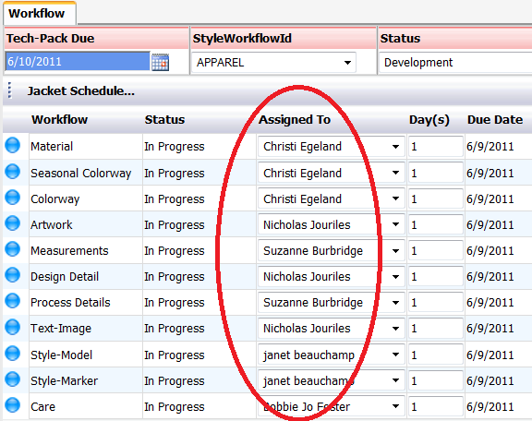

Each of the pages within a workflow will have a colored bubble to the left. The specific color of each bubble will indicate that some action has occurred on that page of the workflow. The color indicators are as follows:

* Blue Bubble – In progress. This is also the default color.
* Green Bubble – Completed. A final status has been indicated.
* Red Bubble – Rejected. The work has been rejected.
* Gray Bubble – Not Started. No work has been done

The specific work that has occurred, or why a specific status was given, will be found directly on the page in question. But the color of the bubble is a quick reference for all parties working in the style folder. The user name listed in the Assigned To field will usually be the one responsible for managing the page status and colored bubble indicator. Other indicators are as follows:

* Blinking green bubble – For Review. The work on the page needs to be reviewed.
* Paper with green check mark – Complete. The work on the page has been completed.
* A conversation bubble icon – Comments. There is a comment thread that needs to be reviewed.

Each of the pages within a workflow can have an allotted amount of time for completion. This time frame is established by entering the number of days that will be expected to complete each task in the Day(s) column. The number of days entered will be calculated beginning from the date that the style folder was created, and then a calendar date will automatically populate the Due Date column.

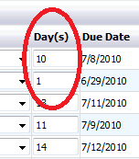

Once all of the data has been entered correctly on the Workflow screen, click on the Save button across the top of the window to store the information. Next, click on the Close button to exit the Workflow screen.

Seasonal Colorway

The Seasonal Colorway page in the style folder is where all of the seasons for which the style folder is being developed are listed. For example a style might begin in Spring 2010 and then be carried over for several seasons going forward in different color offerings. The seasons will ultimately feed the Colorway page where style components from the Material Summary page, can be matched to the specific style colorway offerings. At least one season must be listed on the Seasonal Colorway page. To add seasons click on the **Seasonal Colorway** node on the right side of the style folder. Then select the **Edit** button across the top of the window.

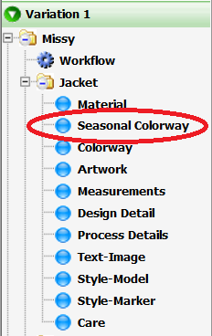 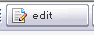

Select the **Season** button across the top of the window.

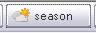

From the list provided on the left select the appropriate season(s) for the style being developed. Move them to the right side with the **green arrow controls** in the center. Once all appropriate seasons are listed click on the **Save** button across the bottom and then the **Close** button to exit the season selection window.

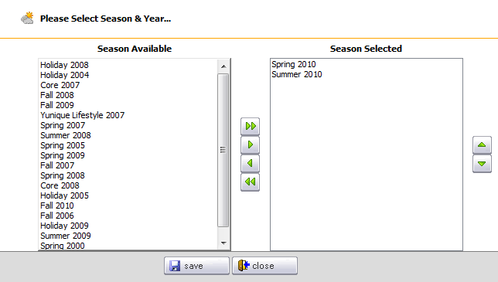

The selected seasons will be displayed to the far right of the center row and highlighted yellow. Information related to SAP entries or other company specific information can be listed in the columns to the left. Rows for each of the actual colorways will be updated once the information has been added to the colorway page.



**\*NOTE:** The information managed on the Seasonal Colorway page is configurable for each individual company and therefore may be very different than this document.

Colorway

The Colorway page is where raw material(s) can be assigned one or more specific colors that will coordinate with the overall colorway of the product being developed. For example if a garment is being produced in both black and white, a black button can be designated for the black colorway of the style and white buttons designated for the white colorway.

**\*NOTE**: Before colors can be assigned to the raw material items at least one season must be listed on the Seasonal Colorway page. Please refer above to the seasonal colorway segment of this document.

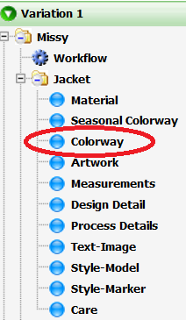

Only items that have been assigned with the qualifier of CLR (color) on the Summary view of the Material page will be listed on the Colorway page.

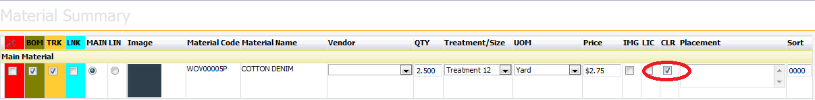

To associate colors for each item click on the **Edit** button across the top of the Colorway page.



Specify a season from the dropdown list in the center of the page and then click on the **Summary** button across the top of the window.

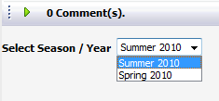 

From the Style Color Combo tab select the **Add** Button across the top of the window.

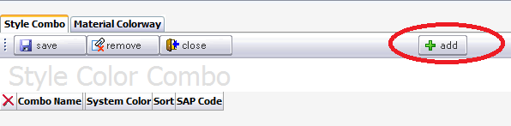

Choose a palette from the color selection list.

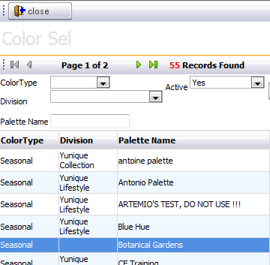

Place a check mark to the far left of the desired colors that correspond to the season. Then click the **Save** button to store the selection and the **Close** button to return to the Style Color Combo tab.

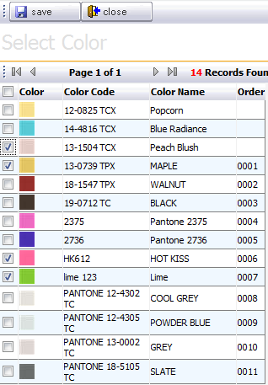

If the color combo information will be going to an SAP system, a code can be entered in the SAP Code column. If colors need to be deleted from the list, place a check mark in the red column on the far left of the color row and then select the Remove button across the top of the window. Click **Save** to store the information and **Close** to return to the main Colorway page.

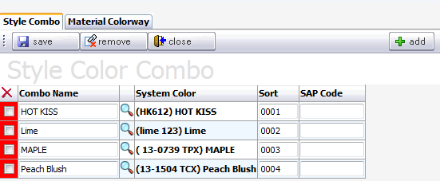

Once the colorways have been selected for a season all items with the CLR indicator selected on the Material Summary page will be listed on the Colorway Page. The style colorways will be listed on the right of each raw material item row. Beneath each of the style colorway headers listed will be blank color chips identified as a question mark. The color chips will be for the specific item color that is to coordinate with the style colorway header.

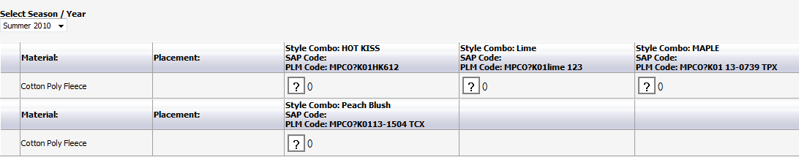

To replace the default color chip with an actual color, click on the **Edit** button across the top of the window and then click directly on one of the **question mark icons**.

 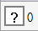

The colors available for the selected raw material item will be listed for selection. Click directly on the color chip intended to correspond to the product colorway. If an item will be the same for all colorways such as a DTM (dyed to match) button, a check mark can be placed to the left of Apply to All Colorway.

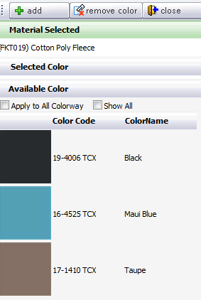

Once all items have been assigned a color the color chips will be displayed below the colorway header.

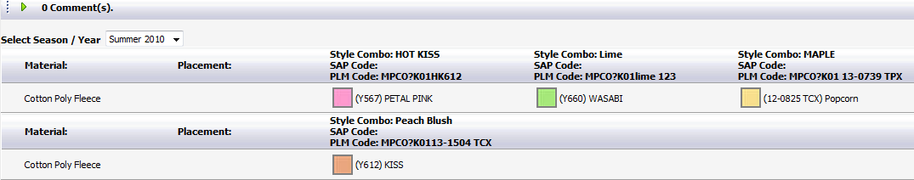

Artwork

The Artwork page is a quick reference view of all artwork items listed on the Materials page.

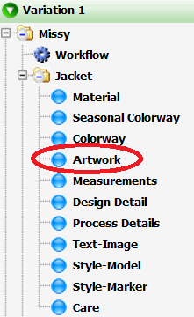

Items that have been assigned with the qualifier of IMG (image) on the Material Summary page will be pushed out to this page so that they can be referenced directly as artwork is being developed.

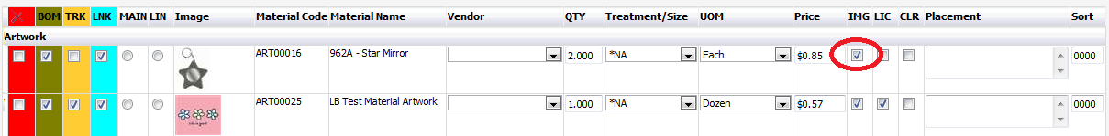

This can be especially helpful if Artwork is actually being developed according to certain specifications concurrently with the style. A representative image of all artwork will be displayed on this page.

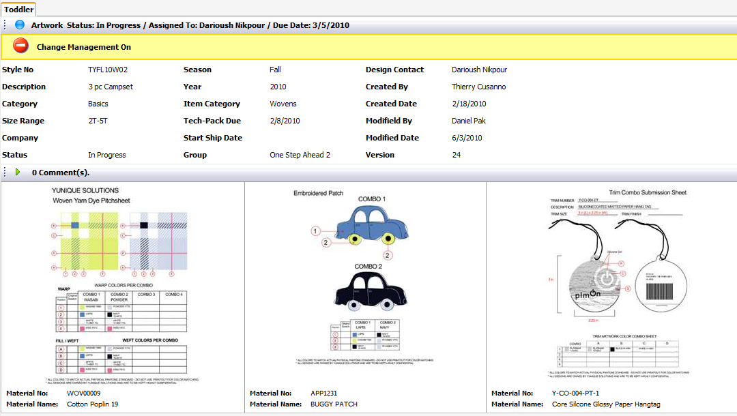

A printout report of the artwork can be generated by clicking on the **Preview** button across the top of the window.

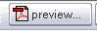

A list of available reports will be presented. Place the selection indicator to the left of the report to be generated and select the **preview** button across the top. Click the **Close** button to return to the main Artwork Page.

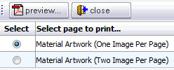

To see the action that has occurred affecting the artwork, click on the **View Log** button across the top.



The actions will be listed with user names and dates and times that the actions occurred. This log file can be emailed to others if necessary by selecting the Email button across the top of the window. Click on the **Close** button to return to the main Artwork page.

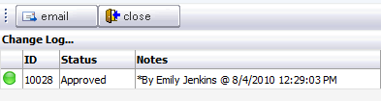

Measurements

The Measurement page is where the initial sample size measurements of a style will be listed for each POM (point of measurement) designated on a template form.

**\*NOTE**: measurement data is established in tables/libraries in the YuniquePLM control panel.

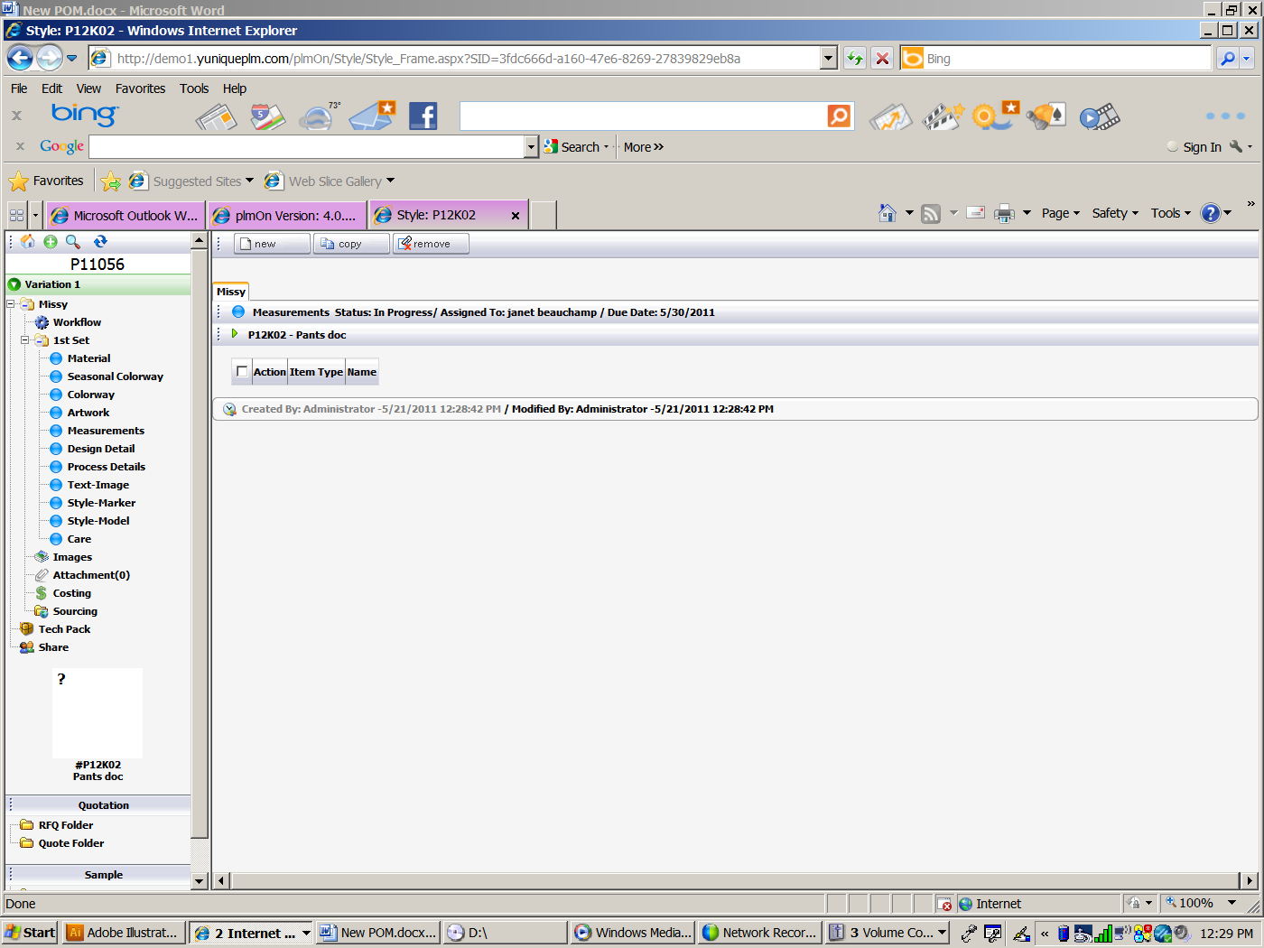

To add measurement information to the page, click **New**.



Choose the Workflow Item type from the drop down and give the item a name in the Item Name dialog box:

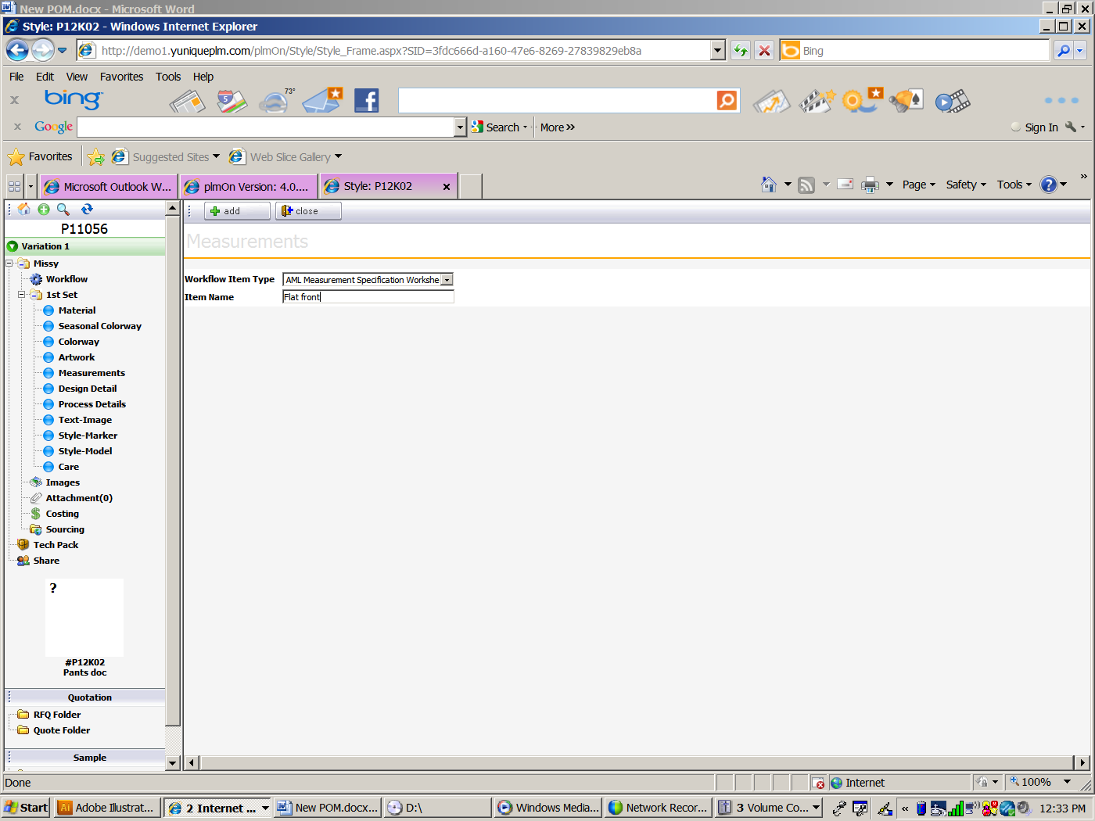

Click the **Add** button.

This will create the page tabs.

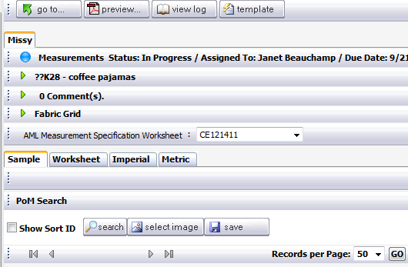

To continue to build the page data, click the **Template** button.



A list of available templates will be presented. To choose a template click on the **Copy** button to the far left of the desired template.

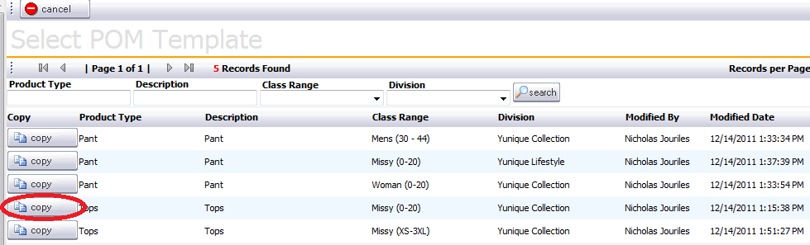

Select OK or Cancel to verify the template selection.

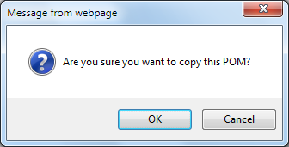

The page will display the POMs and tolerances associated with the selected template.

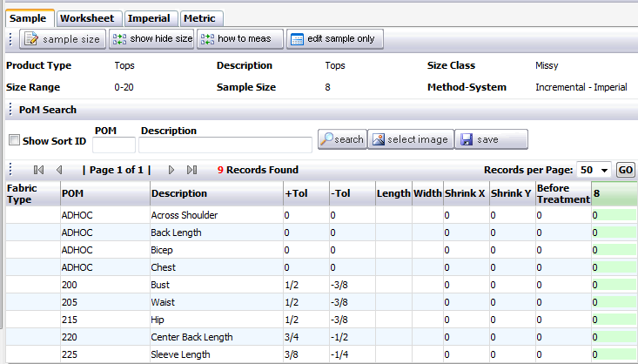

To enter the sample size measurements click on the **Edit Sample Only** button located across the top of the page summary information.

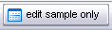

This will put only the sample size into edit mode, so that the proper values can be entered in the sample size column. Additional information can be entered so that before treatment data can be entered to calculate according to fabric behavior. Click the **Save** button across the top of the list to complete the process.

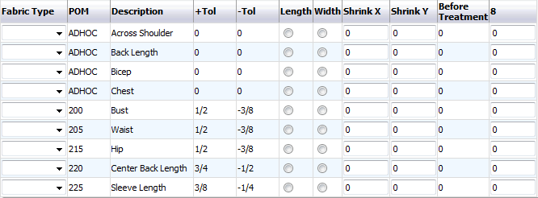

In the Fabric Type column, a fabric code can be selected from a drop down list displaying a list of models and fabric codes that have been populated on the Style Model page.

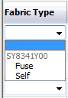

For the selected fabric type information related to the expected fabric behavior can be entered in the Length and/or Width columns, and values of expected shrinkage can be entered in the Shrinkage X and/or Shrinkage Y columns. Ex: Fabric behavior expected is to shrink in the width. The amount expected is 3% and the pieces will be affected in the direction of the X axis according to their pattern orientation in the model.

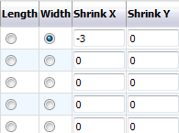

**NOTE:**  If pre-treatment calculations are not important for the product(s) being developed, the fields required for this purpose can be disabled through XML changes performed by a YuniquePLM implementation representative.

Finally the values for the sample size can be entered in the last column. The sample size selected for the template will be displayed at the top of the column.

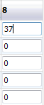

**NOTE**: To save time use F function keys to enter fractions.

F1 = 1/8

F2 = 1/4

F3 = 3/8

F4 = 1/2

F5 = 5/8

F6 = 3/4

F7 = 7/8

Once the sample size values have been entered, the grading increments for each individual size can been viewed by selecting the **Worksheet** tab.

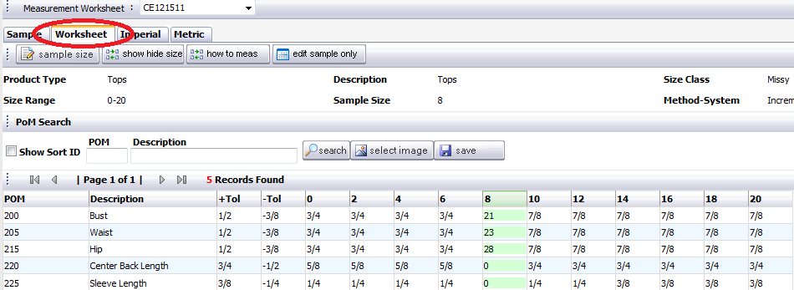

The fully graded size rage can be viewed in inches by selecting the **Imperial** tab.

The fully graded size rage can be viewed in millimeters by selecting the **Metric** tab.

Other options on the page include **sample size** (to change sample size)

**show hide size** (to remove sizes from the size range for this style) **how to measure** (display the how to measure images and text associated with each POM) and **edit sample only** (edit the sample column only):



To change the sample size, click the **sample size** button:

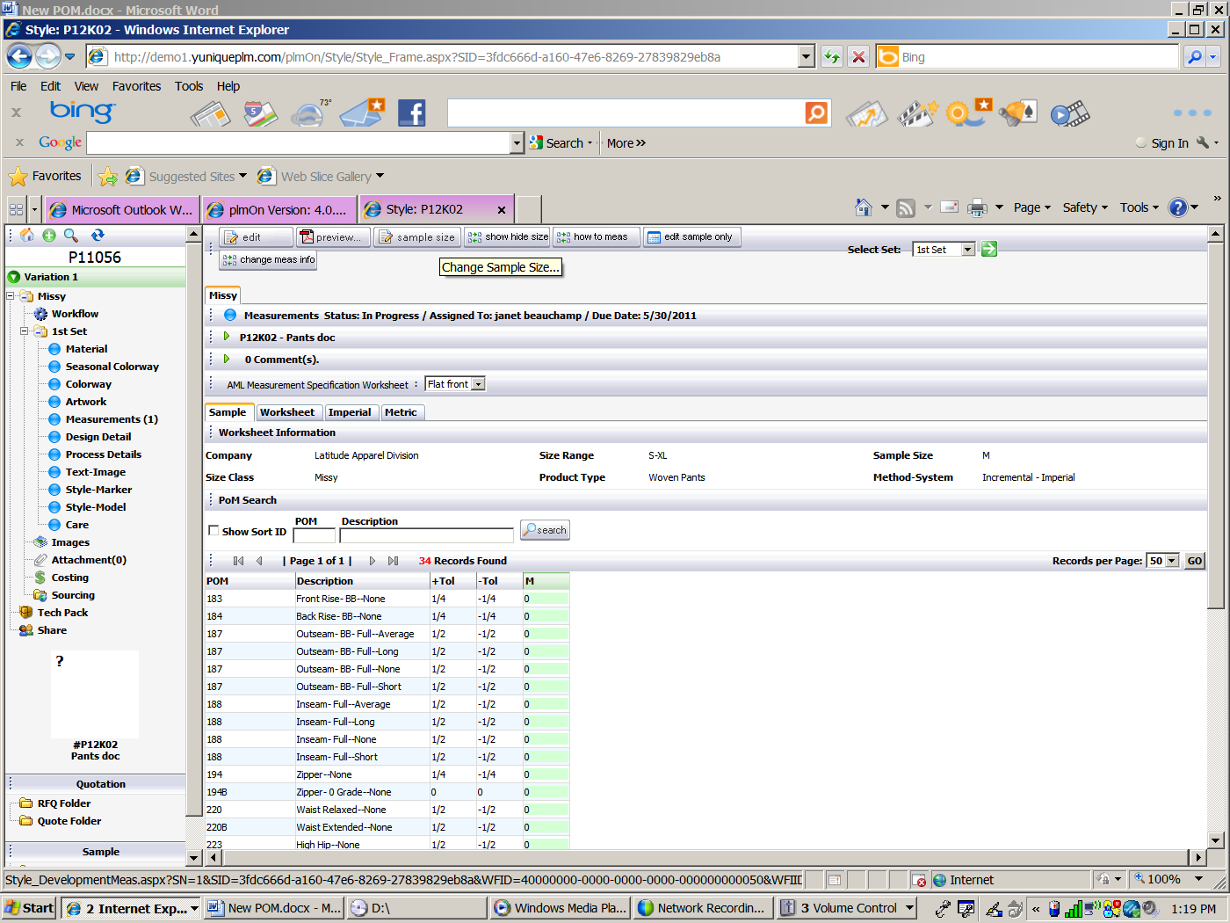

A new window or tab will appear. Click a radio button for the appropriate size change:

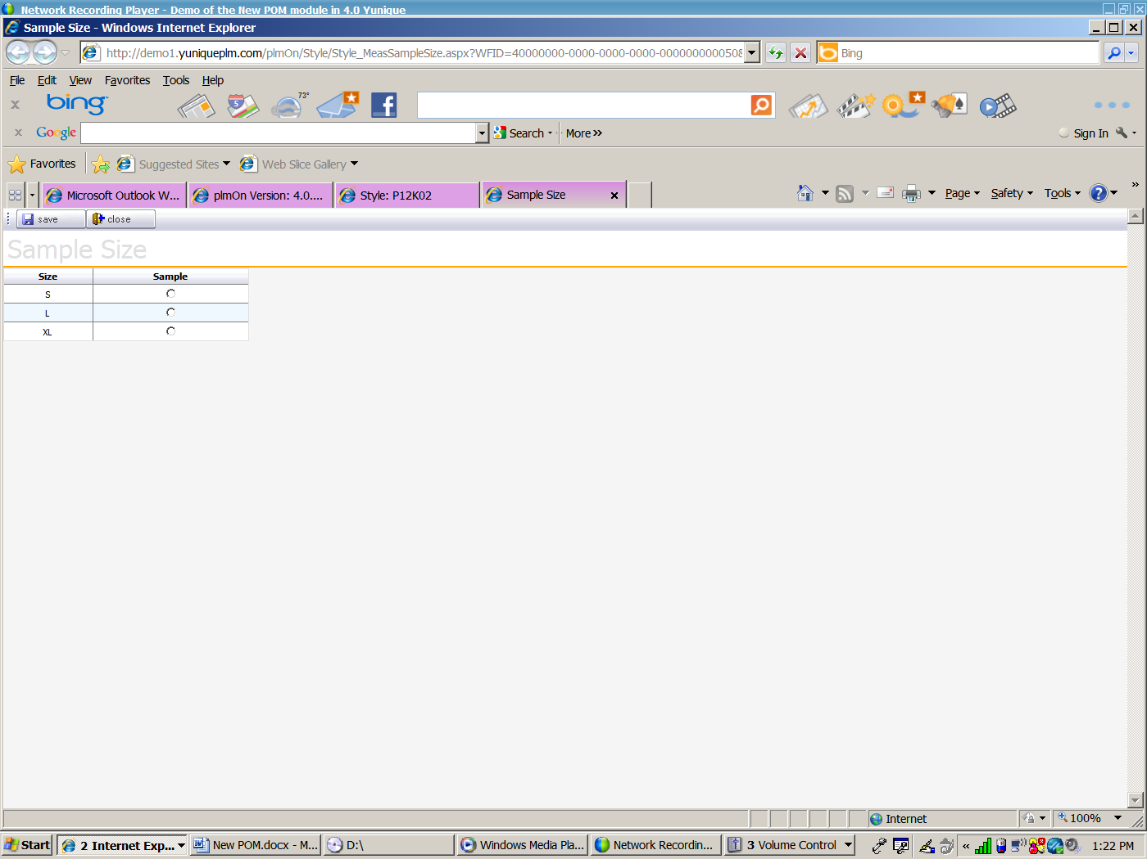

Click the **save** button.



To show or hide sizes, click the **show hide size** button:

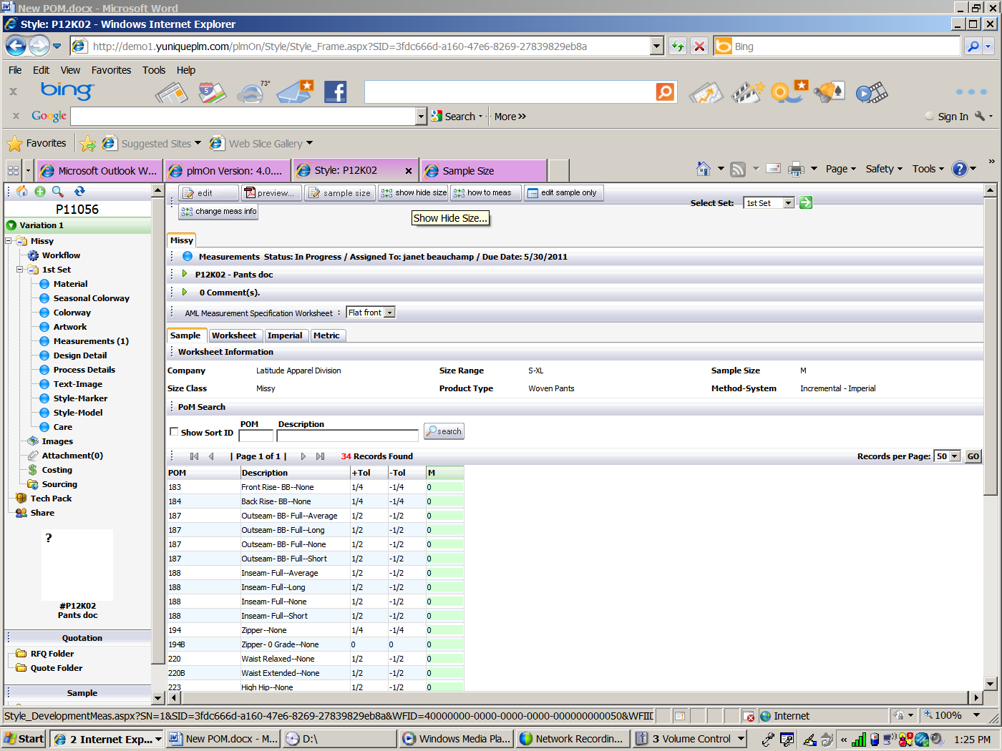

A new window or tab will open:

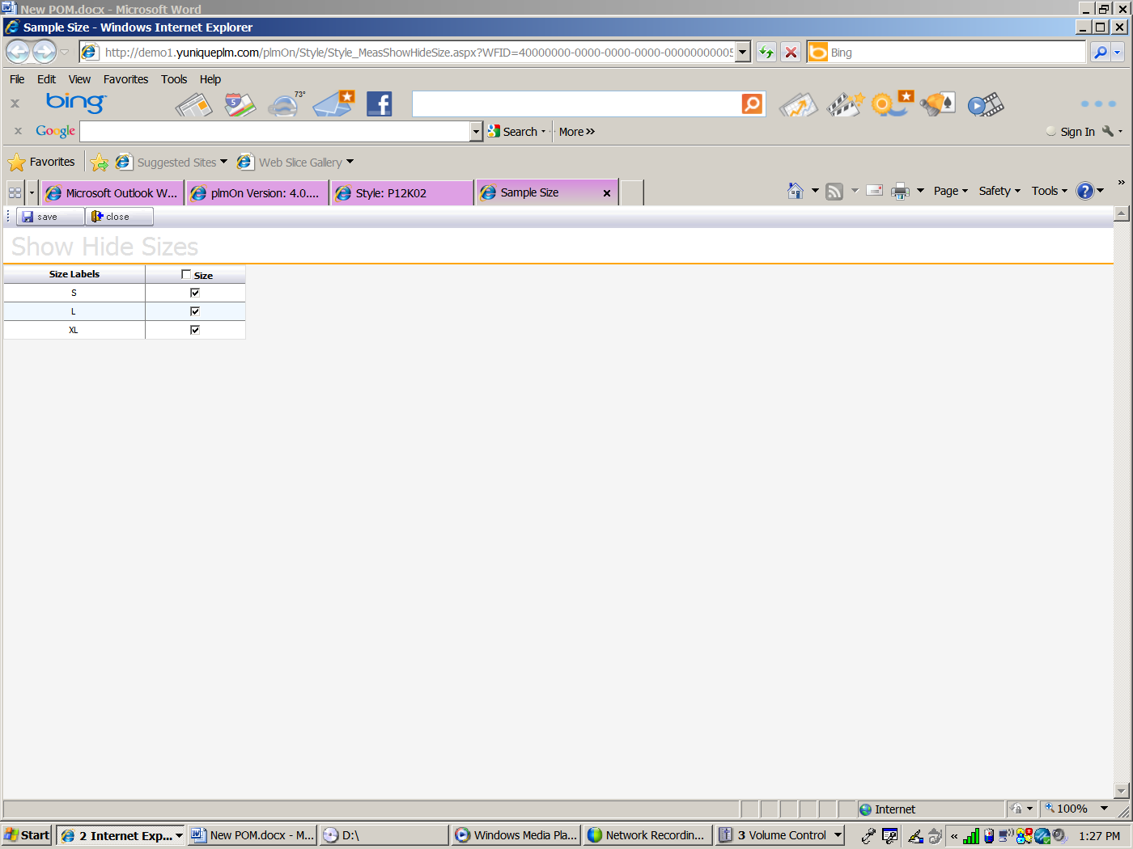

Remove the check mark from any sizes that will not be developed. Click the **save** button.



To view the How to Measure guide click on the **how to meas** button:

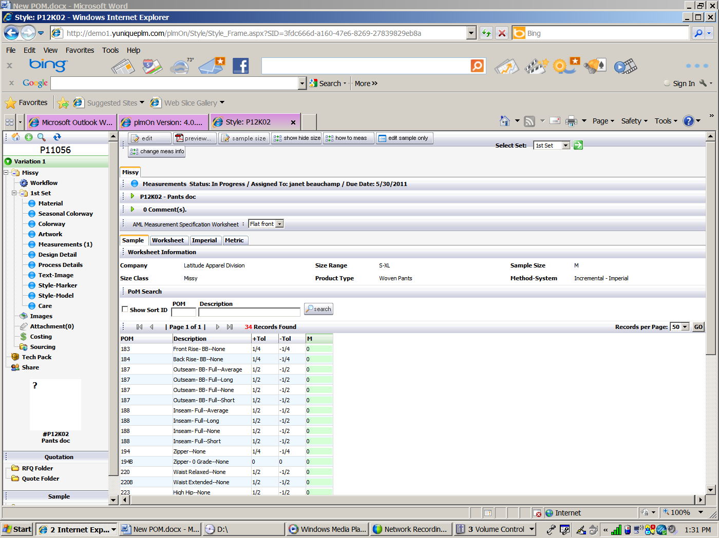

This will display the how to measure guide in a tab or window:

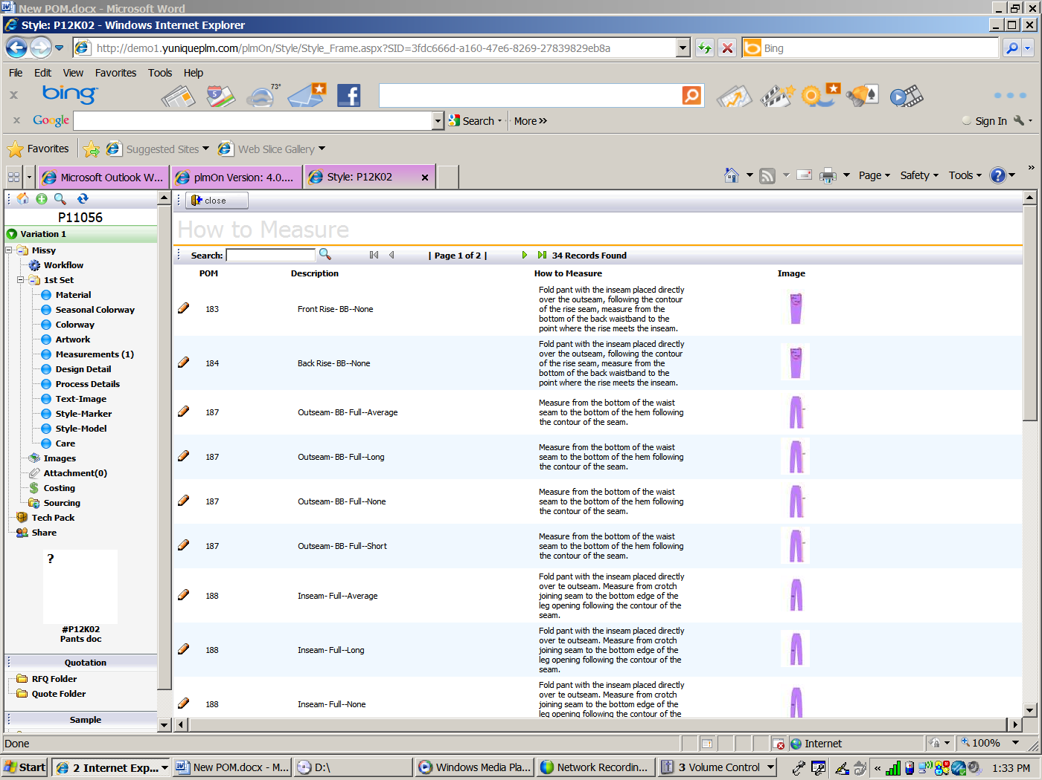

To make changes to the HTM information click on the pencil icon on the far left of the row. Once edits are complete click on the **Save** button to store the new information and click close to compress the HTM data.

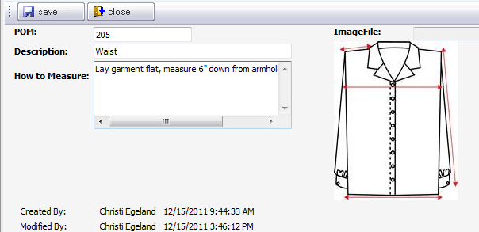

To edit the grade rules, tolerances, POM codes or descriptions of the template, click on the **Edit** button across the top of the window. Once in edit mode all fields will be opened and available for changes.

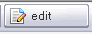

The functions that become active when in edit mode are **break link** (to break the POM link from the template in the library), **link pom** (to re-link POMs that previously had the link to the template broken), **critical pom** (to make sure certain POMs are given a symbol indicating critical attention), **Show On QA** (to indicate POMs that will be used on a quality assurance sample request), **delete pom** (to remove a POM from the list), **template** (to select a different template), **pom library** (to choose more POMs from the library).



To break the link of a POM from the template, click on the Break Link button across the top of the list.



Place a check mark to the left of the POM(s) to be changed and click the Break Link button across the top of the window.

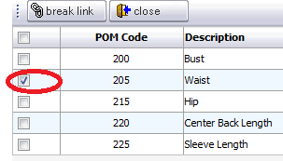

A verification message will be presented to confirm the function. Click **OK** to complete the process or **Cancel** to keep the data as it was.

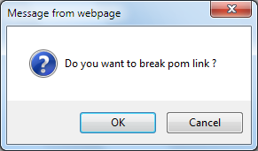

When the link has been broken the “L” column will be blank for the effected POM(s). All POMs that remain linked to the template will display an icon of a chain link in the column.

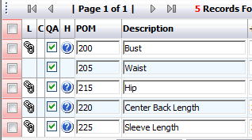

To link a POM back to the template click on the Link POM button.



Only the POM(s) without links to the template will be displayed for selection. Place a check mark to the left of the POM(s) and click Link across the top of the window.

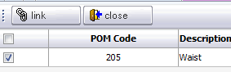

To indicate that a POM is critical to the fit of the product, click on the **Critical POM** button.



A list of POMs will be displayed. Place a check mark to the left of each of the POMs considered critical and then click the **Save** button.

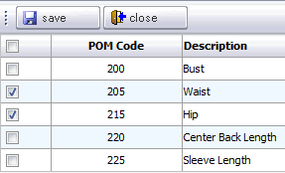

The POMs will then have an exclamation mark in the “C” column to the far left of the row.

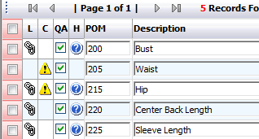

To make sure that specific POMs are added to quality assurance sample requests that are generated for the template click on the **Show On QA** button.



Place a check mark to the left of any POMs required for QA and then click the Save button across the top.

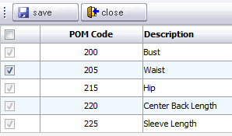

POMs that are required for quality assurance will have a green check mark in the QA column.

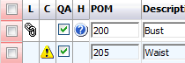

To remove any POMs from the page place a check mark in the red column to the far left of the POM(s) to be removed.

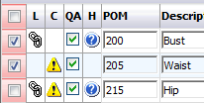

Once all POMs have been selected, click on the **Delete POM** button above the list of POMs in the middle of the page.



When a new template is selected from the library, all POM codes, descriptions, grade and tolerances will be converted to the new template. To retrieve a new template from the library, click on the **Template** button.



A message will be presented warning that any data on the existing template will be lost. Click OK to continue with the process or Cancel to maintain the original data.

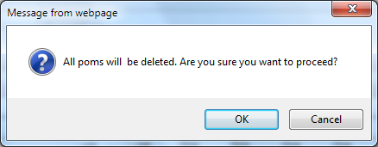

The list of available templates in the library will be presented. Click the **Copy** button to the left of the desired template.

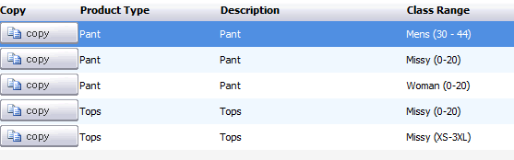

To add POMs to the page that were not on the original template but are in the library, click on the **POM Library** button.



A list of available POMs from the library will be presented. Place a check to the left of all desired POMs and then click the **Add** button across the top of the page.

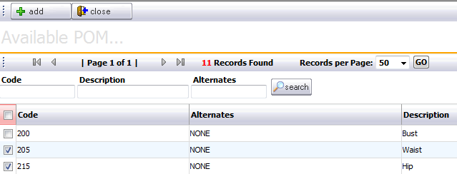

To import AccuMark Measurement data onto the Measurement page there must be a connection to the AccuMark SQL server database and some data established.

In AccuMark PDS create a .txt file using the Measurement Chart and ‘Export to File’ consider using the measurement names from your POM database.

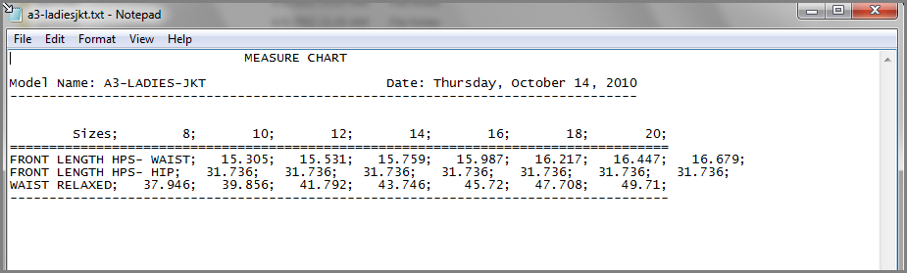

With a Measurement page in edit mode, select the **Accumark Import** button at the bottom of the page.

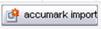

**Browse** to the saved .txt file exported from AccuMark PDS software.

Select the correct **Measurment Type** as either imperial or metric setting and then Upload.

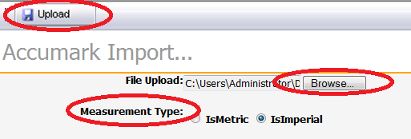

Map the sizes from the text file to the sizes on the Measurement page by selecting the drop down menu next to the size and selecting the corresponding size.

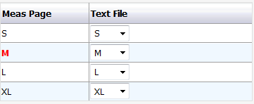

Click on **Save** button in the upper left corner.

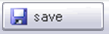

The measurements from the text file are calculated as relative or incremental and populate the measurement page.

If a matching POM description is already on the page, that row will be updated with the new information from the text file. If the point of measure is not already on the page and is not in the measurement library then a new row will be added to the page with a code of “ADHOC”.

Select the different tabs (Sample, Worksheet, Imperial, and Metric) for different views of these values.

Once all changes are complete on the page click the **Save** button across the top of the screen. Then click the Close button.

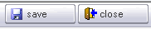

When the page is no longer in edit mode the main page tool bar will be displayed.



To print the page, click on the Preview button in the main tool bar.



Click the print layout option by placing the dot to the far left of the row. Select the language of choice for the printout from the drop down list across the top and then click the **Preview** in the upper left. The PDF file will them be displayed.

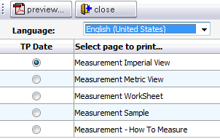

When tech pack is generated for a style the change management status is turned on. Once change management is on all activity is recorded on the measurement page. To view the activity on the page, click the View Log button.



To return to the list of all measurement pages within a style, click the **Go To** button.

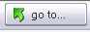

Once all of the measurement pages are listed click on the drop down list in the Action column of the desired page to **View, Edit, Make Copy** or **Rename**.

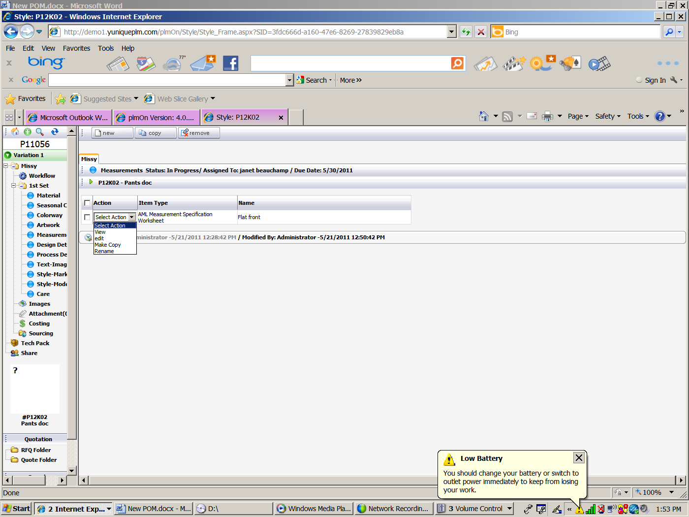

**View** shows the sample column and opens up the option buttons:

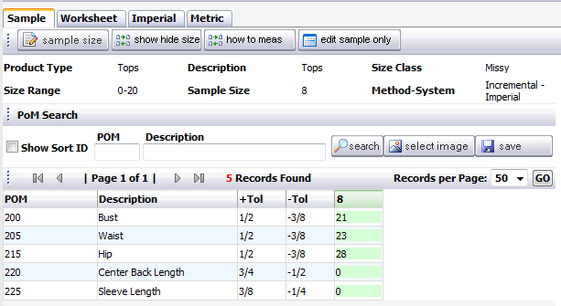

**Edit** allows editing of the grade rules and the sample measurements.

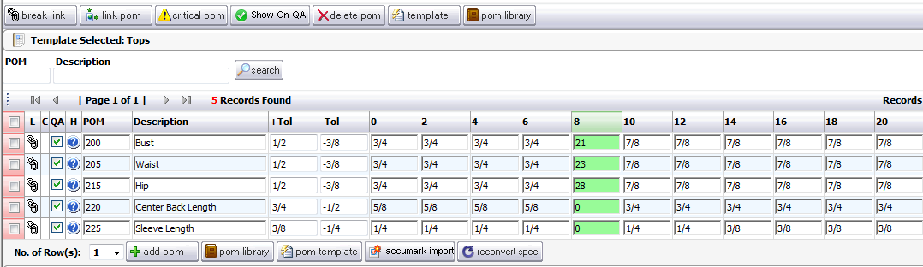

**Make Copy** creates another instance of the Measurement page.

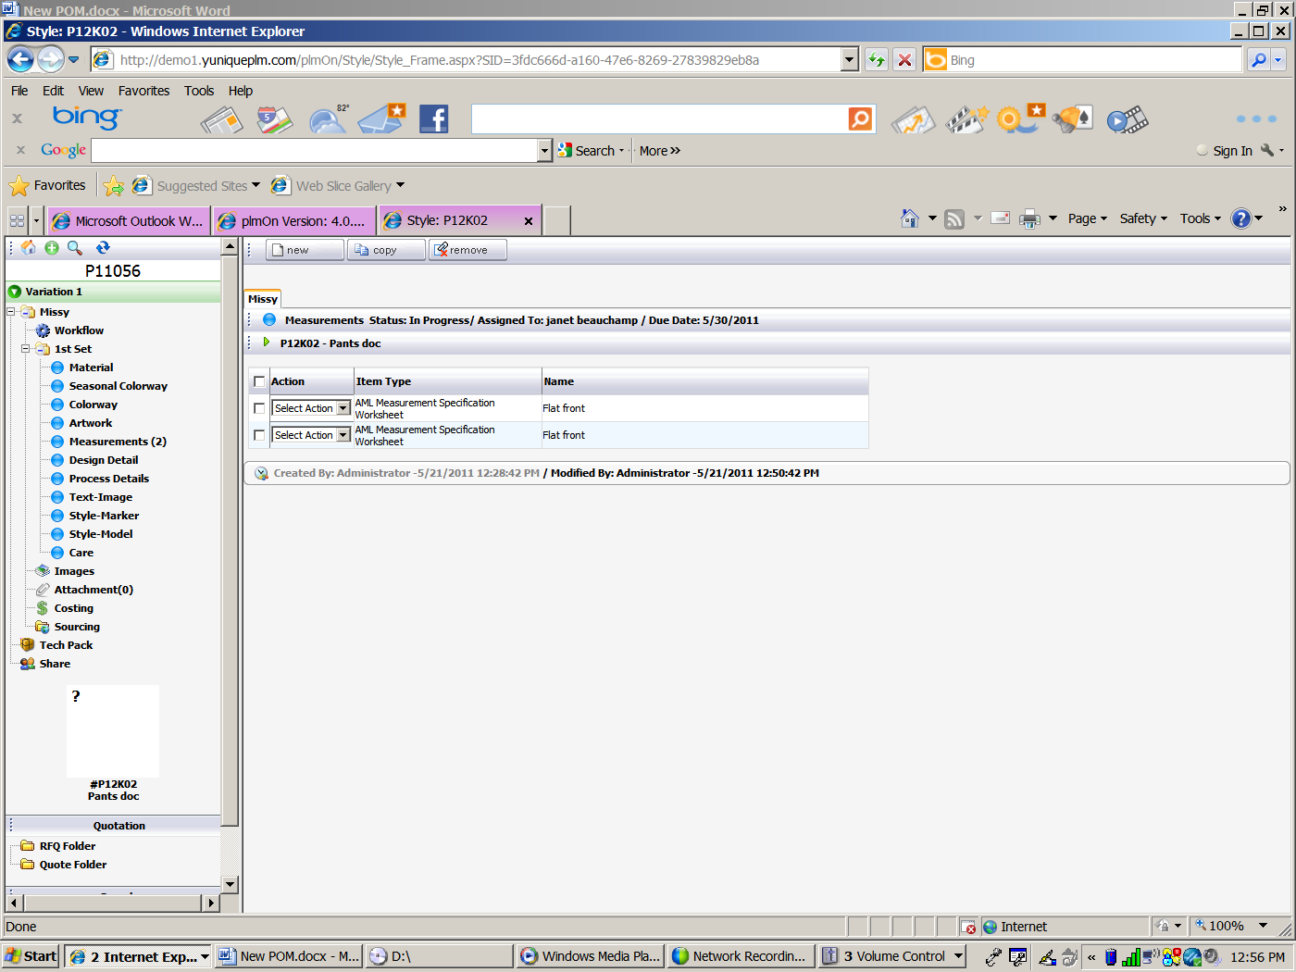

**Rename** allows the page to be renamed. Example: Before Wash and After Wash

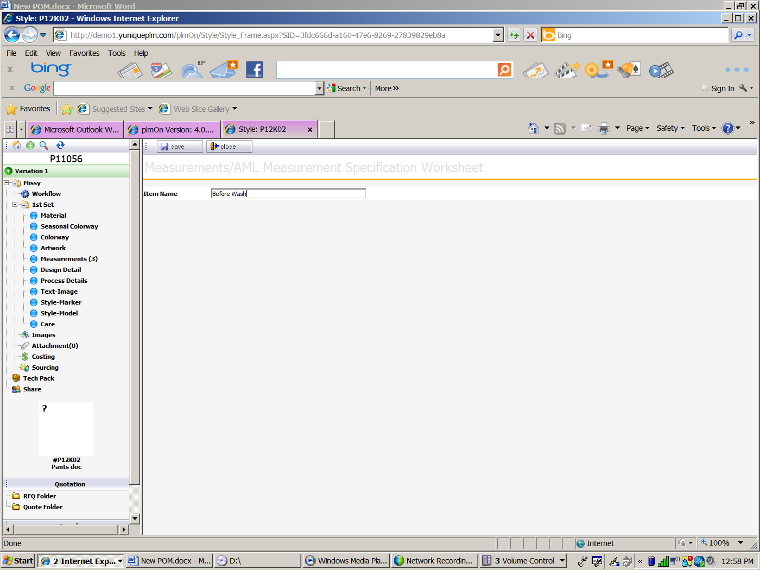

Click **Save** to save changes.



Click **Close** to disregard changes and/or return to the main page view.



To remove a copy of the Measurement page, click a **check mark** next to the page to be removed. Click the **remove** button.

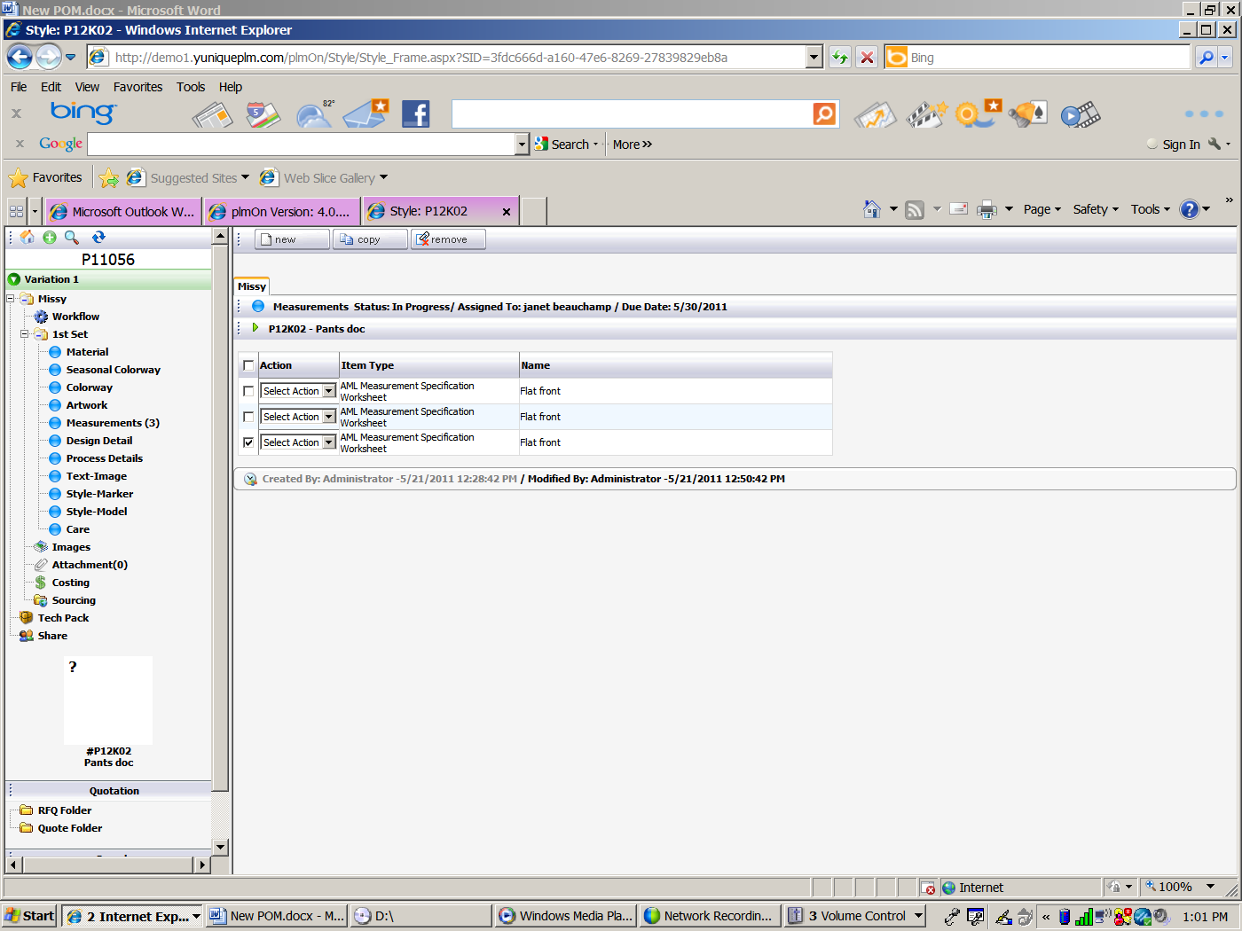

When the button is clicked, the following message appears.

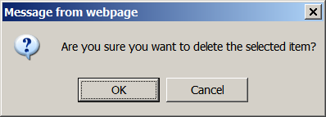

Click **OK** to remove or **Cancel** to not remove.

To copy a Measurements page from another style/folder, click the **copy** button.



This will open the search dialog in a tab or window. Click the **select** button in the upper left corner of the image to select the style to copy.

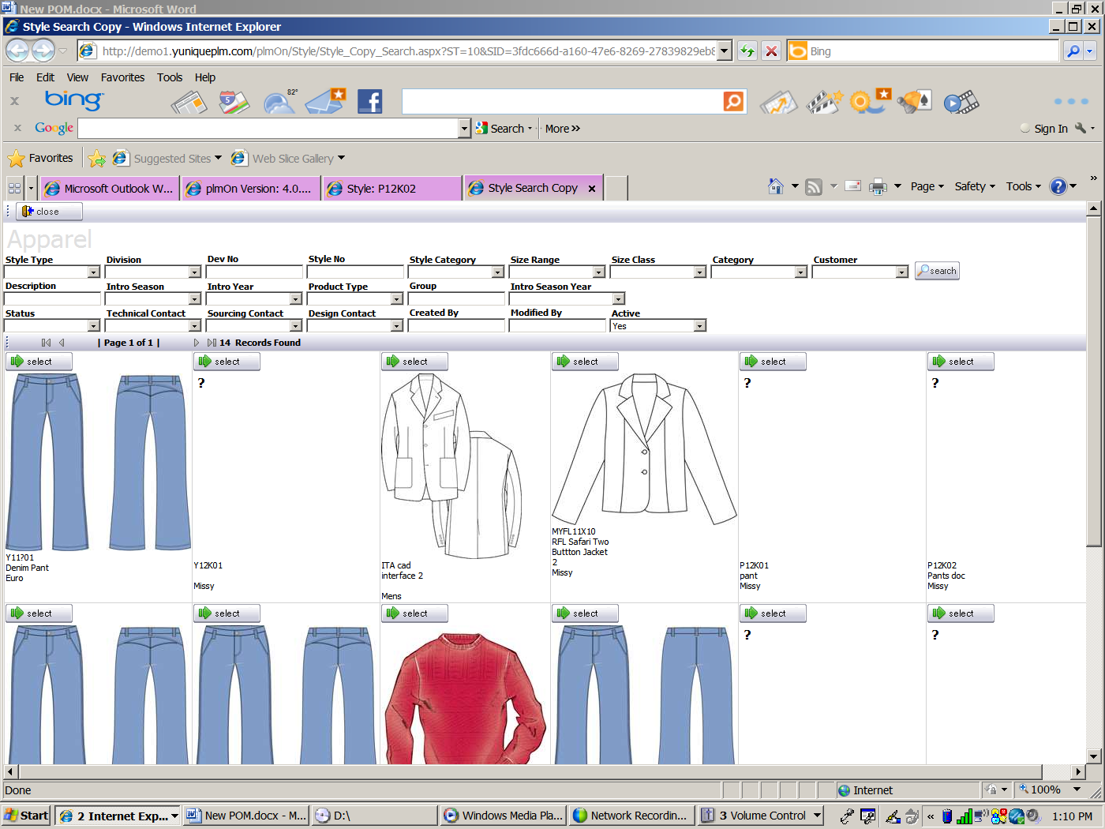

Click the **copy** button next to complete the process.

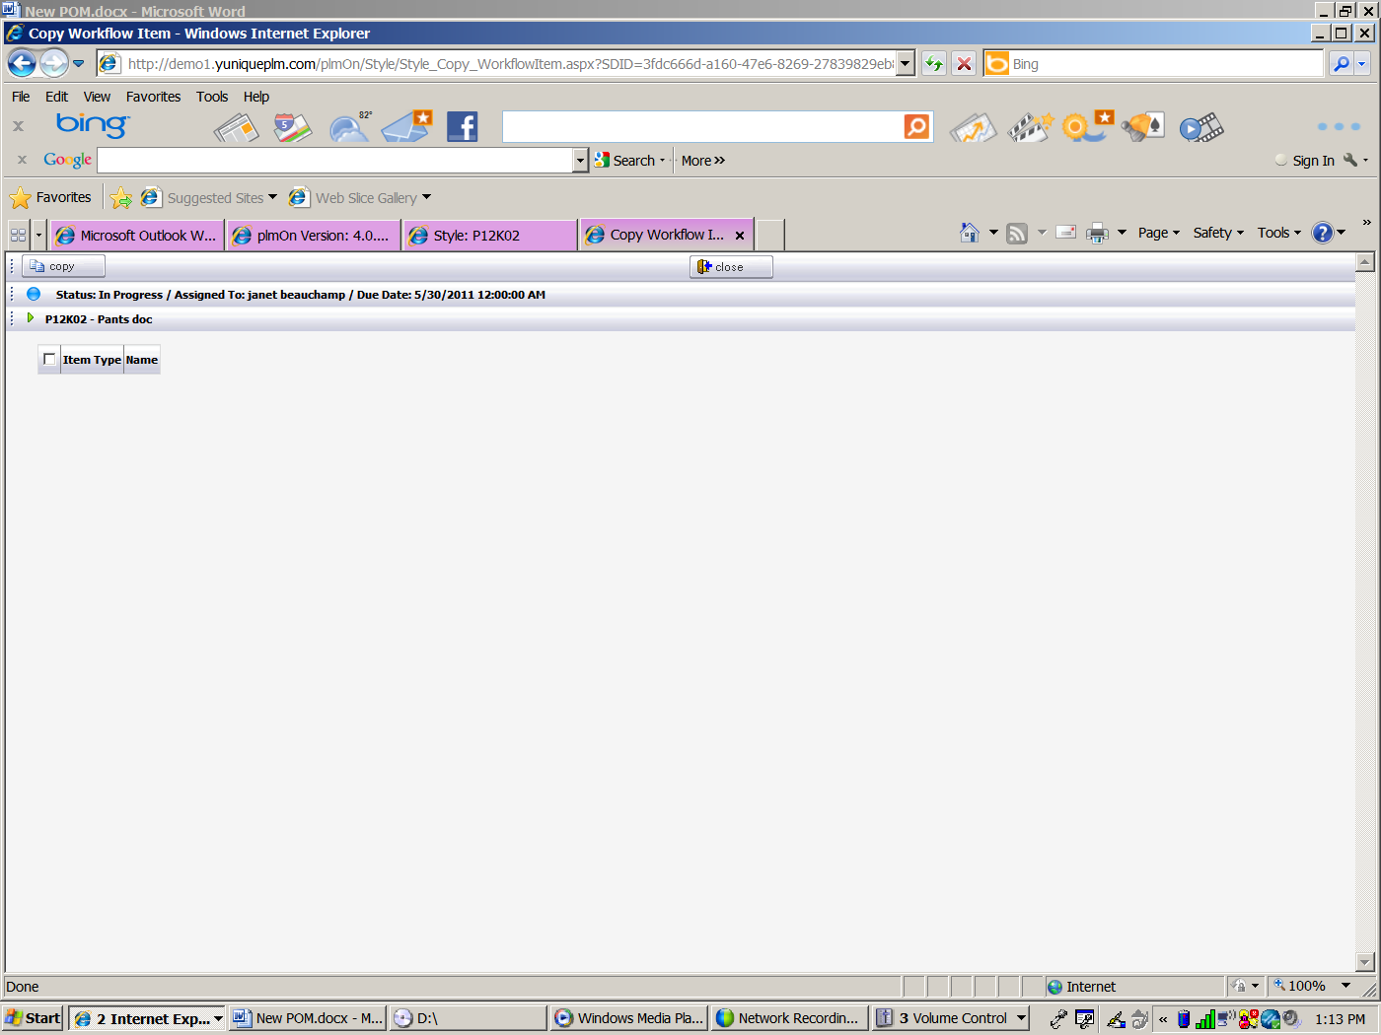

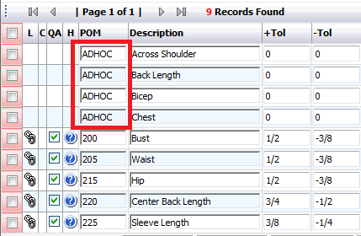

Design Detail

The design details page is where instructional details related to style will be listed. To list information, select the Design Details page and then click the **Edit** button across the top of the window.

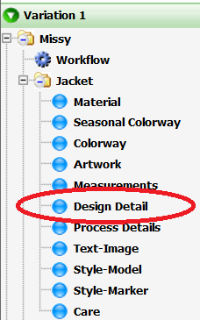 

The information can be stored as a template and housed in the Control Panel of the YuniquePLM application. Not all users will have the ability to generate design detail templates due to permissions. However the available templates can be added by clicking on the **Template** button in the center of the page.

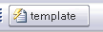

Once the list of available templates is presented click on the **Copy** button to the left of the template to be used for the style being developed.

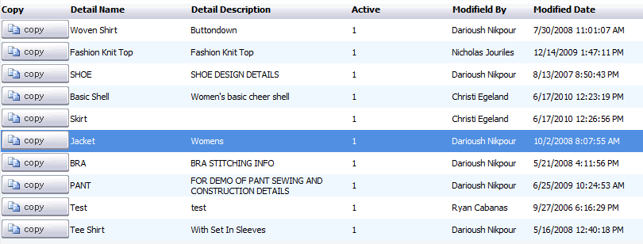

The page will then list all of the information that has been preselected on the template for that product type in the data grid area. Any information that is different for the specific product being developed can be edited by clicking into the appropriate field and retyping the information. If an action is listed that is not needed for the product, a check mark can be placed to the far left in the red column and then deleted from the page by clicking on the button across the top of the window labeled **Remove**.

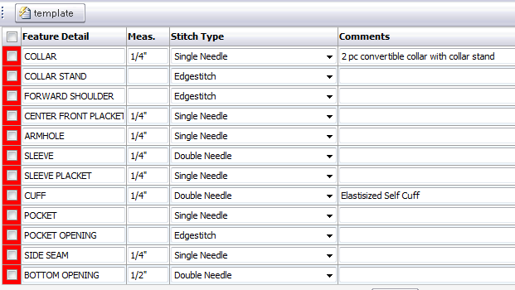

To list instructions specific to this product and not already listed on the template, select the number of rows required for the information and then click the **Add** button in the lower middle of the page.

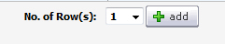

Images can be added to the page in order to visually enhance the instructions listed in the template. In order to add images that exists in the Image Folder click on the **Select Image** button across the top of the screen. To generate new images by accessing a proprietary CAD application made accessible via YuniquePLM, click on the **Create Image** button.



* Please refer to the Image Folder documentation for further explanation on working with images.

Images will be displayed on the lower portion of the page below the template information.

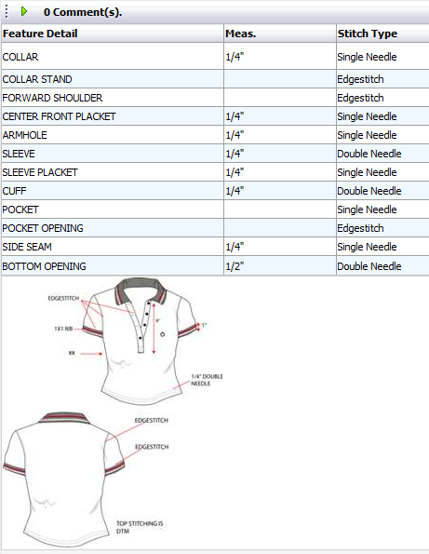

The design details page can be set to display images only. To do this, select No from the **Display Grid** drop down list across the top of the page.

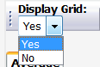

Process Details

YuniquePLM™ offers the ability to create and maintain construction, packaging and labeling standards and instructions. The system makes use of a library of standards that allow text descriptions and images. These records can be added to the style folder. This guide will show how to add the records that exist in the control panel library or to add unique or “ad hoc” records specific to an individual style.

In the navigation on the left, click on the Process Details bubble. The screen to the right will show the Process Details page.

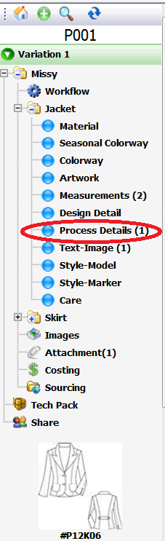

Click the **New** button to start adding records.

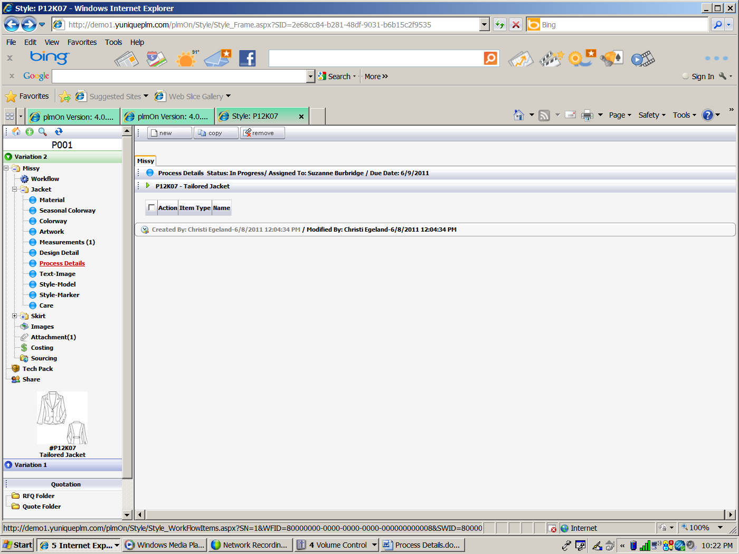

The process “wizard” will appear.

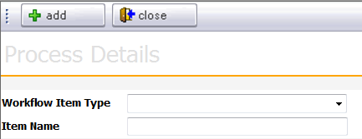

Select the workflow type from the drop down list and give the page a name in the Item Name dialog. Click **Add** and the Process Details page appears.

**Note**: The Item name allows for various instances of the Process Details page/bubble. For example, the process details page/bubble can be used, and therefore named as Labeling, Packaging, Construction Details, etc.

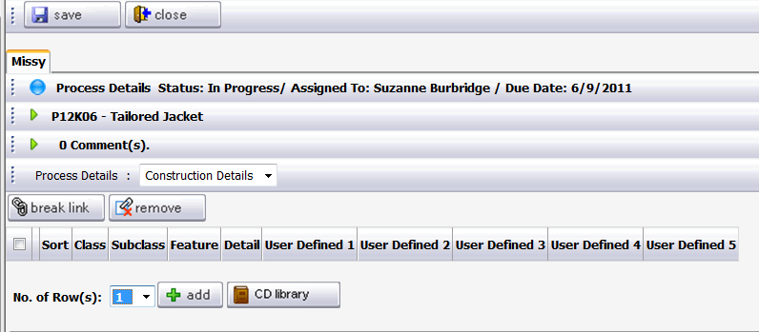

To begin adding records to the page from the control panel library, click **CD Library** button

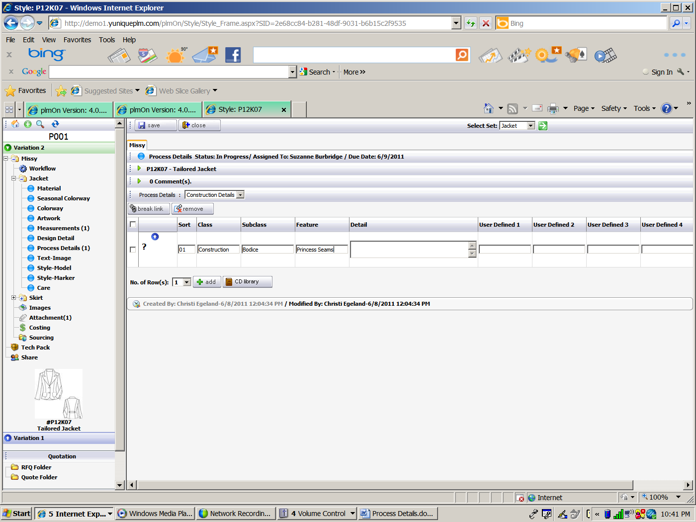

Click the drop down arrows in the **Class** and **Subclass** fields to filter the search criteria. Enter additional data to search for a specific record, and click the **Search** button. The results will appear and can then be added to the page by selecting them with a check mark on the far left.

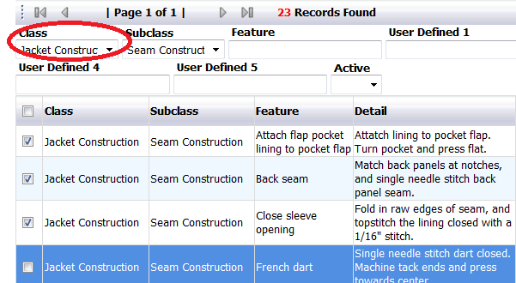

Click Link to add the records to the page.

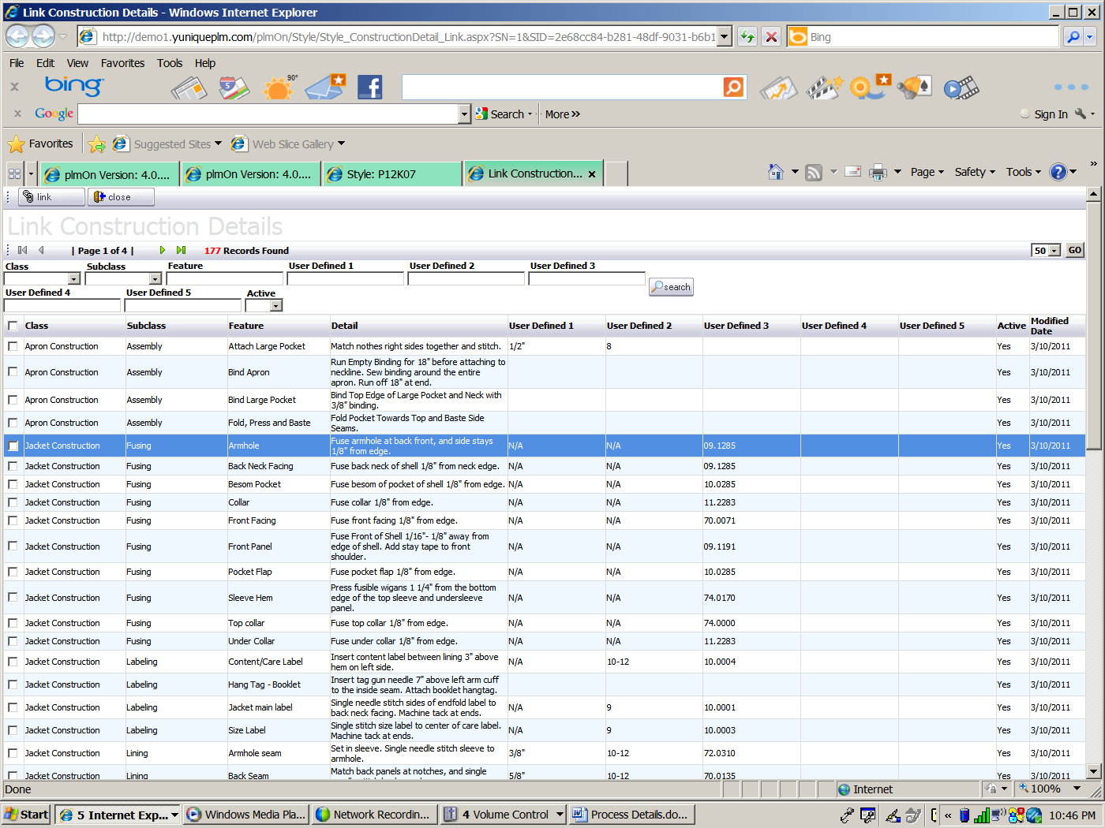

The selected records will appear in the page.

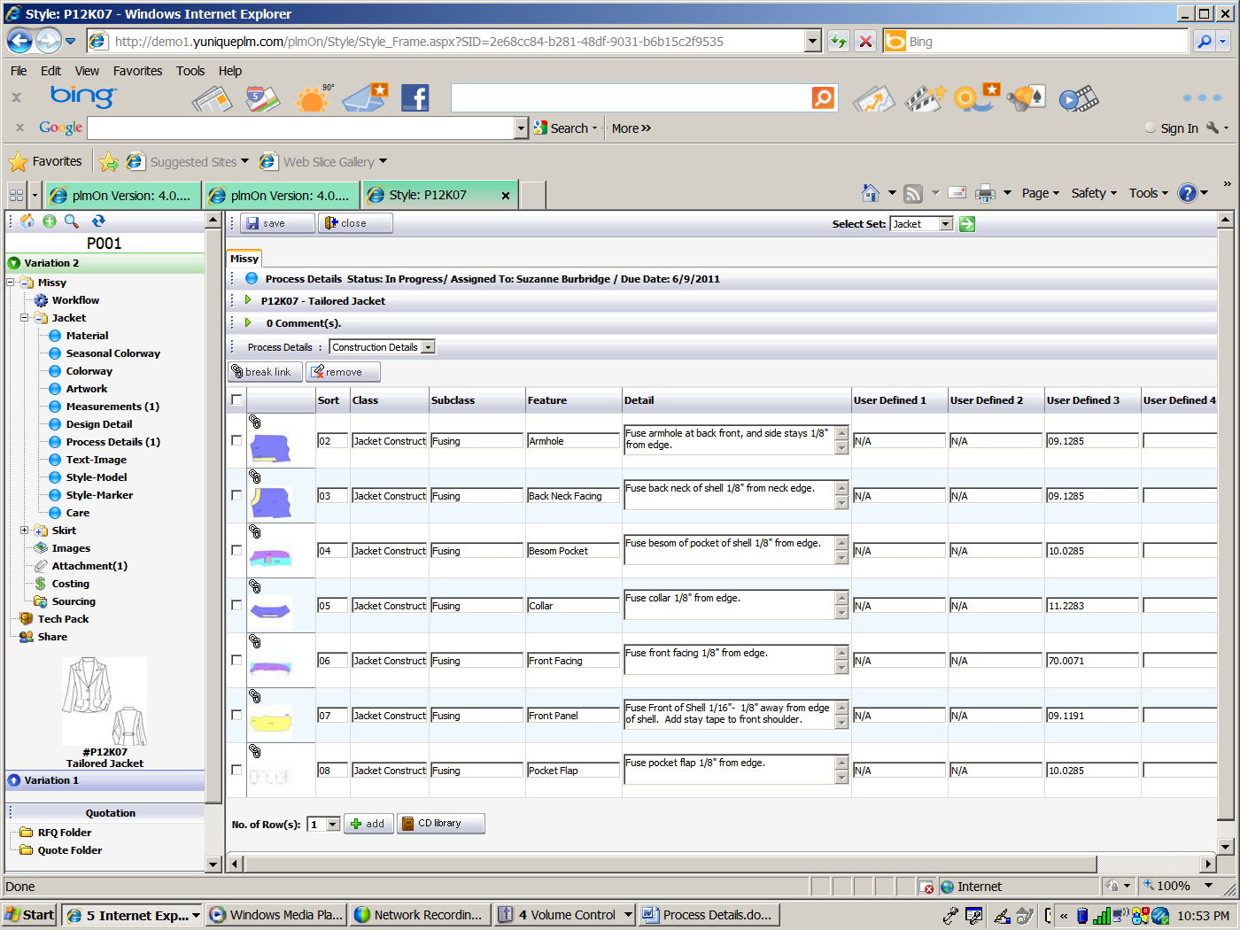

Click the **Save** button to store the records on the page, click **Close** to discard changes.



To change the record information at the page level from the library click a check mark in the record to be changed and click **Break Link**.



A message will appear to verify that the link should be broken. Clik **OK** to complete the process or **Cancel** to maintain the link. Once the record link has been broken, changes to that row can be made that will only effect the individual page/style being edited. The control panel record will remain as it was originally entered.

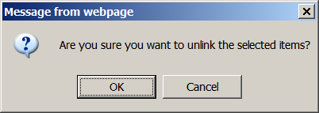

An indication appears in the image area that the link has been broken. 3 icons appear above the image allowing the record to be **Relinked**, the image to be **Deleted**, and/or a new imgate to be **Uploaded** as shown below.

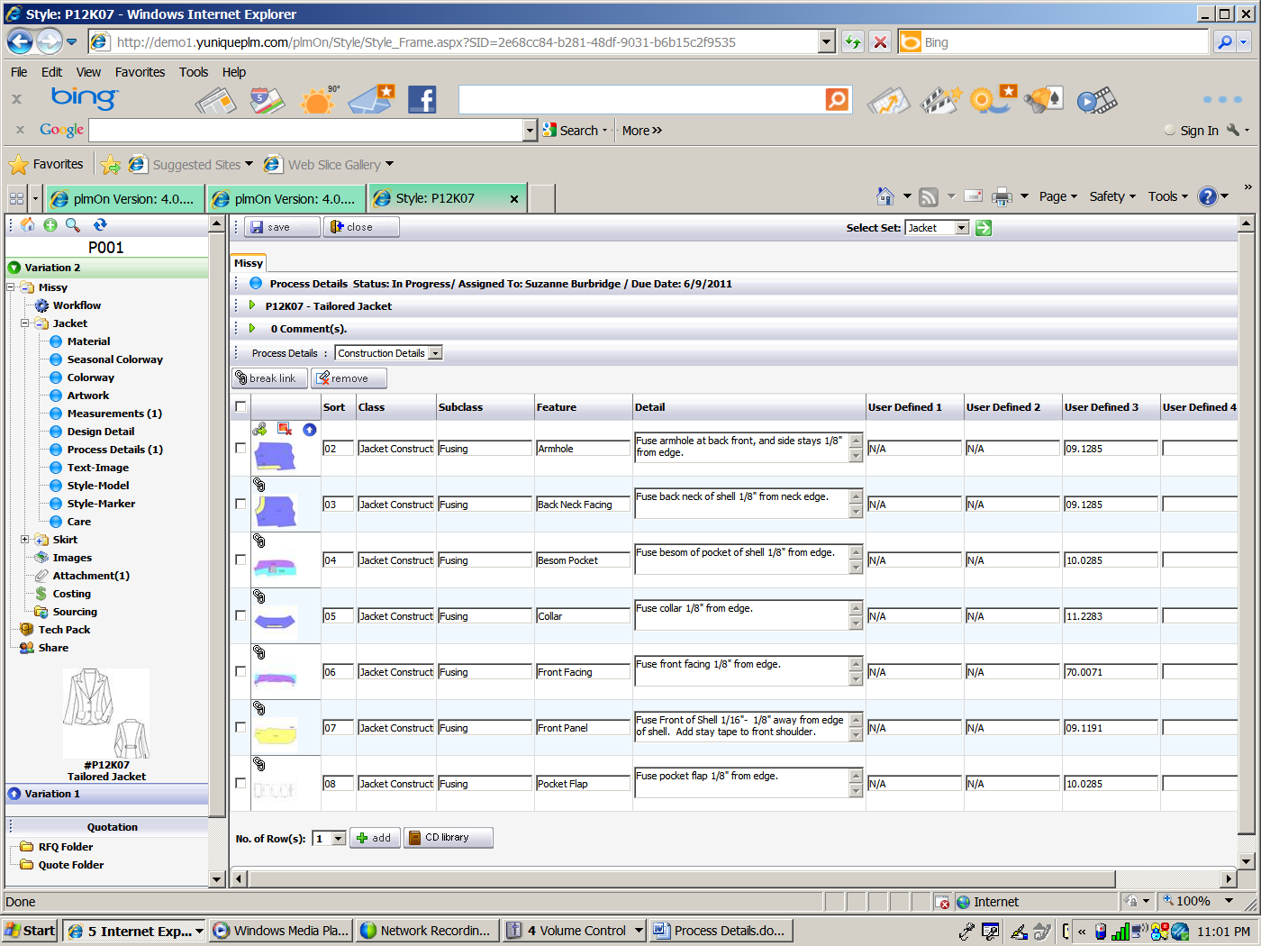

To remove records from the page, place a check mark to the far left for the record(s) to be removed. Click the **Remove** button.



A message will appear to verify that the record should be removed. Clik **OK** to delete the record or **Cancel** to maintain the record on the page.

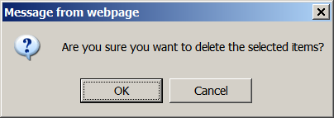

Click the **Save** button to store changes.

To add a record(s) to the page not in the Process Details control panel library, select the number of rows to be added and then click the **Add** button.

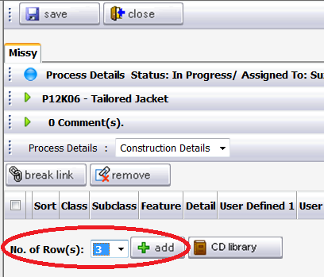

The row(s) will appear and information can be typed manually.

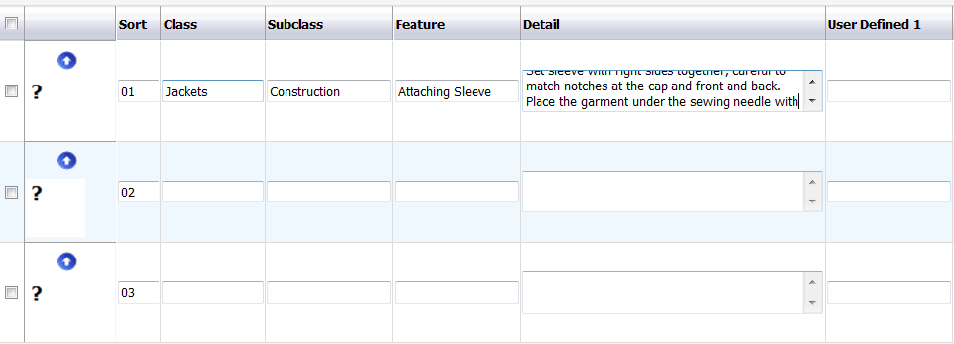

To add another instance, remove and instance, view a process details page, edit the page, copy the page, rename the page click on the Process Details bubble on the left navigation.

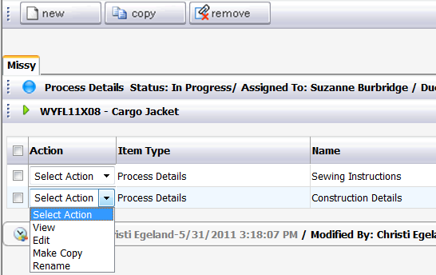

Click **New** to add an additional Process Details page. Another instance of the page will appear. Follow the beginning instructions for adding a new PD page.

When a PD page exists, the Actions available are **New, Edit, Make Copy, Rename** in the action drop down menu.

To edit the page, click on the **Edit** option in the drop down menu.

To make a copy of the PD page, click the **Make Copy** option in the drop down menu. Another instance of the page will appear.

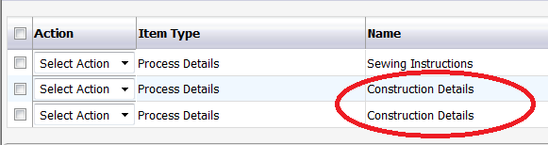

To rename a PD page, click **Rename** in the drop down of the action column. An Item Name dialog will appear. Type in the dialog box to change the default name then click **Save**.

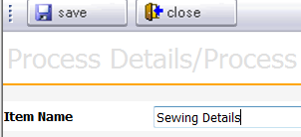

Text-Image

The Text-Image page in YuniquePLM is simple convenient page to place text data and image data. This page can be used to communicate art work, packaging designs, packaging placements, etc.

To use the Text-Image Page, click on the Text -Image bubble.

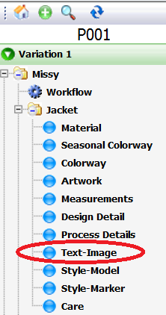

Select the Text form option from the drop down list on the right side of the explorer. Then give the page a more specific name in the Item name field below. Click the **Add** button in the upper right to add the page.

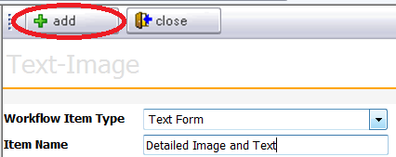

Once the page is added, the control buttons across the top of the screen are available to add one or more images. Click the **Create Image** button to upload a brand new image onto the page.



A second window or tab will open, allowing for an image search to be performed. Select the image type, and then choose **Upload** from the File Type dropdown menu. Once upload is selected the **Browse** button will be presented for searching. Additional information may be added to the other fields presented, so that the appropriate information will be stored with the image once the upload is complete.

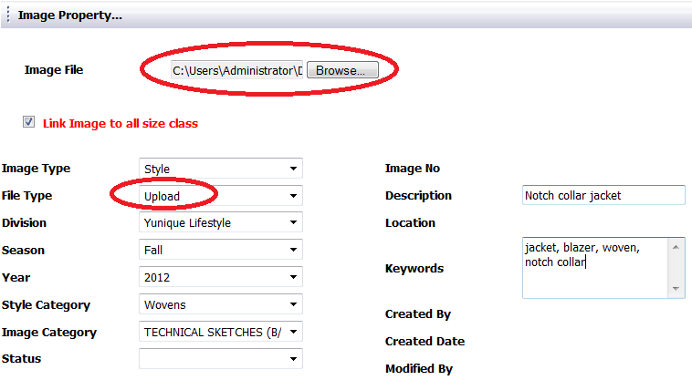

Once the file path has been populated in the Image File field, and any additional information has been populated in the other fields, click the **Create Image** button in the upper right corner.

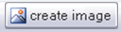

The image file will be presented for review and edit. Click the **Close** button to go directly to the image on the Text-Image form.

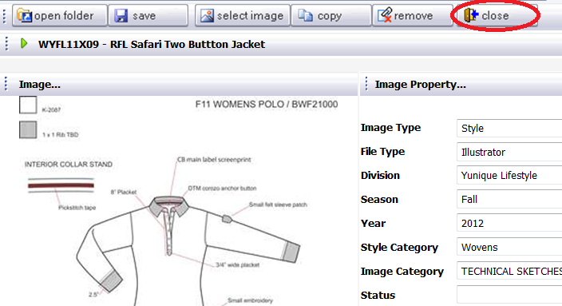

Once the image is uploaded onto the page, text information can be typed to the right of the image.

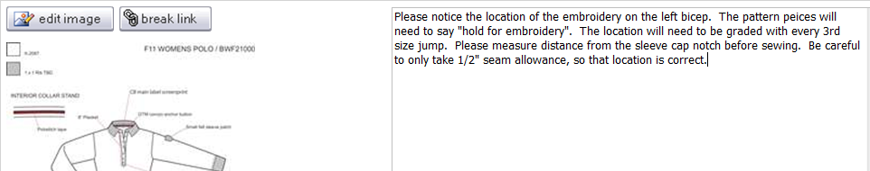

Images can also be selected from the Image Folder. To select existing images, click on the **Select Image** button across the top of the page. Place a check mark in the **Select Image** box above any image(s) to be added to the page.

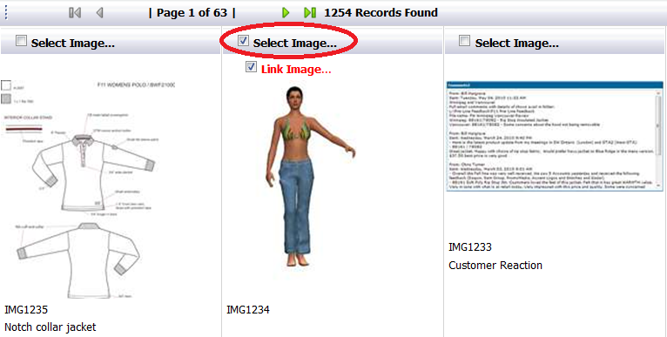

Once the image(s) have been selected click the **Save** button in the upper left, and then click the **Close** button.

If there are multiple images on a page, the images can be sorted by clicking on the **Sort** button.

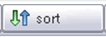

Number the images according to the order that they should be sorted and then click the **Save** button in the upper left. The images will then appear in the specified order on the page.

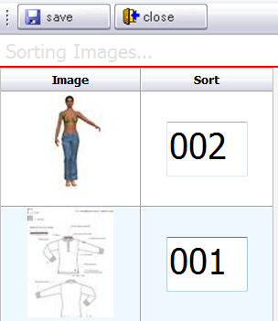

To edit an image, click the edit image button in the image area.



A window or tab will appear. The image or image property (image text information on right of image) can be edited. To edit the actual image, click on the open folder button in the upper left corner.

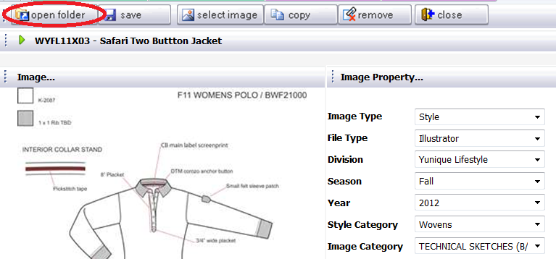

A window will open displaying the image file to be edited. Double click the image file name.

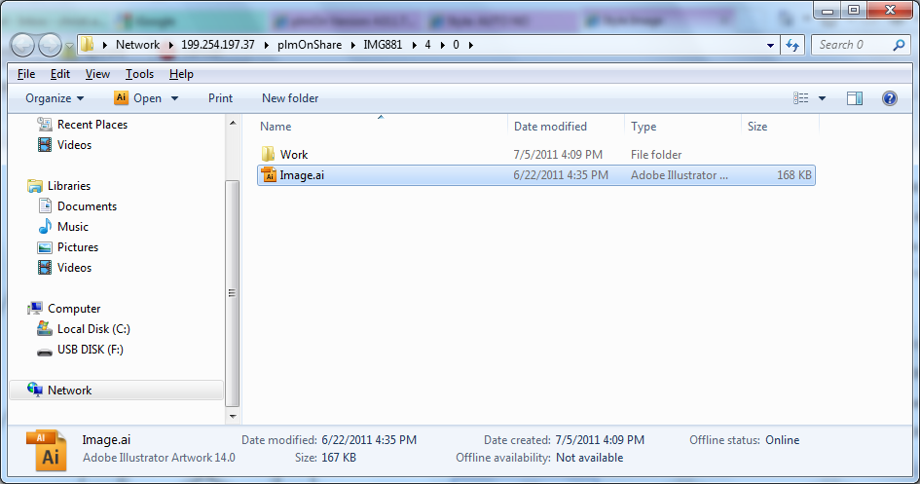

The application originally used to create the image will be launched. In this example Adobe Illustrator has been used. Make any necessary image changes, and then save the image file in the application. Close the application.

Once the image changes are completed click on the Upload button across the top of the screen.

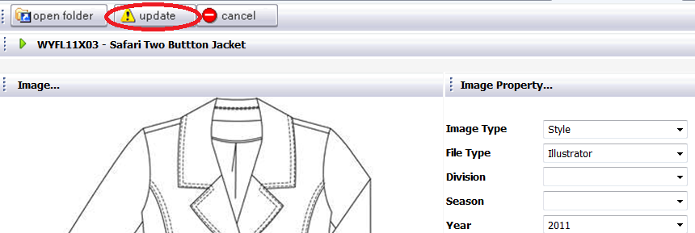

After uploading the changes, click on the Save button and Close button across the top of the screen.



To remove an image, click the remove button.

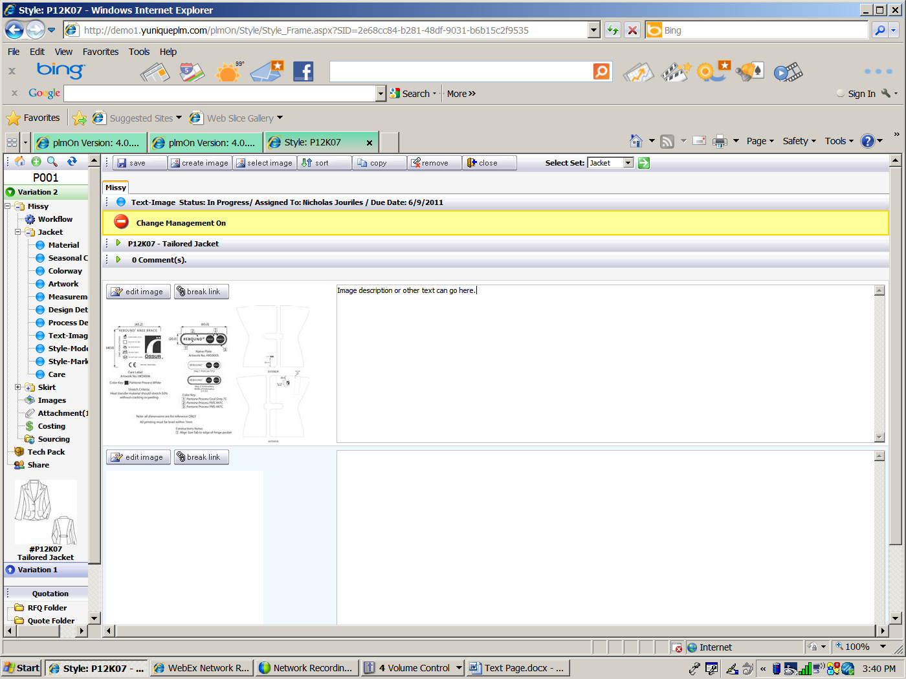

A window or tab opens that allows an image to be selected for removal. Select an image for removal but putting a check mark in the far left box. Click the remove button again.

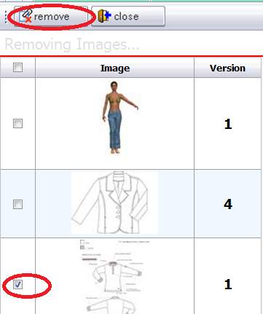

A message appears to ask if you are sure. Click Ok to continue to remove the image/s or click cancel to cancel the image removal transaction.

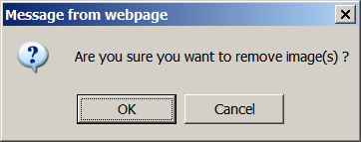

**NOTE:** The method managing images is the same throughout the YuniquePLM software. For more in dept image information please refer to the Image Folder documentation.

Style - Model

The Style Model page bubble is where pattern information can be imported into YuniquePLM from the Gerber AccuMark system. To import a pattern, click on the Style – Model node on the left side of the style folder.

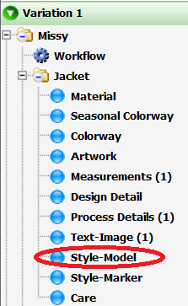

To add a new model, click **New**.

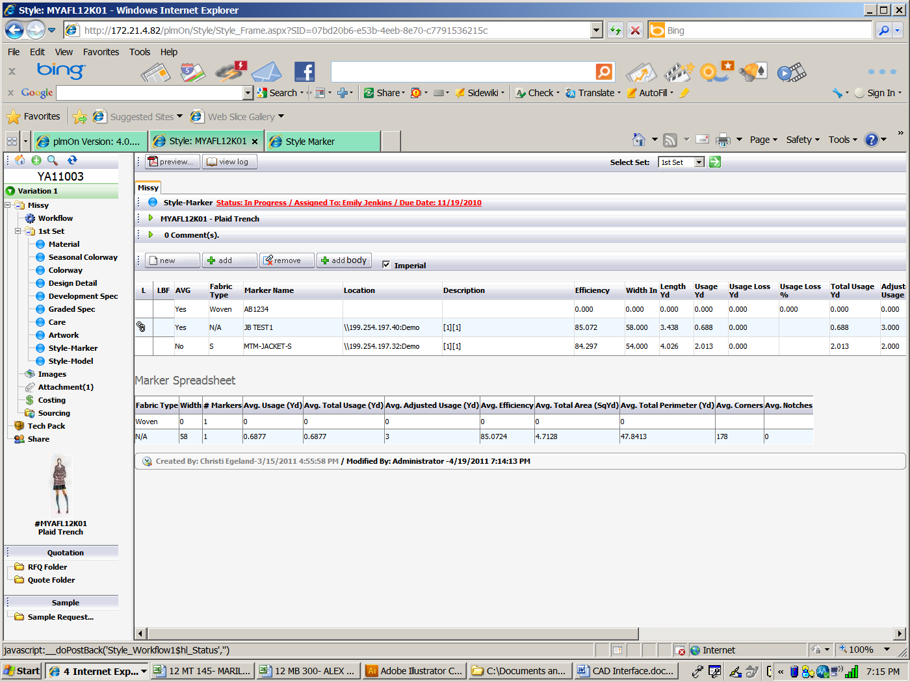

Enter appropriate data. This is not a model from the AccuMark system. It is information that might be used as a “cutter’s must” or a guide for a patternmaker/technical designer.

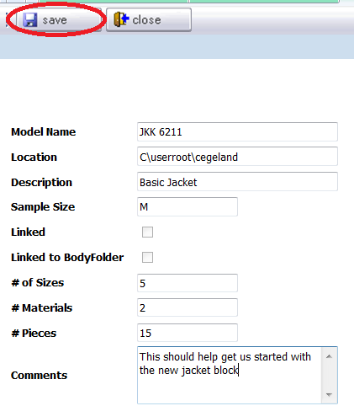

Once the information has been entered click **Save**.

To add a model from the AccuMark database, click **Add**.



Use the dropdown in the filter area to navigate through the storage area hierarchy. This is where the desired model from AccuMark is saved. Select the appropriate model and click **Save**.

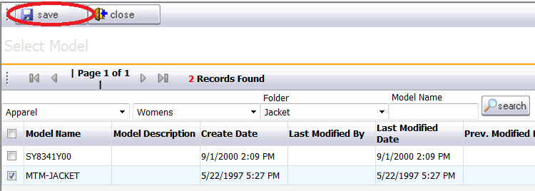

To add a style body, click **Add Body**.



The existing Body Folders are listed.

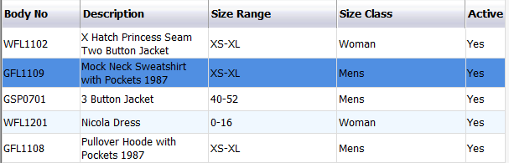

Select the desired Body Folder that contains the template model(s) for the style page.

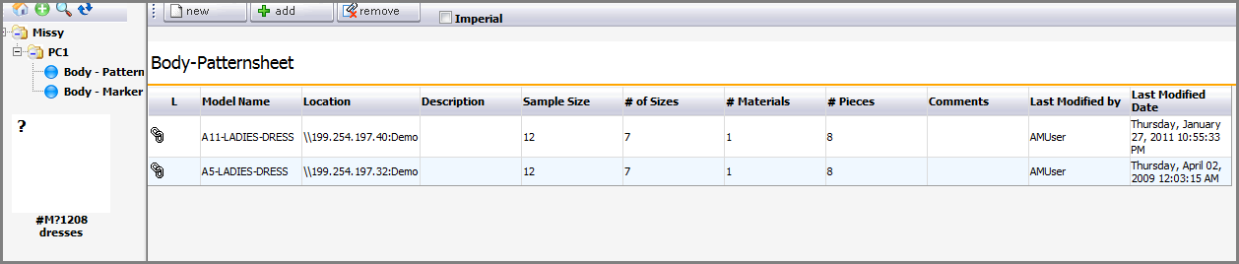

Select the model(s) to be linked on the style model page. Click **Save**.

To remove models from the style model page: Click on the **Remove** button.



Select the model(s) to remove.

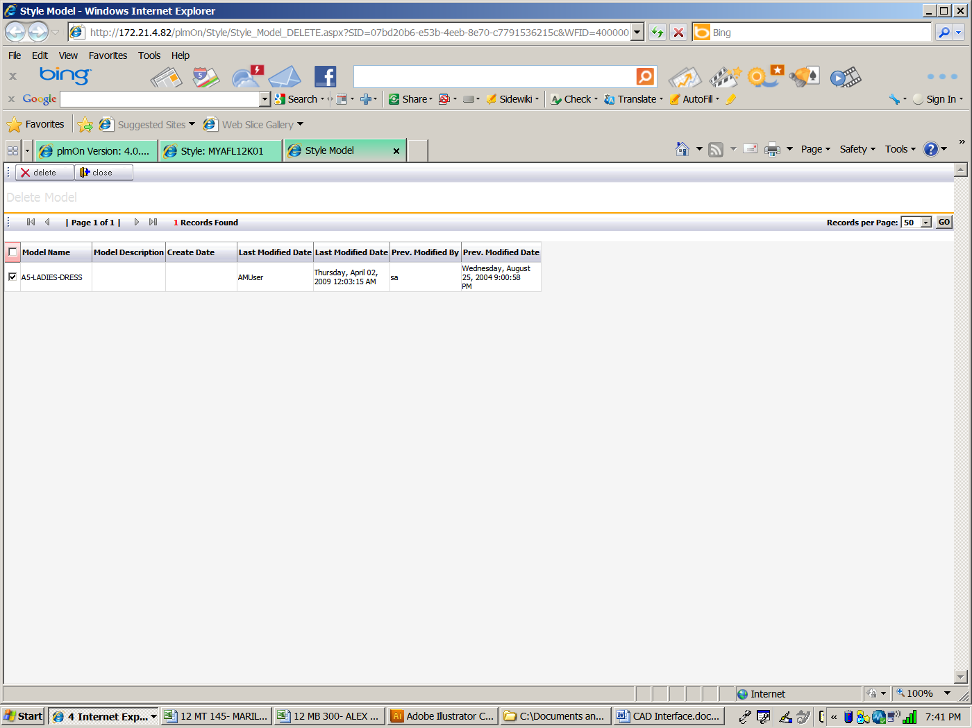

Then click **Delete**.

**NOTE**: To view dimensions in metric – uncheck the ‘Imperial’ box.

To view and edit the pieces: Click on the model row.

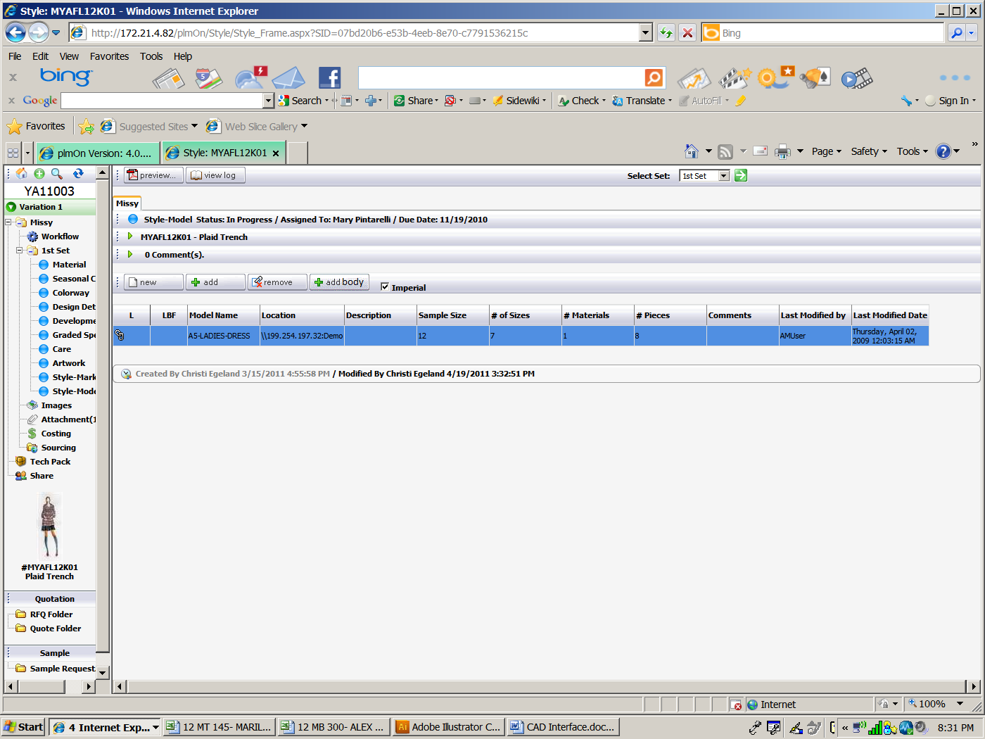

A list of pieces will be displayed on the **List** tab**.**

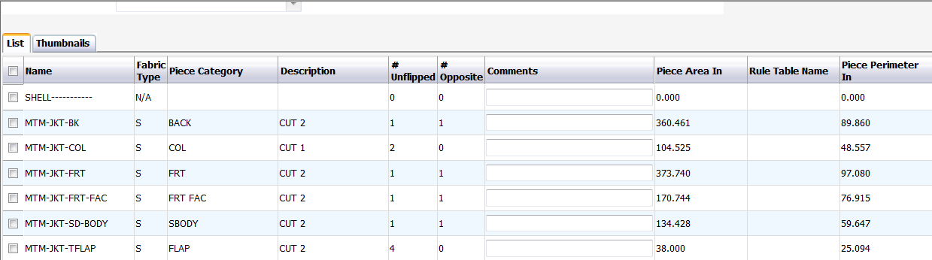

A representative image of each piece will be displayed on the **Thumbnails** tab.

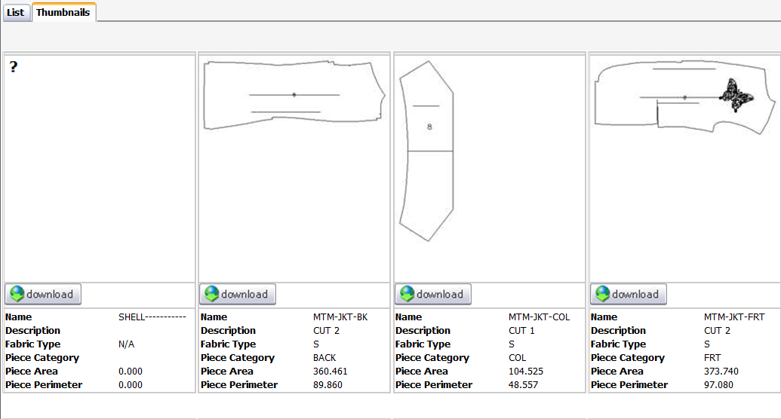

The pieces are listed and viewed in the order that they are listed in the AccuMark model editor.

If the Linked checkbox is unchecked – most of the fields will be editable, but they will no longer be updated from the database. As long as the **Linked** box remains checked, then whenever the page/bubble is selected the data will be refreshed to display any changes made in AccuMark.

Click the **Preview** button to generate reports of the data on the style model page.



Select the desired report(s) from the list and then click the **Preview** button in the upper left corner.

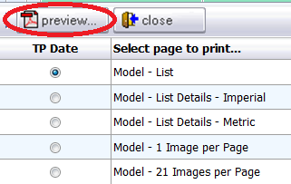

All the models listed on the page will be included in each of the above reports.

Style – Marker

The Style Marker page bubble is where marker information can be imported into YuniquePLM from the Gerber AccuMark system. To import a marker, click on the Style – Marker node on the left side of the style folder.

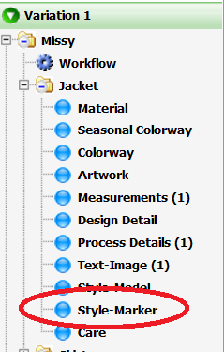

To create a New Style Marker, click the ‘New’ button.

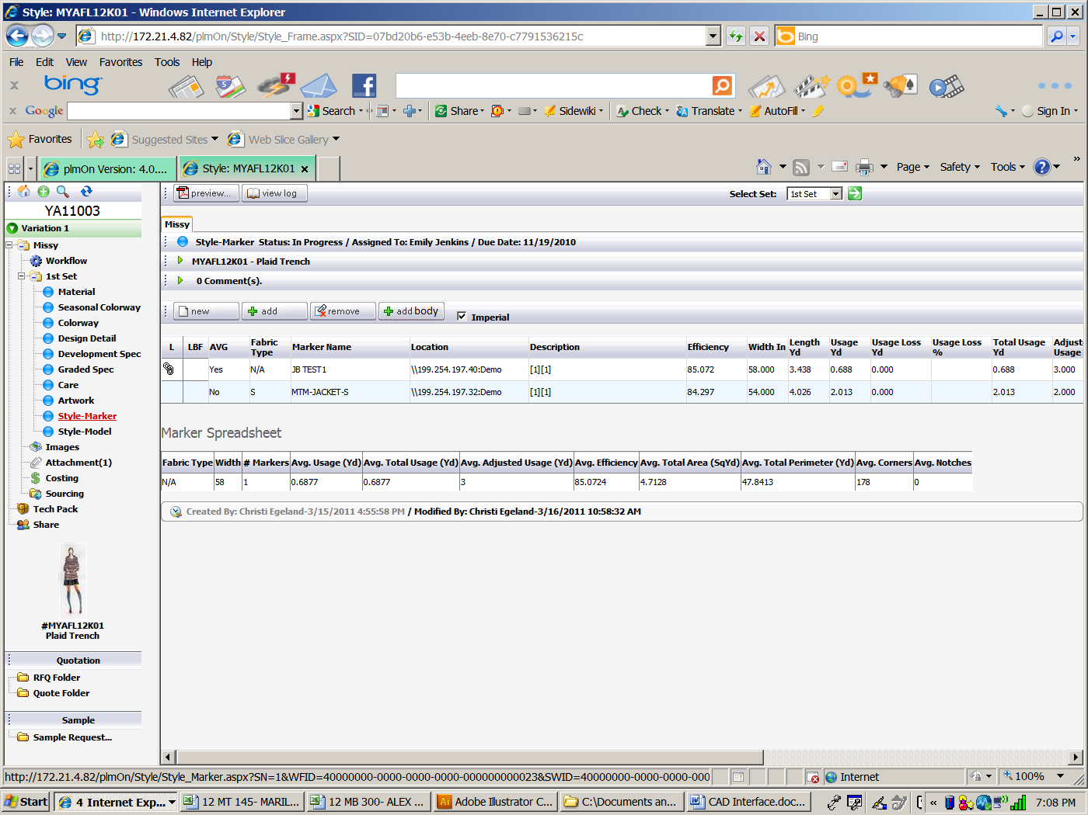

This blank screen can be filled in with preliminary data or data entered manually to use as a guide for a marker maker.

Enter data in the screen shown then click Save.

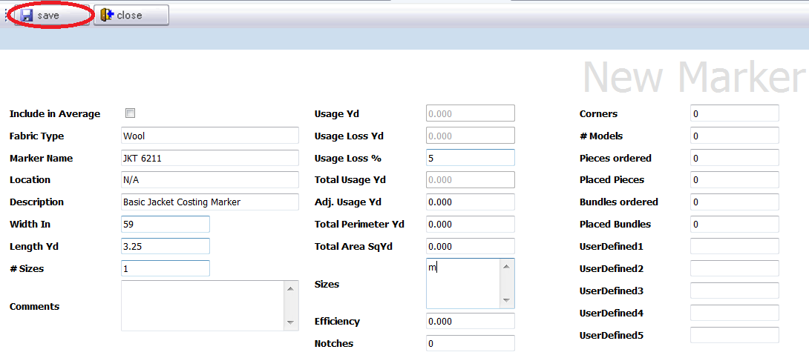

To add a marker from the AccuMark data saved into the SQL Relational database, click the **Add** button.



Select the filter dropdowns for the AccuMark storage area path to find and select the desired markers. Place a check mark to the left of the AccuMark marker(s) and click **Save**.

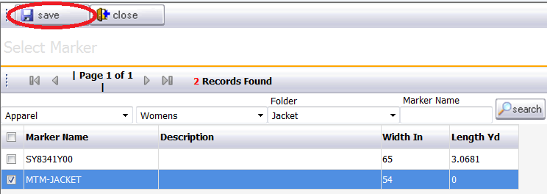

.

Each entry will have the linked symbol and will update whenever the page is refreshed or reopened. If unlinked, then all the fields can be edited.

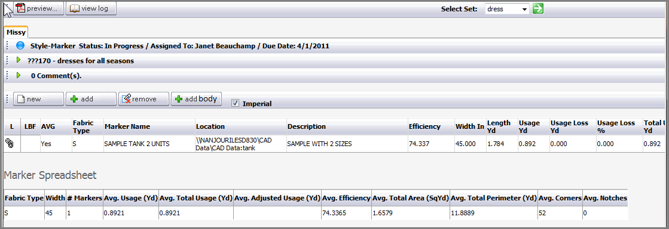

To add a Style Body, click Add Body.



The existing body folders are listed. Select the body folder that contains the silhouette or markers to be linked to this style marker page.

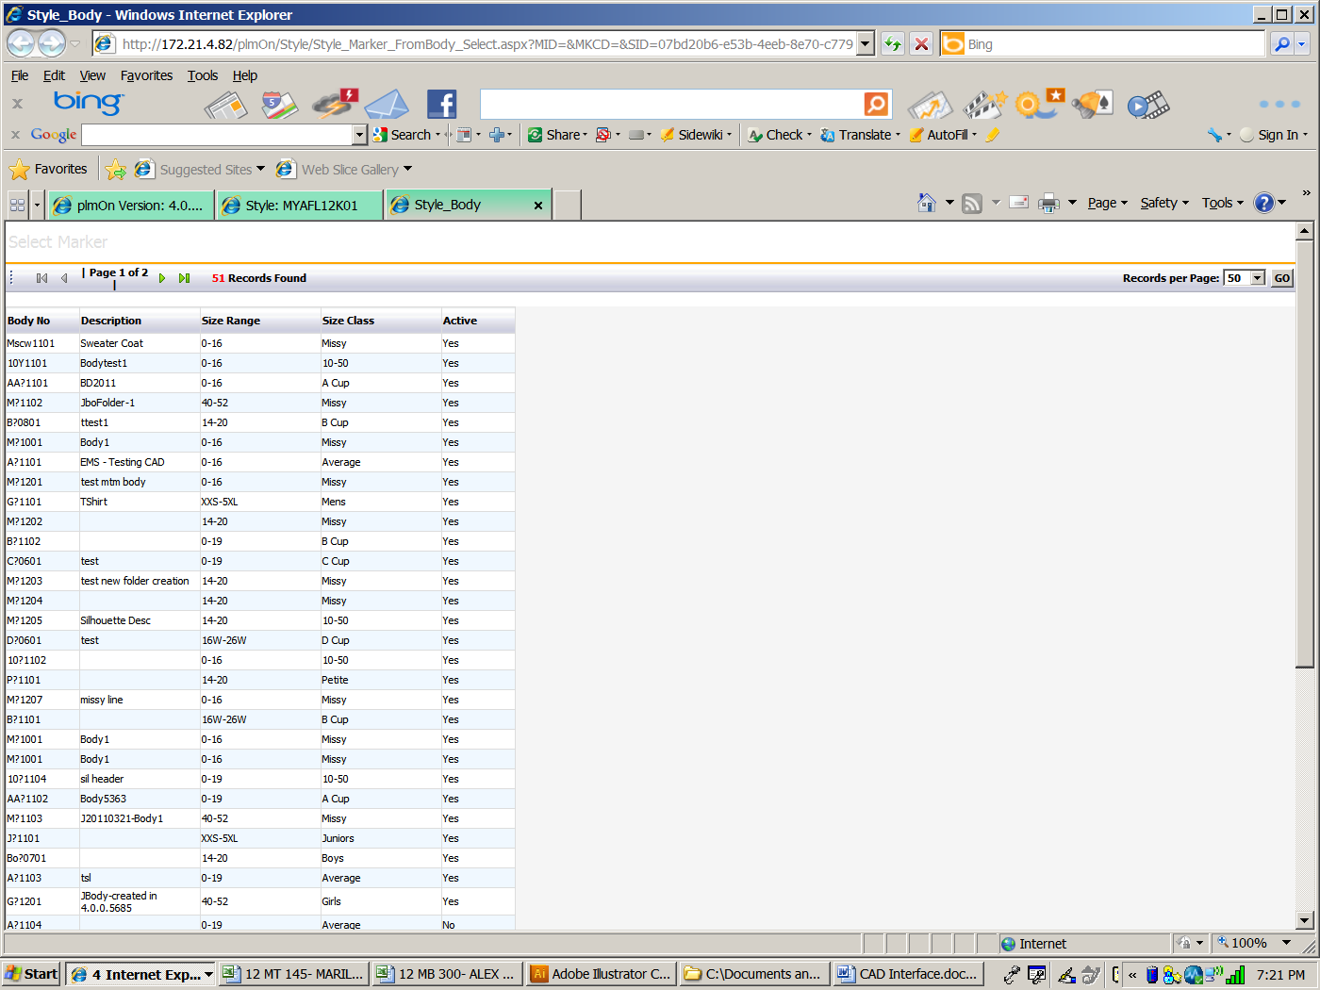

Select the desired Body - Marker that contains the markers(s) for this style marker page.



Select the marker(s) to be linked to the style marker page. Then click on the **Save** button.

To Remove click on the **Remove** button.



Select the Marker(s) to be removed.

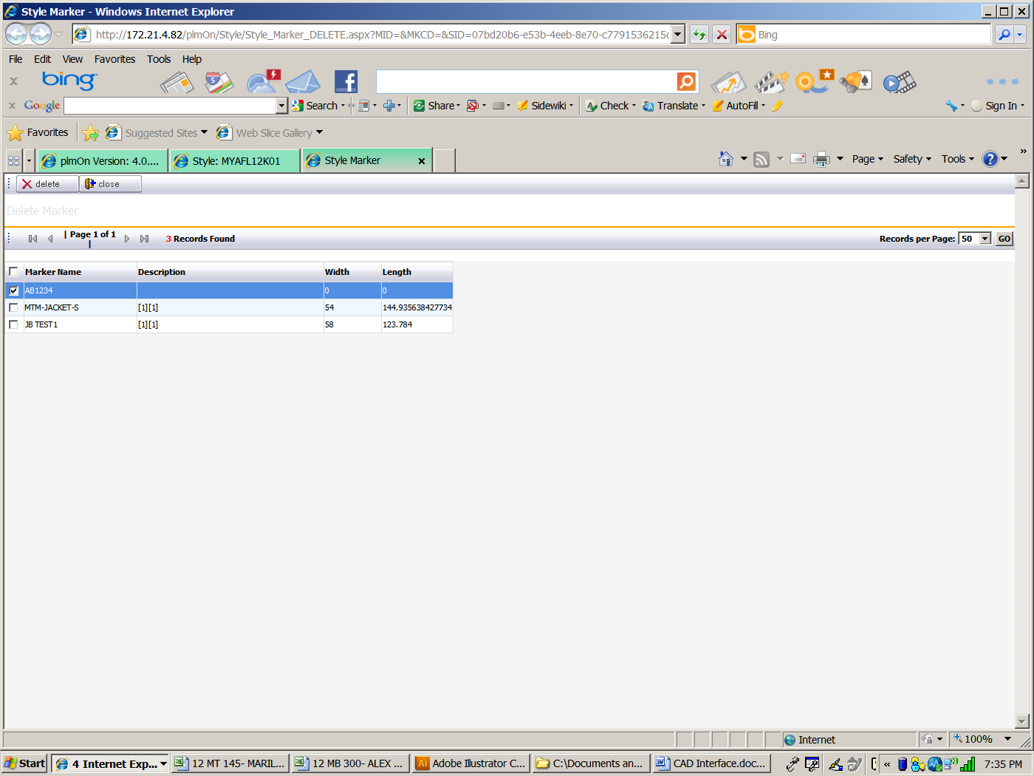

Then click **Delete**.



To view the marker images or details on the page, click on the marker row on the page.

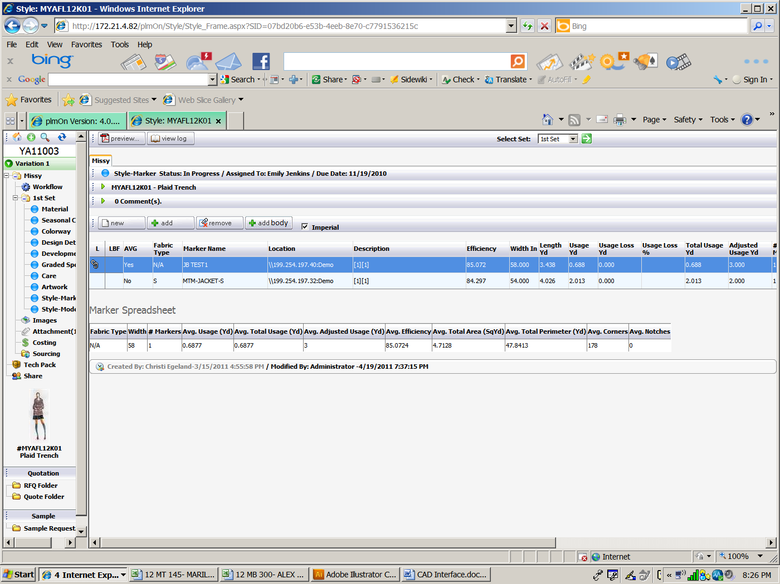

* Selection shown highlighted above with bright blue line.
* Marker Spreadsheet is an averaging section matching Fabric Type and Width as criteria.

**NOTE:** To view dimensions in metric – uncheck the ‘Imperial’ box.

This will open the detail page with more specific information from the AccuMark system.

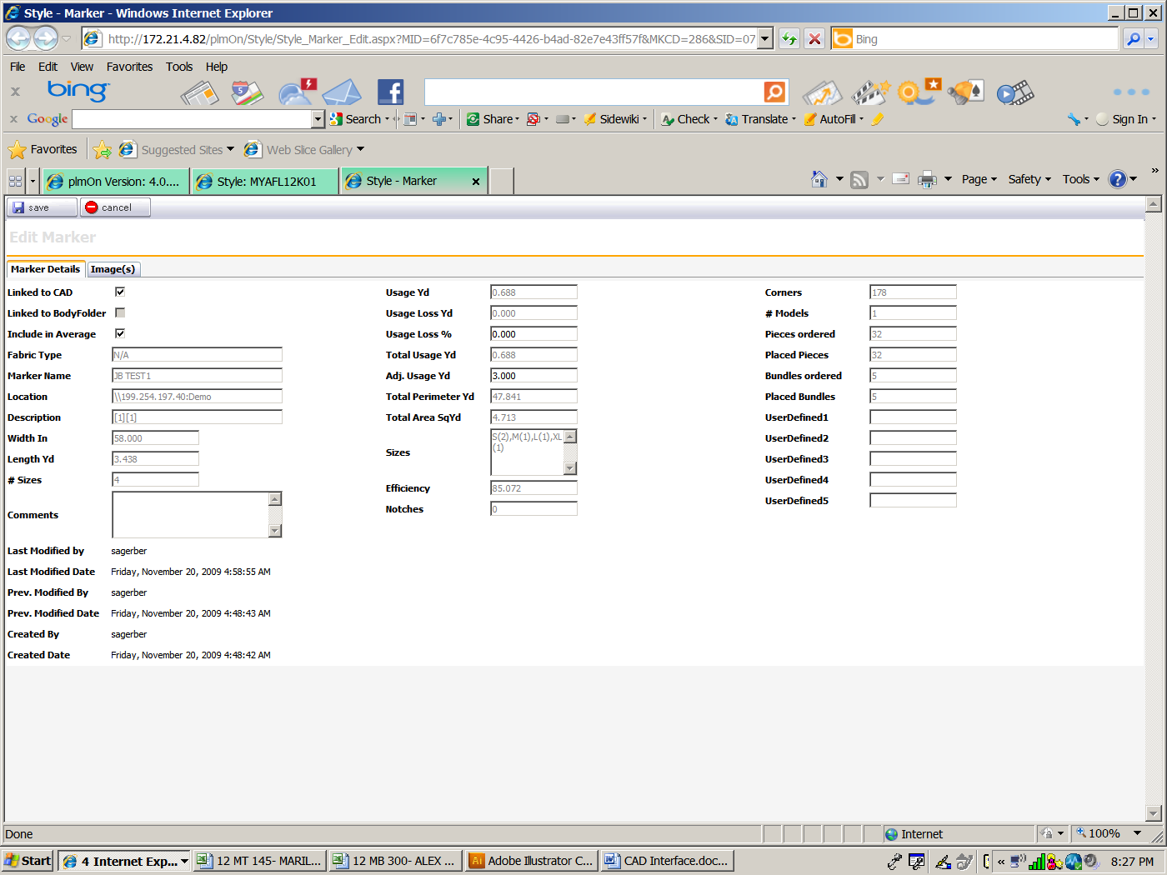

* **Include in Average** will calculate an average of the markers with the same fabric type. If this is not checked, the marker will not be included in the bottom averaging portion on the marker screen.
* To utilize the **Usage** fields the **Length** and the **Placed Bundles** fields must have a value greater than 0.
* In the **Usage Loss %** field enter a multiplier like ‘1.02’ to calculate 2% of the Usage value.
* The **Usage Loss Yd/M** will calculate when the page is saved.
* The **Adjusted Usage Yd/M** value is an optional field where Yards/Meter values are expected but are not actually calculated from other fields.
* **Comments** are saved on the page only and will display in the Preview printouts.
* If there is not a check mark in the the **Linked to CAD** field then all other fields on the page will be editable and will not match the data saved by the AccuMark system. However, this can be rechecked and refreshed with the data from the AccuMark system as well.

To see the marker representation, click the **Image(s)** tab. The image can be downloaded to your system by selecting the **Download** button under the image.

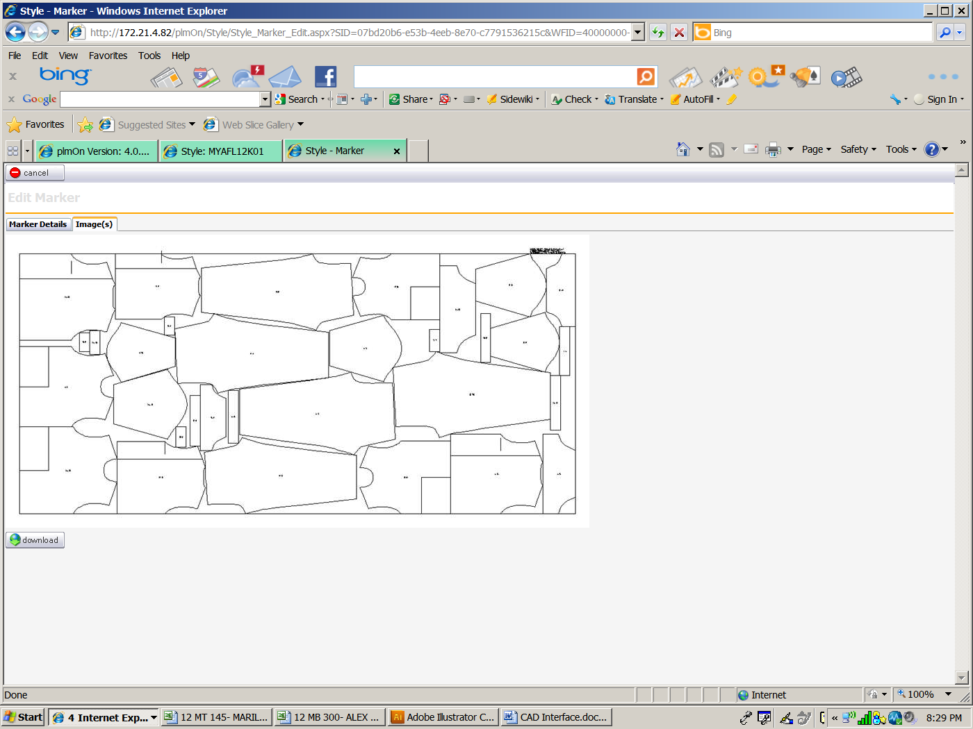

Click the Preview button to generate reports of the data on the Style Marker page.

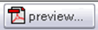

Choose the report to print from the list of available options and then click the Preview button in the upper left corner.

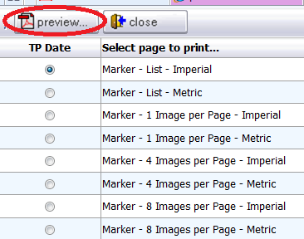

All markers listed on the page will be included in all the reports.

Care

The care page is where the recommended laundering instructions for a finished product are listed.

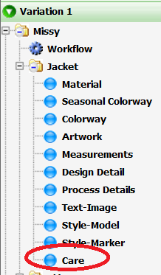

The page is preset with fields for each area of care that would need to be designated for the product.

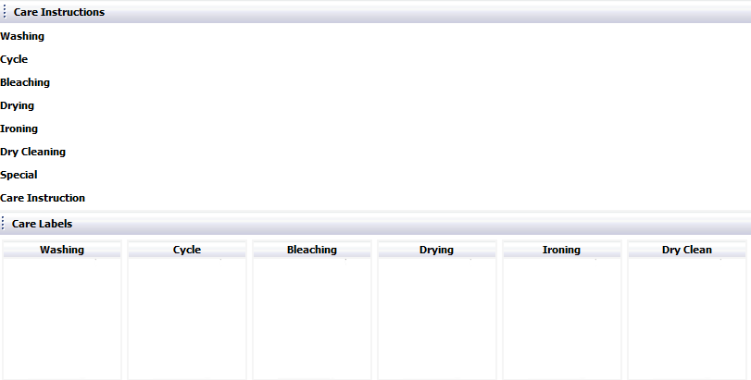

Click the **Edit** button across the top of the window to populate the care information.



Once in edit mode, care instructions can be selected from a drop down menu listed for each of the categories. If all care instructions follow a specified preset format, click on the **Template** button to choose the appropriate template from the control panel.

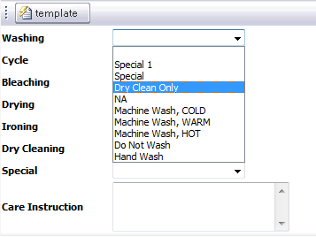

As each care category field is populated, an image will automatically fill the appropriate fields across the bottom of the screen. If a particular care label is not applicable to the product type being developed, select N/A from the list or leave the field blank.

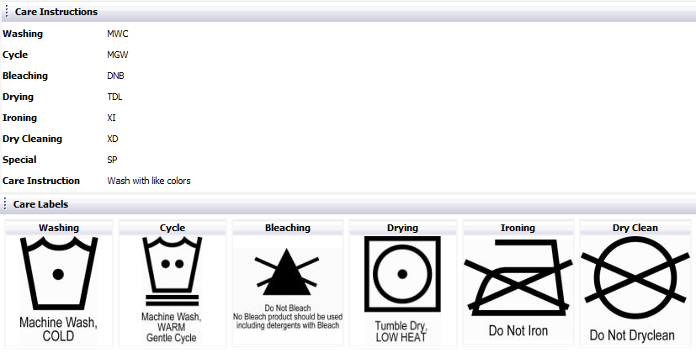

When a style folder is being developed with multiple items, very often the care instructions will be the same. A style set drop down has been provided across the top of the window for quick comparison of care instructions for all items within a style set.

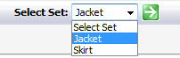

Care instructions can also be copied from a different style folder by clicking on the **Copy** button across the top and then selecting the appropriate style from which to copy.



Once all care instructions have been entered, click **Save** across the top of the page to store the information.



**Images**

The Images node of a style folder is a quick reference display of all of the images within the folder.

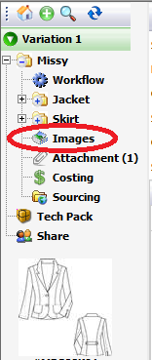

As images are added to various pages within the style folder representative images will simultaneously populate the Images area on the left of the style folder.

The images will be listed under the page header name to which they were added originally.

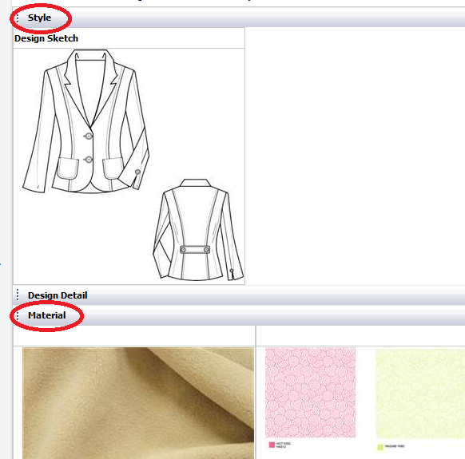

The images can be burned to a CD for use outside of the YuniquePLM™ application. To do this, click on the **Burn Files** button across the top of the window.



To run a report of all of the images within a style folder, click on the **Preview** button across the top of the window.

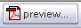

**Attachment**

When information regarding a style occurs outside of the YuniquePLM™ application, it can be easily associated to the style folder by being added as an attachment. This could be information that is prepared as a word document, excel file, or PDF to name a few. To add an attachment to a style folder click on the **Attachments** node on the left side of the style folder.

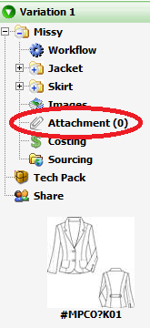

On the right click on the **New** button across the top of the window.

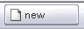

Next click on the Browse button to the right of the **File Upload** field and find the network location of the desired file.

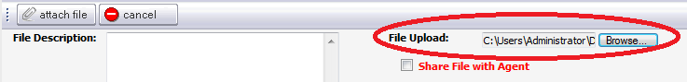

If Agents or Vendors collaborating on the style folder will also be allowed to see the attachment, place a check mark in the field labeled **Share File with Agent**.

If this field is blank the attachment will not be visible to those individuals. To clarify what the attached document represents type in a **File Description** in the field provided. Once all known information is entered, click on the Attach file button across the top of the window and the file will be added to the style folder. The **Cancel** button across the top will stop the process without attaching a file.

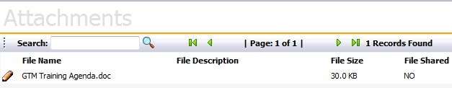

The attachment(s) will be listed in the order that they were added to the style. If several attachments have been added to a style the **Search** field is available to filter the list quickly.

**Costing**

The costing node is the area in which data can be established for the purposes of costing scenario mock-ups and/or prepared to be shared with agents and vendors so that quotes agreements can be negotiated. To prepare costing information, click on the Costing node on the left side of the explorer window.

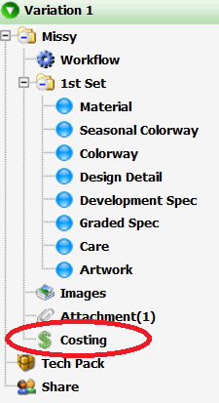

The right hand side of the costing window will have a message stating “Costing Not Found” since the method of costing has not been established.

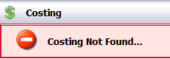

To being entering the costing information click on the **Edit** button in the upper right of the window.

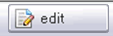

Click on the **Add** button across the top of the screen to establish the costing method for the style.

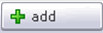

Place a check mark to the left of the costing method(s) to be used and click add across the top of the screen. Click the **Close** button to return to the costing screen.

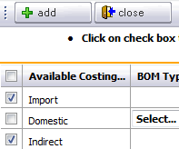

If Domestic costing is being selected a drop down list will be available to specify the BOM type and BOL type to be used for calculations.

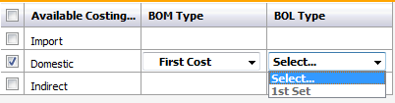

The BOM Type is referring back to the Dimensional BOM page and the BOL type is referencing the BOL (Bill of Labor) page and the factory selected in the RFQ.

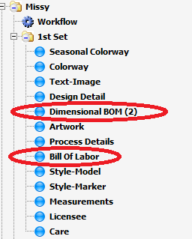

Once the costing method has been saved a **Costing Property** column will be presented. To the right will be a column for each of the costing methods selected. Data can be entered in the Costing Property area that will calculate in each costing column along with some other costing data such as duty percent, quote, etc. Once the costing method is established and all known costing information is added the quote process can begin.

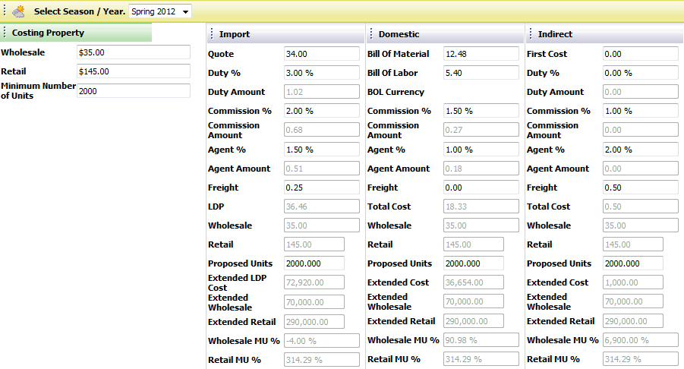

The fields available in the costing columns are as follows:

Quote = Free entry field

Bill of Material = Complete BOM cost pulled directly from the selected BOM page

Bill of Labor = Complete BOL cost pulled directly from the BOL page

BOL Currency = Indicates the currency used for calculations on the BOL page

First Cost = Free entry field

Duty % = Free entry field

Duty amount = Duty % multiplied by Quote

Commission % = Free entry field

Commission amount = Commission% multiplied by Quote

Agent % = Free entry field

Agent amount = Agent % multiplied by Quote

Freight = Free entry field

LDP (Landed Duty Paid) = Quote + Duty Amount + Commission Amount + Agent Amount + Freight

Wholesale = Data is filled in from the corresponding field on the left

Retail = Data is filled in from the corresponding field on the left

Wholesale MU % (Mark-up) = Wholesale divided by LDP

Retail MU % (Mark-up) = Retail divided by LDP

Proposed Units = Free entry field

Extended LDP Cost (Landed Duty Paid) = LDP multiplied by Proposed Units

Extended Wholesale = Wholesale multiplied by Proposed Units

Extended Retail = Retail multiplied by Proposed Units

The costing information can be deleted from a style by clicking on the **Delete** button across the top of the costing window.

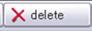

Place a check mark to the left of the costing method to be removed and click the **Delete** button in the upper left. Click the Close button to return to the costing page.

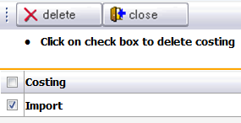

Costing information can be copied from an existing style by clicking on the **Copy From** button across the top of the screen.



Select the style folder from which the costing information will be copied from by double clicking on the desired style name presented in the list.

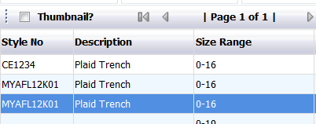

Place a check mark to the left of the costing type and click on the **Save** button across the top of the screen. Click **Close** to return to the main costing page.

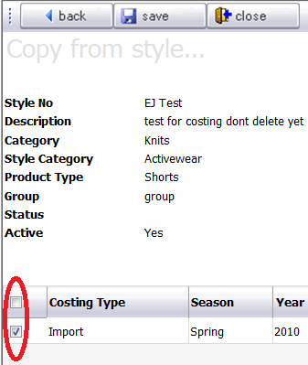

**Tech Pack**

The tech pack node is where preset page groupings from within a style folder can be generated as PDFs and either printed and/or shared with vendors, or emailed, etc. To generate a Tech Pack, click on corresponding node on the left side of the style folder window.

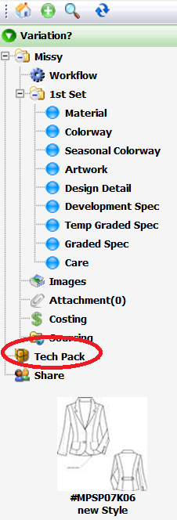

Any existing tech packs will be listed to the right of the explorer window. Highlight the row and double click to access information within the selected tech pack.

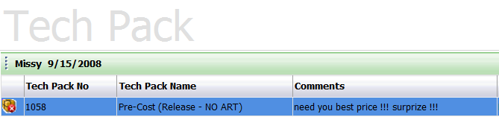

The tech pack number and name as well as the date time and user that originally generated the tech pack is listed in the center of the window.

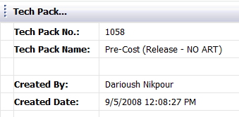

The Comments area will display any on going dialog related to the tech pack.

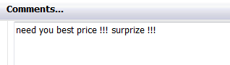

The agents or vendors with whom the tech pack has been shared will be listed under agent.

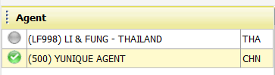

To share the tech pack with additional agents/venders click on the **Add Agent** button across the top of the window.

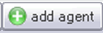

Select the desired agents with whom the tech pack should be shared from the list on the left. Use the green arrow controls to move the selected agents to the list on the right. Then click the **Save** button across the top of the window and then **Close** to return to the main tech pack window.

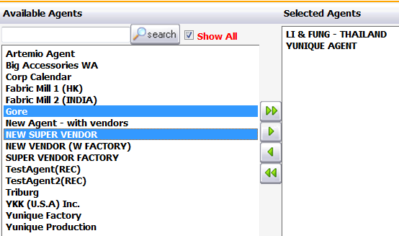

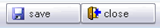

The Activity Log tab can been reviewed in the lower right portion of the window under. This area will show the date, time and user(s) that have either viewed or downloaded the tech pack.

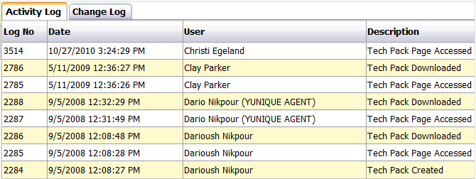

To generate a PDF of the tech pack click on the **Preview** button across the top of the window. Once the tech pack displays it can be sent to a physical printer if desired.

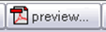

To generate a new tech pack, click on the main Tech Pack node on the left side of the style folder window and then click the **New** button across the top of the window.

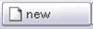

Next select the desired tech pack to be generated by placing the selection indicator next to the desired title. For each of the tech pack titles listed there will be a different group of pages from a style folder that will be included. If there is not a preset grouping then pages can be selected individually by clicking the On-The-Fly tab. Once the tech pack is selected click **Save** to store the teck pack and close to return to the main window.

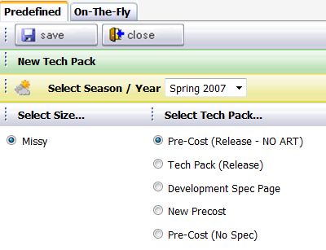

**\*NOTE**: that the page groupings and titles will be different for each company.

**Share**

The Share node is an area where the agents and vendors that will have access to various portions of a style folder can be managed.

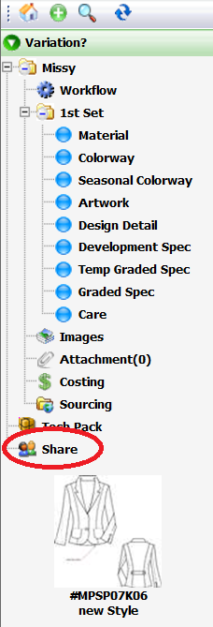

The agents that have been given some access to the style folder will be listed on the right side of the window.

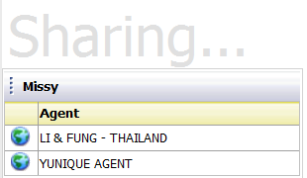

To add an agent, click on the **Add Agent** button across the top of the window.

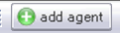

If there are size variations within a style, the specific variation must be selected from the list on the right and moved to the list on the left.

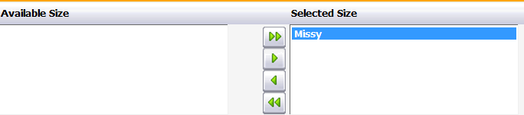

Highlight the agents with whom the style will be shared from the list on the left and then move them to the list on the right by using the green arrow controls in the center.

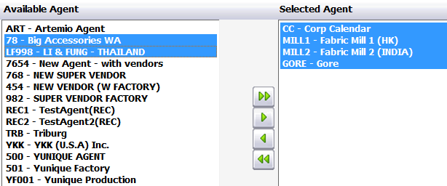

Once a style folder has been shared with an agent, specifically what is shared can be referenced by clicking on that agents name in the list.

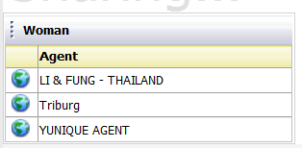

The list on the right will display any information available to share with an agent, and the list on the left will display the information that has been shared with the vendor. The green control arrows in the center allow this list to be managed. The items that can be shared are page(s) within the style folder, tech packs, quotes, and samples.

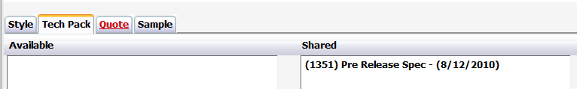

**Variation(s)**

Very often a single style being developed will have variations based on fit, or customer, etc. For example a dress might be offered in Missy, Petite, and Plus size class variations. The variations will be developed simultaneously with little or no differences in the data required for development. By default every style folder that is developed will display the header of Variation 1 above all nodes on the left side of the style folder window

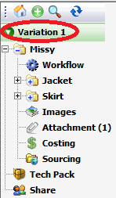

To add variations to a style folder being developed click on the **plus symbol icon** located on the left side of the style folder window.



Make the appropriate selection for the variation type by clicking the circle to the left of the desired setting and then click the **New** button across the top of the window. Click the **Close** button to return to the style folder.

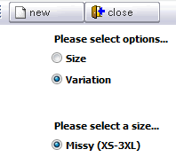

The new variation will be displayed as Variation 2 on the top left side of the style folder, with all of the pages needed for development data listed below. Variation 1 will be visible at the bottom of the list. To toggle between Variation 1 and Variation 2 click on the arrow to the right of the desired variation.

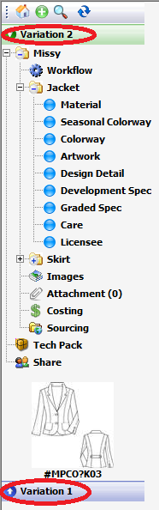

To change the title of the variations, click on the **Edit** button on the right side of the window above the representative images.



Type in the field above the representative images the new variation names. Then click the **Save** button across the top of the screen. Click the **Close** button to return to main the style folder view.

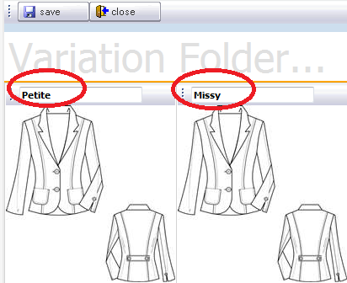

The header changes will be reflected on the left side of the style folder window.

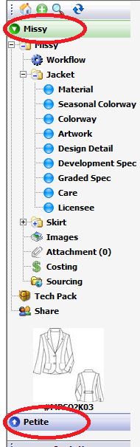

**Quotation**

If a style folder contains costing information then a request for a quote can be submitted and managed in the Quotation area.

To submit a quote request, click on the **RFQ Folder** node on the left side of the explorer window. Then click on the **New** button across the top of the screen on the right side of the window.

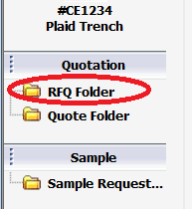 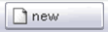

Next select an agent by clicking on the icon to the right of the Agent field. Once the agent is selected the other fields will be filled in automatically with related information.

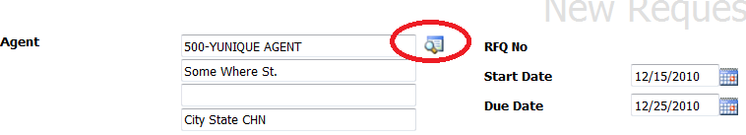

Next click on the **Save** button across the top of the screen to store the new request record.

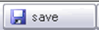

Place a check mark in the upper left corner of the version of the style for which the quote is being requested. Costing information is required for each variation in order to generate an RFQ.

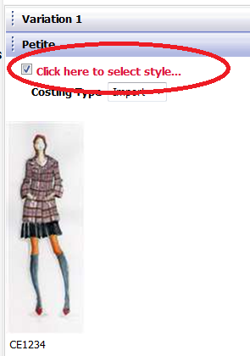

Next click **Save** across the top of the screen to store the new request.

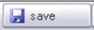

Once the style and agents are selected the record will be displayed with the costing information listed below the style image. At this point vendor information can be added to the request. Clicking on the **Vendor** button above the image will present a list of available vendors to choose.

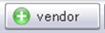

Place a check mark to the left of all vendors with whom the RFQ will be shared and click the **Add** button across the top of the screen. Click on the **Close** button across the top of the screen to return to the main RFQ window. Selecting the vendor completes the RFQ process.

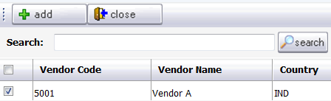

If it is necessary to replace the vendors it will be managed from the RFQ area. To replace the vendor for the quote, click on the **Edit** button just above the image.

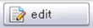

Click on the **Replace Vendor** button across the top of the screen to select a new vendor from the list as before.

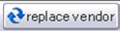

Request for variations of a style or for the entire style can be deleted if no quote information has been submitted by the vendor. To remove a variation, click on the **Variation** button above the image.

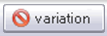

Once the variation(s) have been selected a dialog box will be presented to verify that the information should be deleted. Click **OK** or **Cancel** to complete the delete variation process.

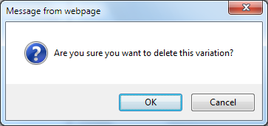

To delete the entire request, click the **Delete** button across the top of the screen.

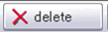

A dialog button will be presented to verify that the request should be deleted. Click **OK** or **Cancel** to complete the delete process.

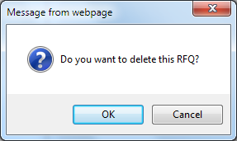

If additional style variations are needed for the quote they can be added by clicking on the **Add Style** button.

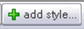

The available variations will be presented. Place a check mark in the upper left of the variations to be selected as before.

Once all information has been added to the request correctly it can be managed from the **Quote node** on the left hand side of the style folder.

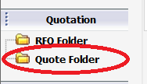

A list of all quotes for the style will be presented in a list. Double clicking on a selected quote will open up the record to be viewed or edited.

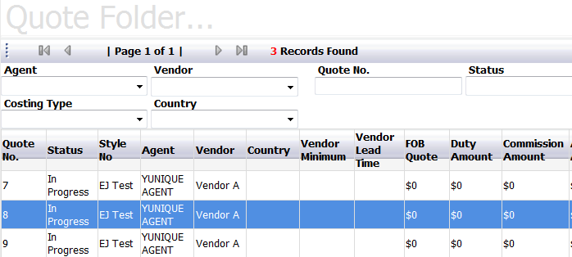

Once a specific quote is opened data information can be added, vendors can be replaced and dialog strings can be viewed and edited according to specific user permissions.

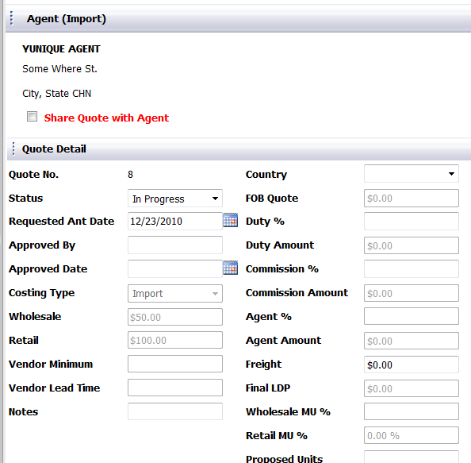

In the lower right portion of the quote window is an area labeled Vendor. This area will actually be edited by the vender via the SRM On application.

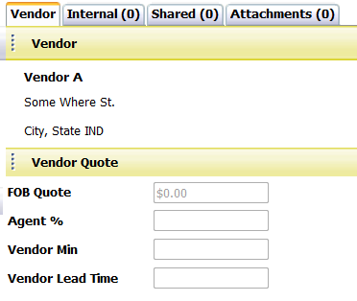

The tabs labeled Internal and Shared are for dialog strings associated with the quote. Comments placed on the **Internal** tab will not be visible to any vendor user log in accounts. The **Shared** tab, on the other hand will be available for viewing and editing to the vendor log in accounts. The **Attachment** tab is available for any supplemental documentation necessary for the quote, such as PO’s.

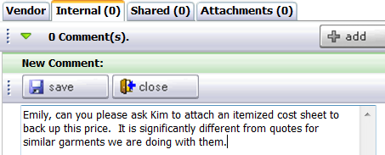

**Sample**

The sample node is where communication with vendors related to all product sample requests is managed. This could include samples for fit, lab dips, fabric testing, etc. To view or create a new sample, click on the **Sample** node on the left hand side of the style folder window at the very bottom.

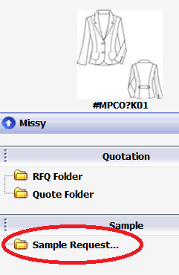

To create a new sample click on the **New** button across the top of the screen.

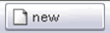

If there is more than one variation of a style, choose the specific variation to be sampled.

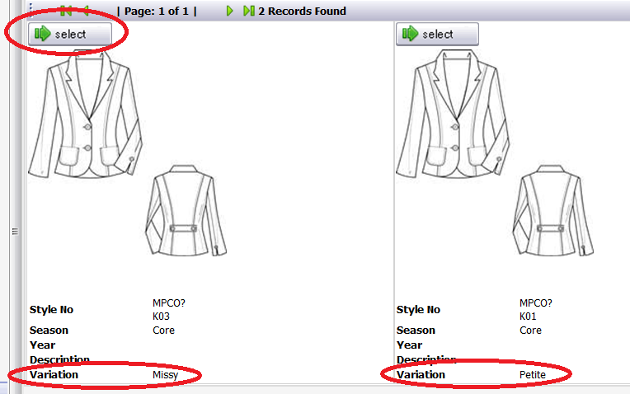

Next choose the specific product colors for the new sample process, as well as the specific item of the product set by placing a check mark to the left of each selection.

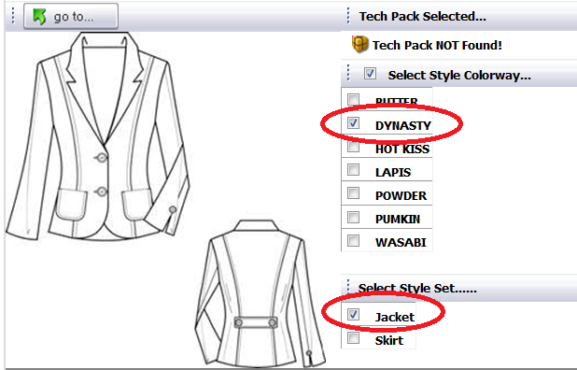

Click the **Next** button to continue the sample request process. If more information needs to be gathered, click the **Save** button to save the sample request and carry on at a later time. The **Back** button will return to the previous screen.



Next, select a date on which the calendar timeline will be based. Sample processes can be managed by start date or end date, or by an “average date”. Then a specific **Template** will be required. A template is a workflow for the sample process that is being managed. The specific milestones will be different depending on the template chosen.

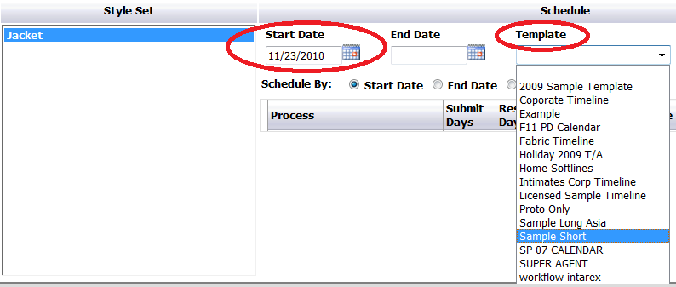

**\* NOTE:** The workflow templates are created and managed in the Control Panel area of the YuniquePLM software application. Not all users will have access to create or edit templates.

Once the template is selected from the drop down list, the required action items will be displayed in the list below. If necessary, changes can be made to certain fields by clicking and selecting a new date, or name from the drop down list provided.

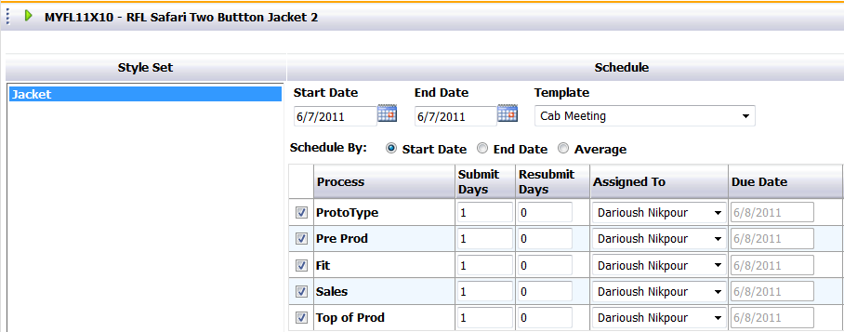

Click **Next** across the bottom of the screen to continue the sample request process.

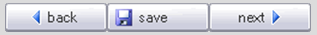

Next select a specific vendor to be responsible for the sample request being generated. If there are no vendors listed, be sure to remove the check mark in the **Show Vendor with Quotes**. Click **Next** at the bottom of the screen to continue the sample request process.

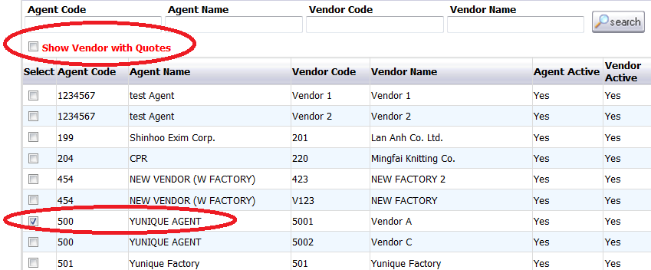

Once the sample request is completed the information will be displayed. After reviewing, click **Save** to complete the process or **Cancel** to end the process without storing the record.

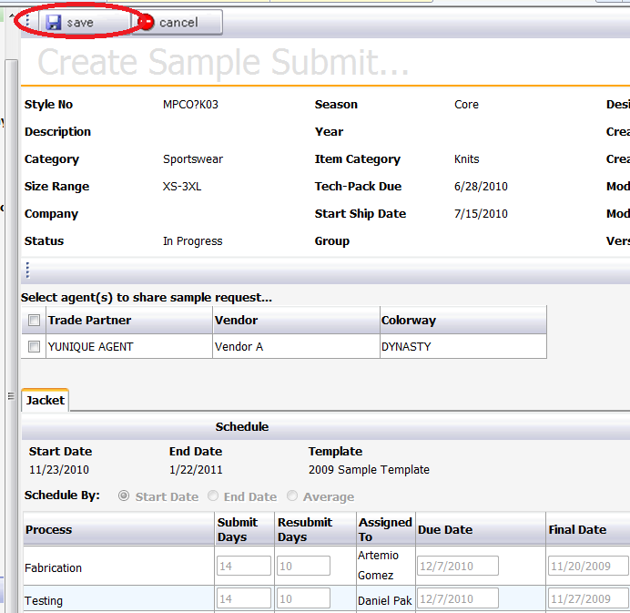

Once a sample request is generated, it will be displayed in a list with all other sample requests for the style folder. Each row will represent a specific sample request to a specific vendor. The action items for that request will be listed from left to right in columns across the top of the page. Each vendor may have multiple outstanding requests, and each request can be for a different process. For example a vendor may be responsible for a fit sample as well as an artwork sample. A date and colored “bubble” indicator will be displayed beneath the appropriate column headers for outstanding requests for each vendor. If no bubble and date is displayed beneath an action item, then the vendor is not responsible for that specific task.

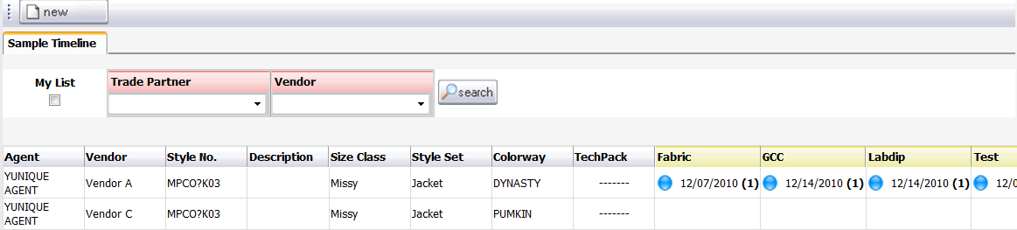

To review the specific details of a sample request and to correspond directly with the vendor, click directly on the desired date beneath the process header label. In the example below, the sample being selected turns red.

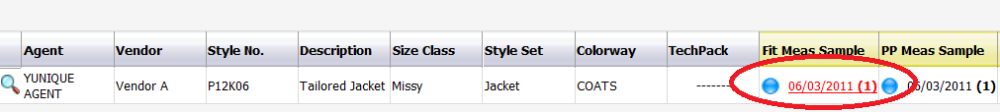

The workflow for that specific sample request type will then be displayed.

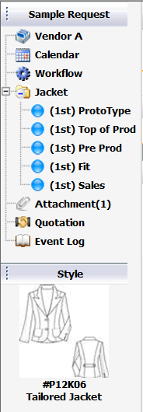

Each sample submit will also have a tab on the right side of the explorer where additional information can be managed and shared with the vendor. To generate the development spec information for the samples, click on the **1st Submit** tab and then click on the **Create Spec** button at the bottom of the tab.

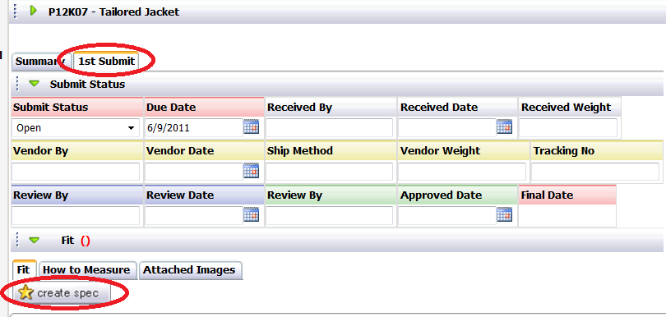

Select the measurement page containing the correct grade information to be used for the sample and click on the Next button across the top.

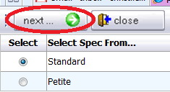

Choose the size of the sample to be made. This can be different than the sample size indicated on the measurement page if desired. Click the Save button across the top.

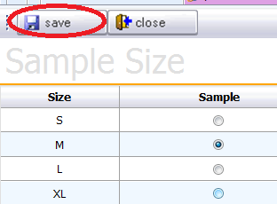

The page will then display the development spec information for the sample being requested. In this screen, various fields of information can be entered with data under the Submit Status bar. On the tab containing the POM information, labeled “Fit” below the submit status, the actual measurements of the actual fit process can be entered. **Vendor Sample** is where the measurements taken by the vendor would be entered. , **Sample** is the column in which the technical design employee would enter the measurements once the sample is received from the vendor. **Sample Revisions** is the column where a new measurement value can be entered different than that on the original measurement page. If the **Post Revisions to Measurement** box is checked, then these revised measurements will automatically update the corresponding measurement page once the data is saved.

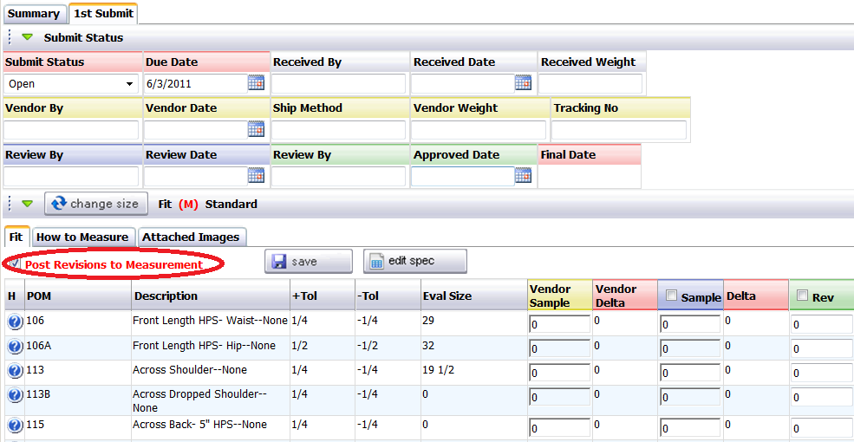

To view the How to Measure Guide, click on the How to Measure tab.

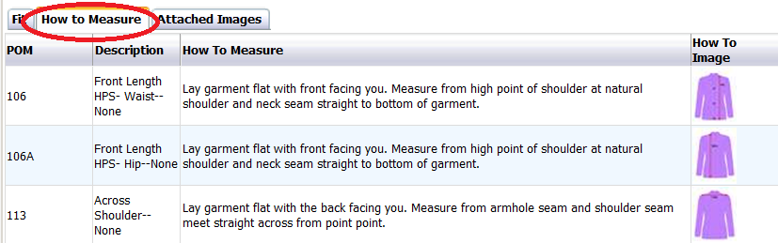

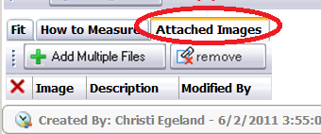

To attach additional images, click on the Attached Images tab.

Then click the +Add Multiple Files button.

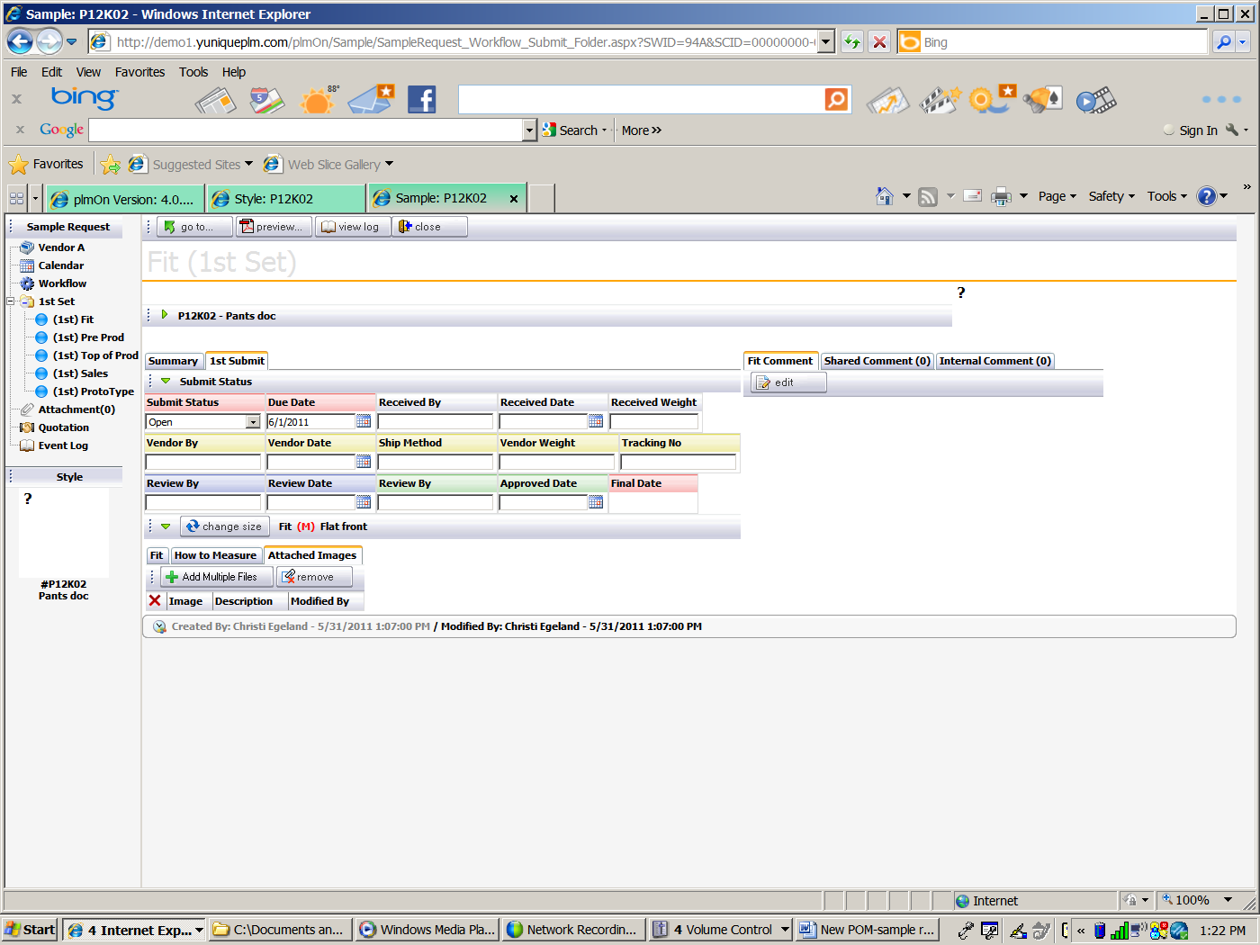

A New Image tab or window will appear

.

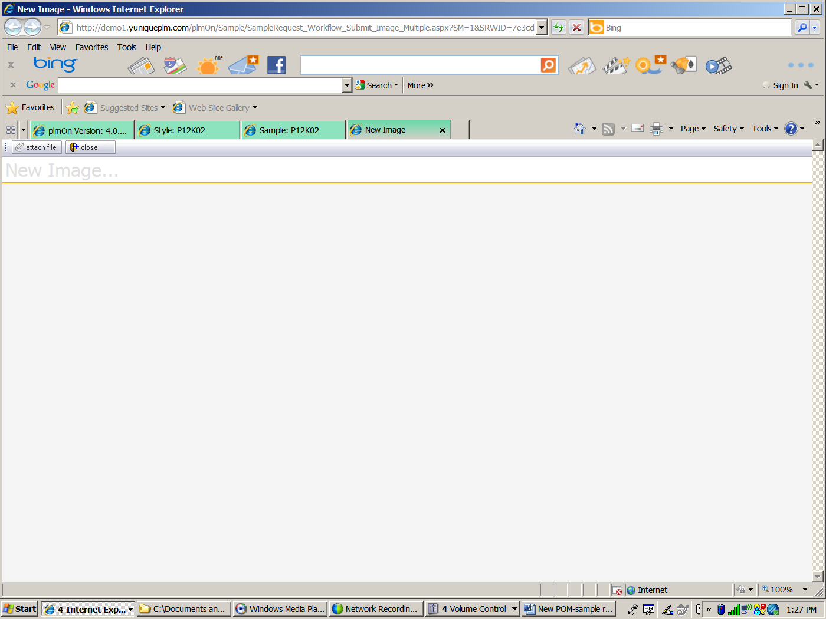

Click the attach file button.



The windows Open dialog box will appear so that a file can be selected.

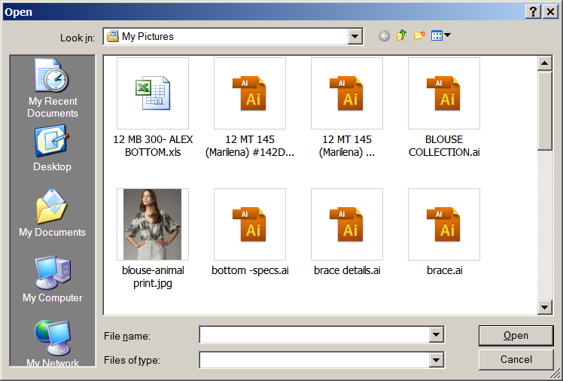

After the file is selected, it will upload as shown.

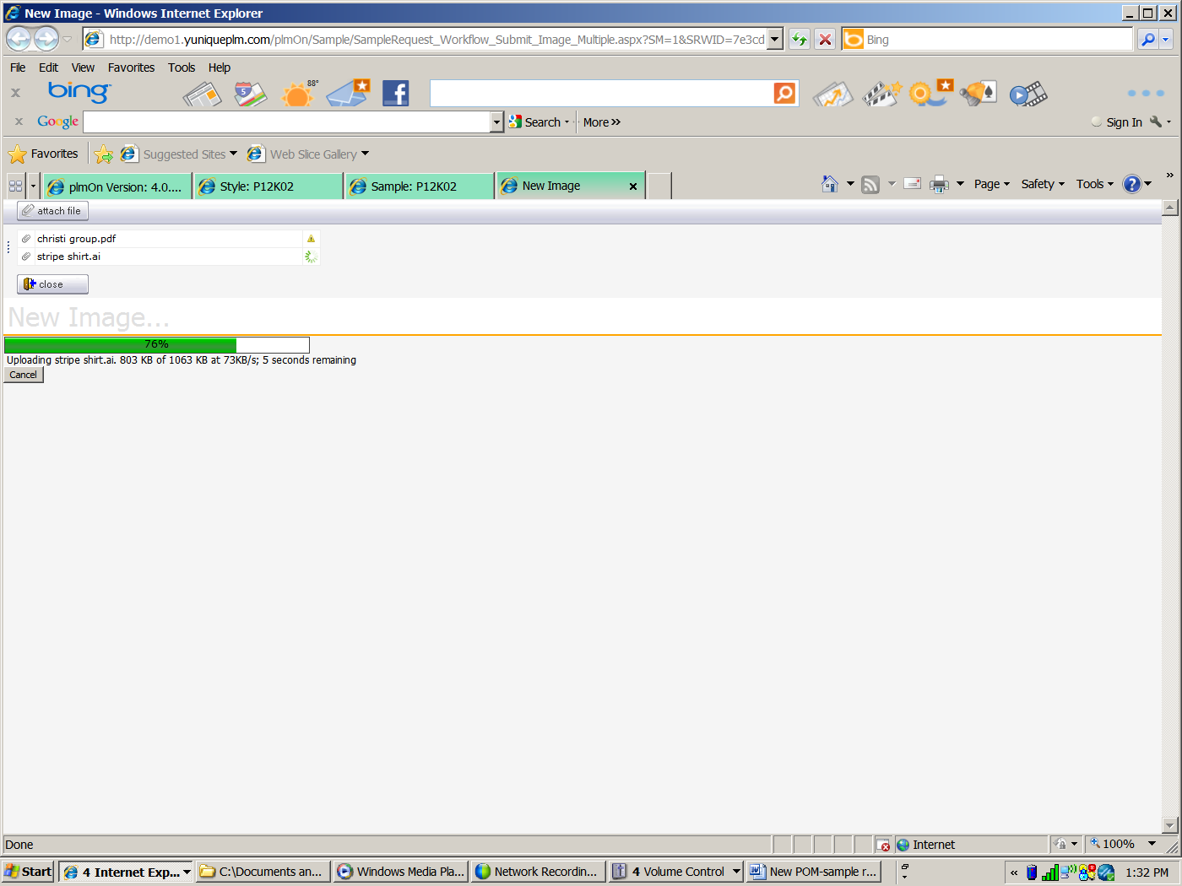

Click Save to save the file, attach file to attach an additional file, or close to discard changes.

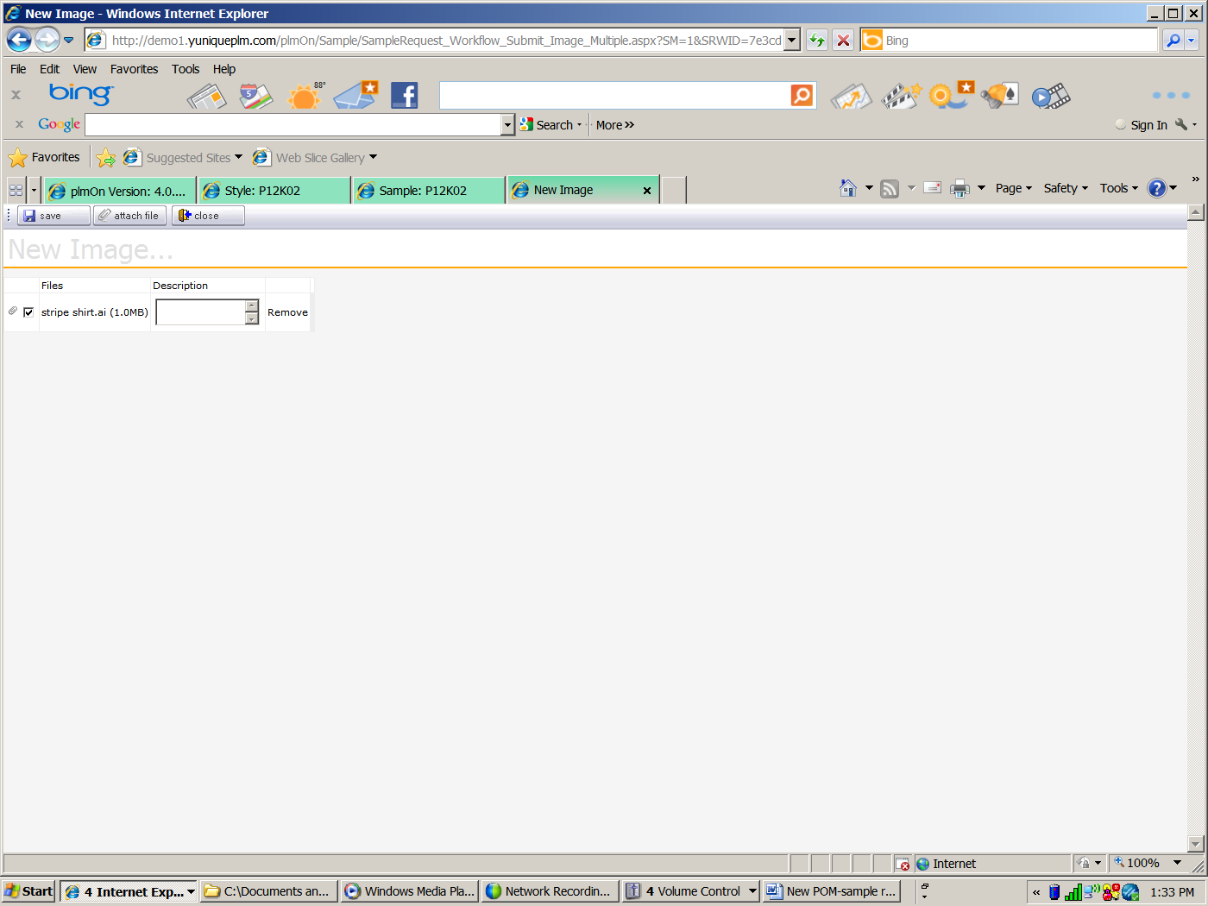

On the right side of the screen/view is an area to add fit comments. To add fit comments on the Fit Comment tab, click the **Edit** button.

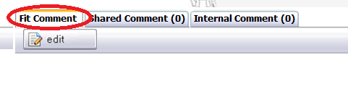

A fit comment tab or window will appear. Type in a comment or click the check the box **Auto Fit Comment** for a system generated comment. Then click **Save**.

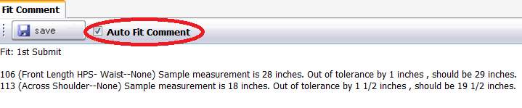

For comments that can be entered and viewed by both vendor users as well as employee users, click on the Shared Comment tab. Click the **Add** button on the right.

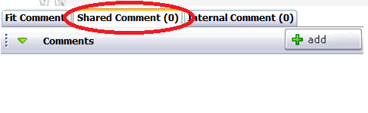

For comments that cannot be viewed by the vendor, click the Internal Comment tab. Click the **Add** button on the right.

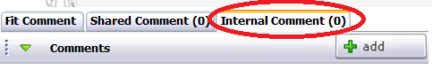

To Change a sample size during the sample process, click the **Change Size** button.

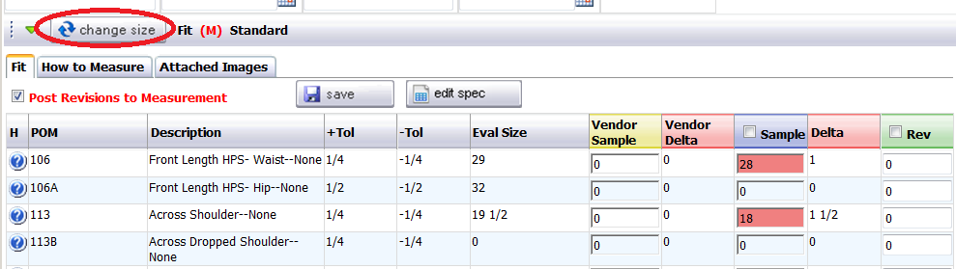

The system will ask you are you sure. Click **OK** to continue or **Cancel** to discontinue.

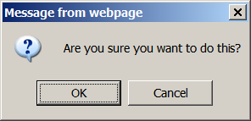

Then sample size listing will appear in a window or tab. Select the new sample size and click **Save**. Click **Close** to disregard changes.

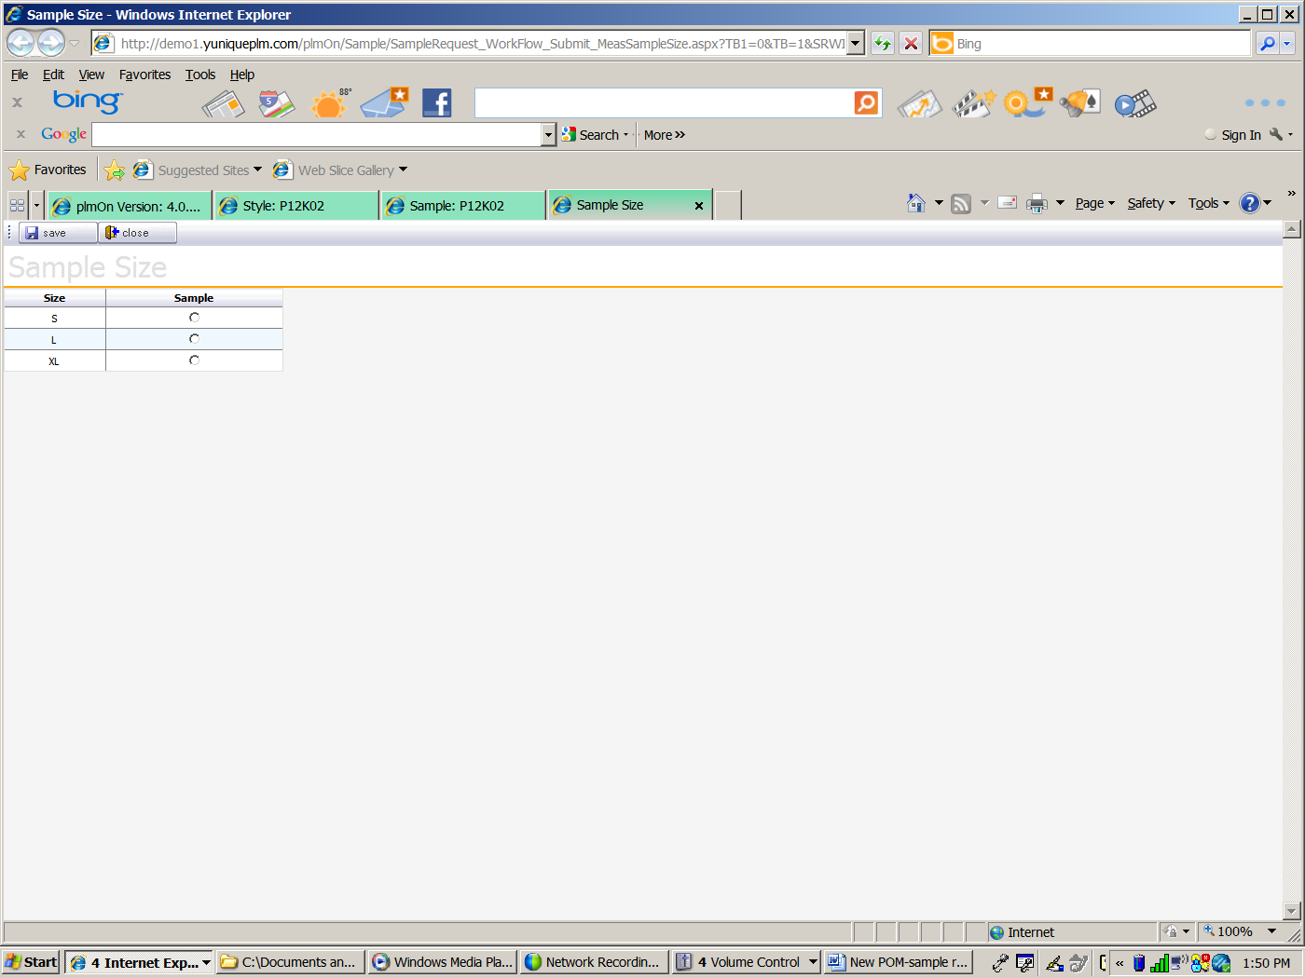

To go to a page or bubble in the style that is being sampled, click the **Go To** button

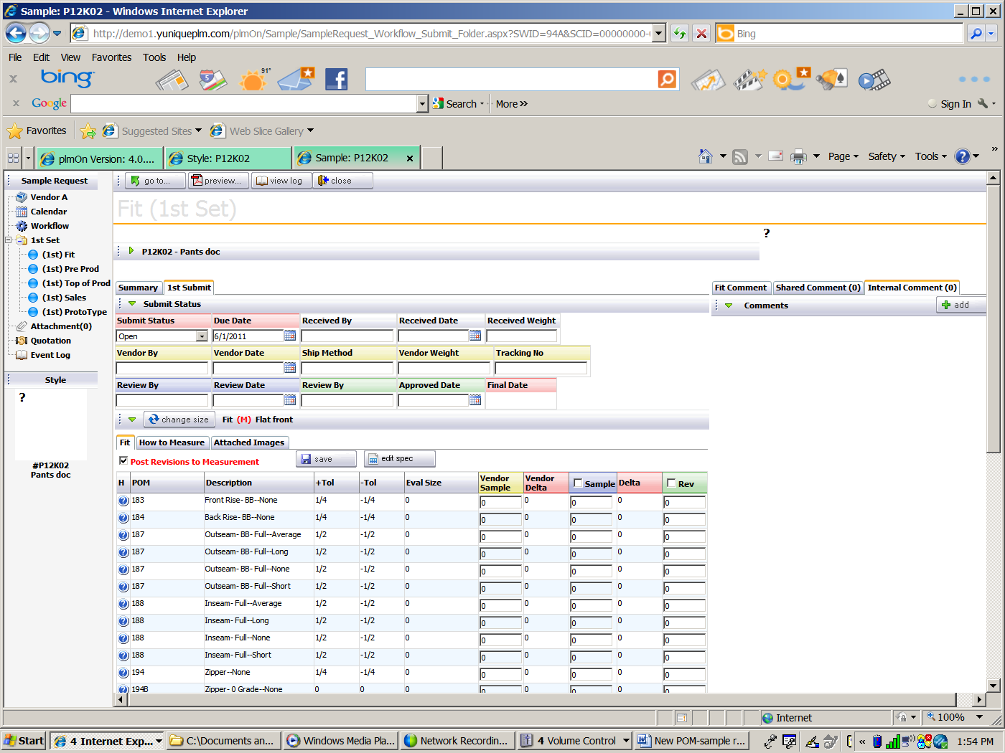

A page list will appear. Click on the page to go to or click Close to cancel.

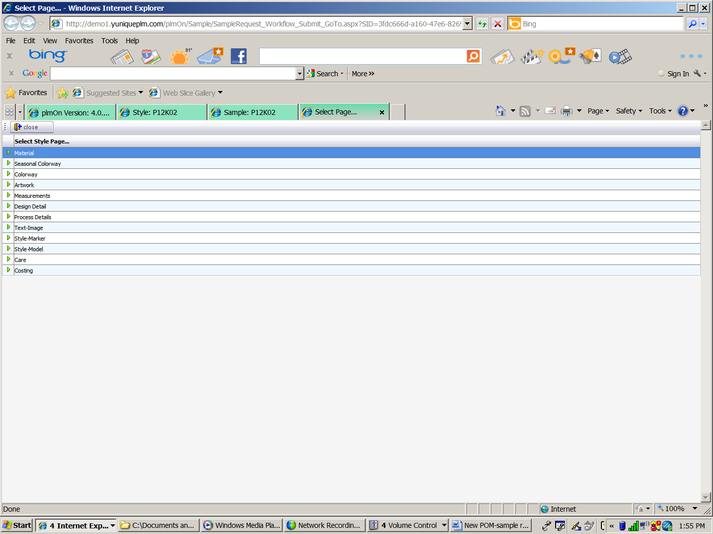

To view a print preview, click the **Preview** button. Choose the printout to view and click the **Preview** button.

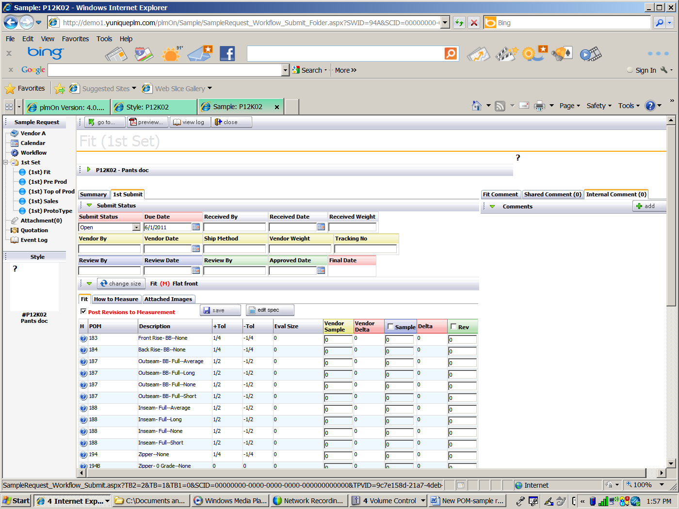

To view the sample log, click on the **View Log** button.



A Sample Submit log will appear in a window or tab.

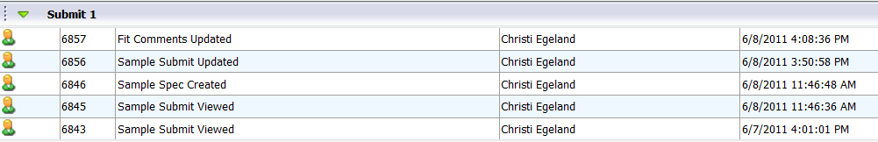

Click the X to close the tab or window.

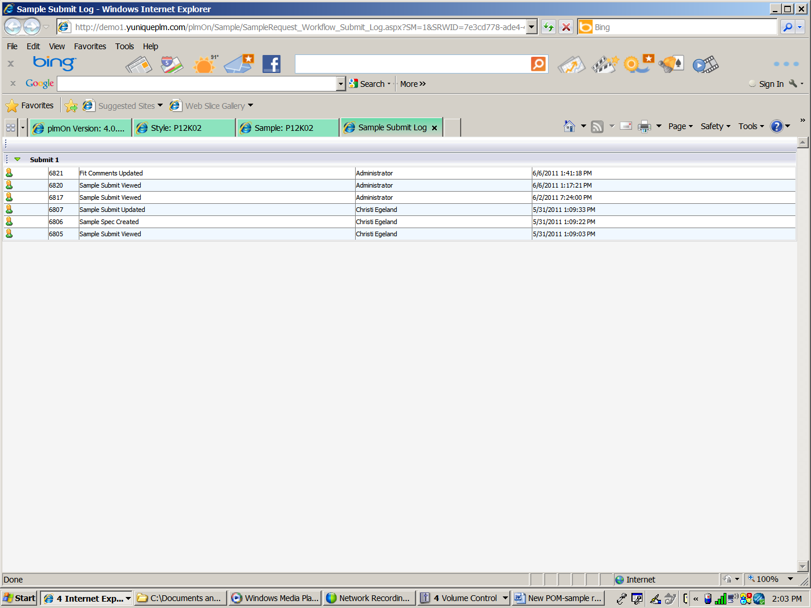

Since the sample process is also managed as a workflow, the explorer window is unique to the selected sample workflow. Therefore the nodes on the left side are different than those found in the style itself.

**Vendor A** is the first node to appear in the left hand explorer area. “Vendor A” indicates the vendor that has been selected for the sample process. The information in the workflow will all be provided to and/or by this vendor.

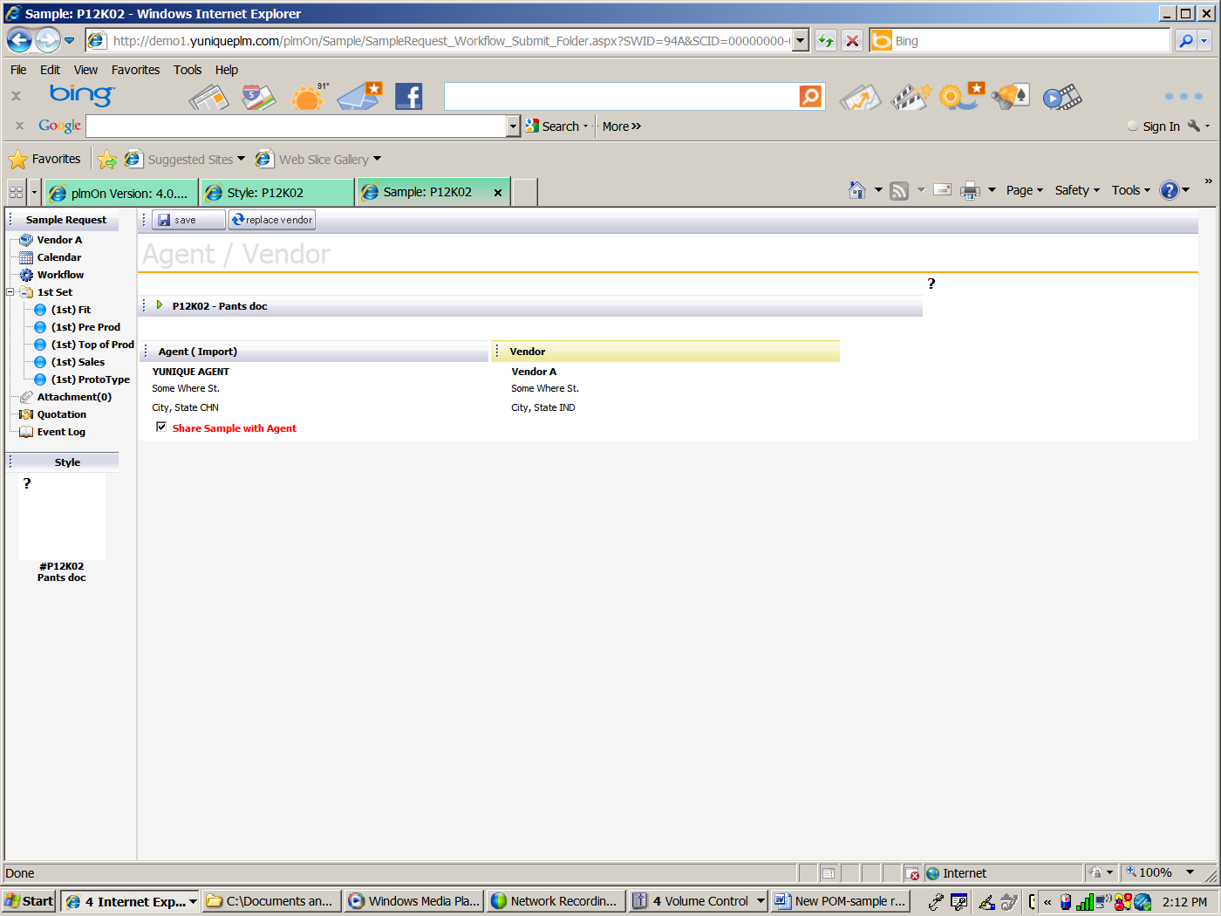

This view allows the selected vendor to be replaced with a different vendor. To replace a vendor, click the **Replace Vendor** button.



A replace vendor window or tab will appear.

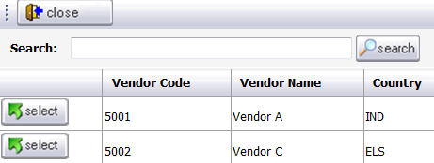

Click the **Select** button to select a new vendor and then click **Save**.

To view the sample submits required for the workflow there is a calendar node. Click on the **Calendar** in the left navigation.

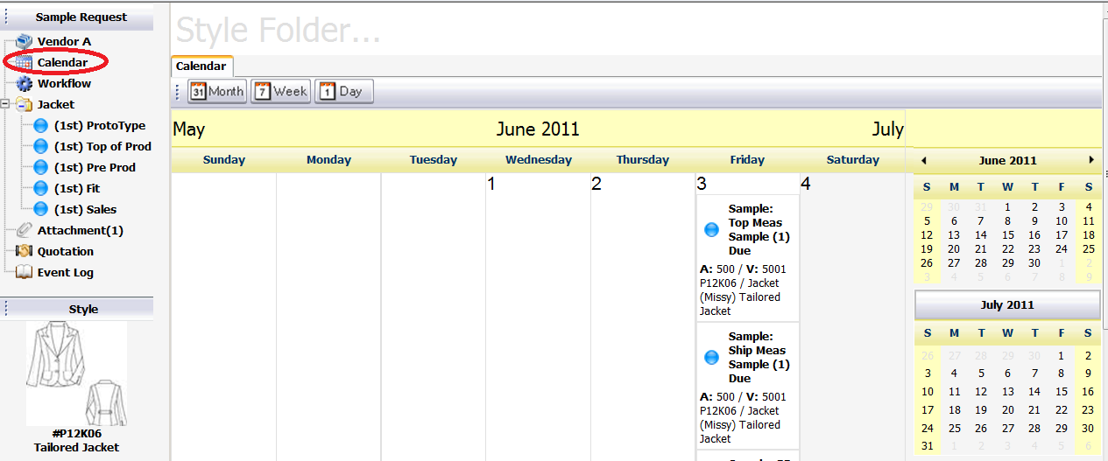

To view the workflow that has been selected for the sample process, click on the **Workflow** in the left navigation. A list of the action items that have been predefined for the workflow will appear along with the due dates and the name of the person responsible for the process.

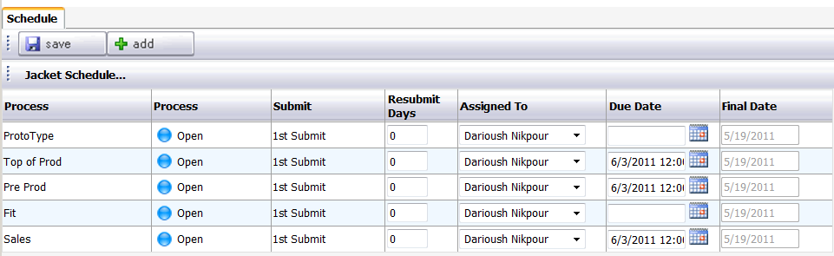

To add a milestone process to the workflow, click the **Add** button. A select style set dialog will appear. Chose the appropriate option, then click **Next**.

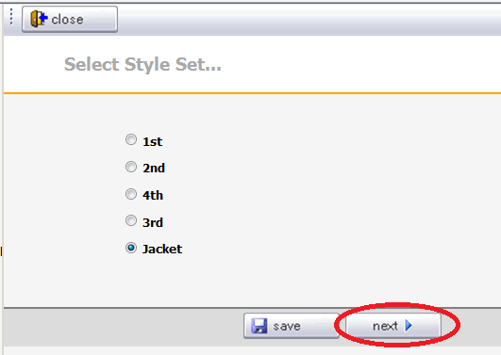

Additional processes that can be added to the workflow will appear. Chose the appropriate process from the left window and add it to the process selected box on the right by using the green selection arrows in the middle. Use the green up/down arrows to place them in the correct order. Click **Next** across the bottom.

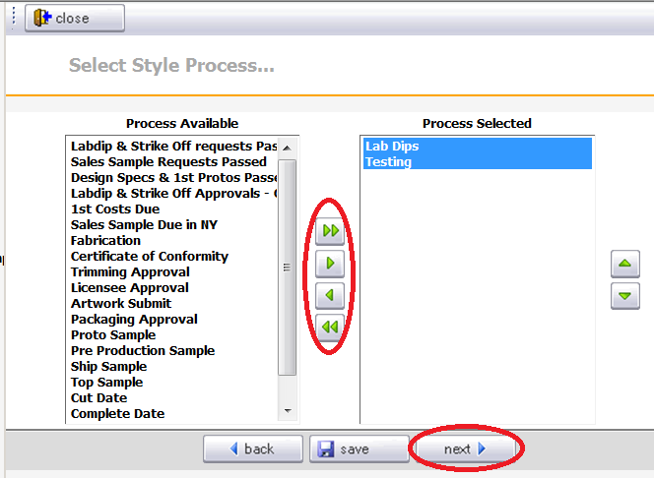

Based on the type of process selected, additional selections may appear. The process will then be added to the workflow. Click the **Save** button to add save it to the workflow.

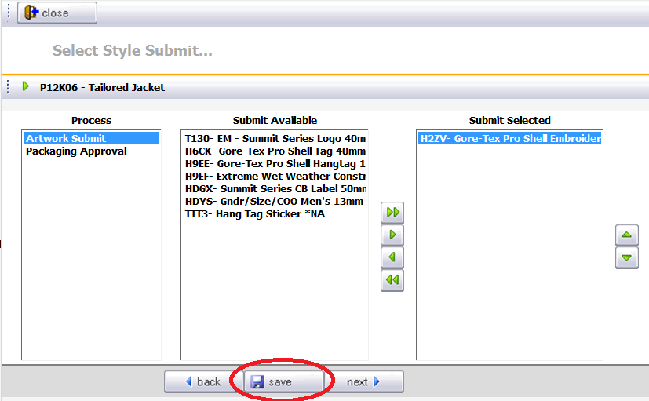

From the submit calendar, navigation allows viewing of the style folder at any time. Click on the **Go To** button to view the style folder.

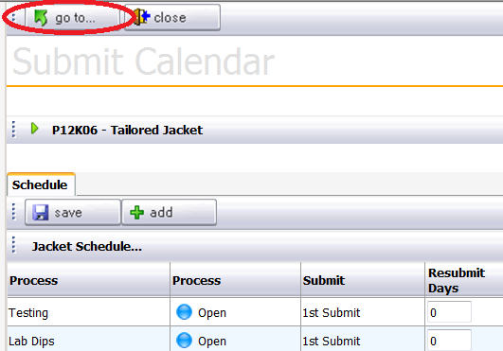

To view or add attachments, click on the **Attachments** node in the left navigation.

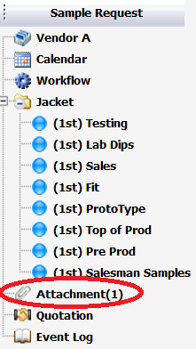

To add an attachment, click the new button on the right side of the explorer window across the top.

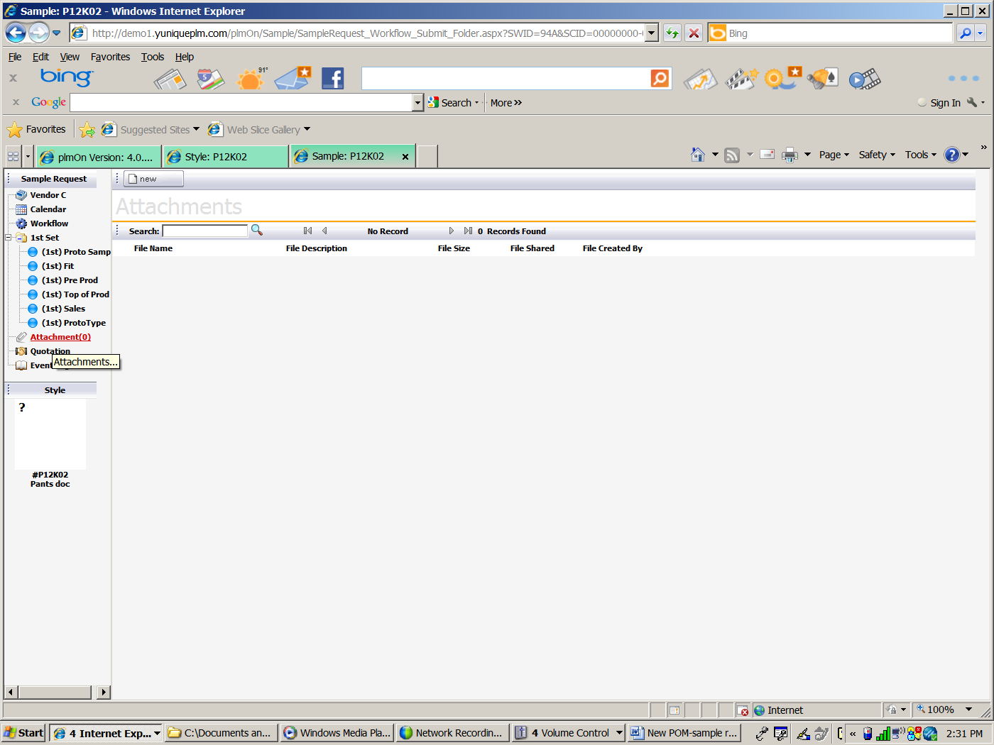

A dialog will appear. Click the browse button to select a file. If the file can or should be shared with the Agent, place a check mark in the box next to “Share File with Agent.”

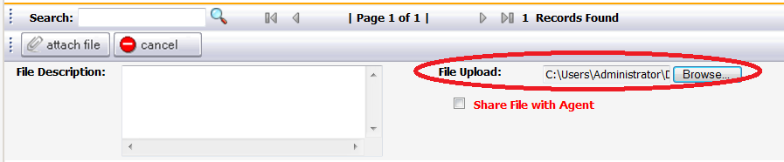

After the file is selected and appears in the File Upload: click the Attach File button.

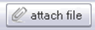

The file will then be listed on the attachments screen.

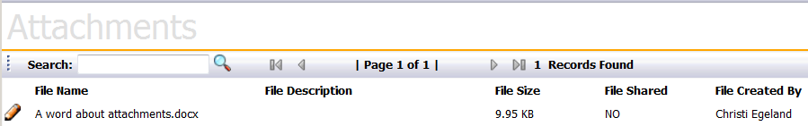

To view the event log, click the **Event Log** node in the left navigation.

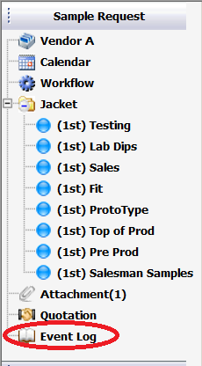

A history of actions dates and user names will be listed for each of the milestone processes listed for the workflow.

